Master Thesis

for the Attainment of the Degree

Master of Science

at the TUM School of Management

of the Technische Universität München

**Blockchain Technology Adoption among Consumers:**

**An Analysis of Usage Intention and Application Usefulness**

Examiner: Prof. Dr. Isabell Welpe

Chair of Strategy and Organization

TUM School of Management

Technische Universität München

Advisor: Pascal Mehrwald, M.Sc.

Study Program: M.Sc. Management and Technology

Submitted by: Dennis Henning

Quiddestraße 72

81735 Munich

Matriculation Number: 03725153

Submitted on: 31.05.2022

**Abstract**

Blockchain technology research has mainly been focused on general usage intention, mostly examined the organizational perspective, and lacked a differentiated view at specific blockchain applications from the consumer perspective. To foster adoption of blockchain technology, consumer perception of blockchain technology needs further understanding. Building on recent technology adoption literature and employing a representative survey for Germany, we identified context dependent predictors and moderators of blockchain technology usage intention. Results show that drivers of usage intention depend on consumers’ age, gender, experience, and cryptocurrency possession. Findings guide practitioners by shedding light on blockchain adoption and usefulness of specific blockchain applications. Moreover, results indicate that blockchain adoption research should be more granular and differentiate between applications and contexts. Our identified specific blockchain applications provide a basis for future research.

*Keywords:* *Blockchain Technology, Technology Adoption, UTAUT, Usage Intention*

**Contents**

List of Tables 5

List of Figures 6

List of Abbreviations 7

1 Introduction 8

2 Field report 14

2.1 Consumer perception of blockchain technology in Germany and the United Kingdom 14

2.2 Consumer technology readiness in Germany and the United Kingdom 21

3 Literature review 25

3.1 Blockchain technology and its applications 26

3.2 Blockchain technology adoption 28

4 Research model and hypotheses derivation 30

4.1 Research model 30

4.2 Hypotheses derivation 33

5 Methodology 36

5.1 Data analysis 36

5.2 Measures 36

5.2.1 Dependent variables 37

5.2.2 Independent variables 37

5.2.3 Moderator variables 39

5.2.4 Reliability and validity 40

6 Results 44

6.1 Descriptive results 44

6.2 Effects on usage intention 45

6.3 Effects on application usefulness 48

7 Discussion 51

7.1 Theoretical contributions 54

7.2 Practical contributions 54

7.3 Limitations and future research 57

8 Conclusion 57

References 59

Appendix 68

Declaration of Authorship 73

List of Tables

Table 1: *German sample baseline characteristics* 15

Table 2: *British sample baseline characteristics* 15

Table 3: *Latent class segmentation using TRI data of German sample population* 24

Table 4: *Latent class segmentation using TRI data of British sample population* 24

Table 5: *Demographic and technology characteristics of German TRI-based clusters* 25

Table 6: *Demographic and technology characteristics of British TRI-based clusters* 25

Table 7: *Descriptions of specific blockchain applications* 33

Table 8: *Construct variables* 35

Table 9: *CFA results* 42

Table 10: *HTMT ratios* 43

Table 11: *CFA model fit statistics* 44

Table 12: *Descriptive statistics* 44

Table 13: *Regression results of research model I: Usage intention* 46

Table 14: *Regression results of research model II: Application usefulness* 48

Table 15: *Summary of results of the hypothesized effects* 50

List of Figures

Figure 1: *Consumers’ usage intention towards different technologies* 17

Figure 2: *Consumers’ awareness of blockchain technology applications* 18

Figure 3: *Consumers’ trust in other blockchain technology users* 19

Figure 4: *Consumers’ trust in blockchain’s integrity, benevolence, and ability* 20

Figure 5: *Consumers’ technology readiness* 22

Figure 6: *Research model I* 31

Figure 7: *Research model II* 32

Figure 8: *Consumers’ usefulness assessment of specific blockchain applications* 51

List of Abbreviations

AVE *Average Variance Extracted*

BIC *Bayesian Information Criteria*

CFA *Confirmatory Factor Analysis*

CFI *Comparative Fit Index*

HTMT *Heterotrait-Monotrait*

LCA *Latent-Class Analysis*

NFT *Non-Fungible Token*

RMSEA *Root Mean Square Error of Approximation*

SRMR *Standardized Root Mean Square Residual*

TLI *Tucker-Lewis Index*

TRI *Technology Readiness Index*

UK *United Kingdom*

UTAUT *Unified Theory of Acceptance and Use of Technology*

VIF *Variance Inflation Factor*

# Introduction[1]

Numerous practitioners and scholars believe that blockchain technology has the potential to disrupt many industries and to be a main force in modern businesses (Aydiner, 2021; Chong et al., 2019; Cong & He, 2019; Frizzo-Barker et al., 2020; Weking et al., 2020). In fact, venture funding to blockchain startups surged by 713% from 2020 to 2021 to reach $25.2 billion, while the number of global blockchain unicorns increased by 422% from nine in 2020 to 47 in 2021 (CB Insights, 2021). However, as our studies of the German and British consumer market show, only 3% and 6% of consumers (e.g., end-users) have knowingly used blockchain applications so far, respectively (see also Knauer & Mann, 2020). These findings contrast the current hype around blockchain technology and raise questions about the underlying drivers of blockchain usage intention and specific application usefulness perceptions from a consumer’s perspective. This paper attempts to give answers within the fields of technology adoption by providing an empirical analysis.

At the intersection of computer science, cryptography, and economics, blockchain is thought to be a foundational technology of the fourth industrial revolution (Iansiti & Lakhani, 2017; Toufaily et al., 2021). At its core, blockchain refers to a decentralized ledger technology that enables serial, peer-to-peer transactions without third-party intermediaries (Liang et al., 2021; Toufaily et al., 2021). Its key characteristics constitute anonymity, transparency, security, traceability, and efficiency of transactions (Liang et al., 2021). This allows for publicly auditable ledgers that simultaneously preserve the privacy of the individual (Yin et al., 2019).

Numerous studies indicate that blockchain technology has the potential to create value in several ways (Abdollahi et al., 2022; Nowiński & Kozma, 2017; Weking et al., 2020; Zheng & Boh, 2021). First, blockchain technology creates an ecosystem of actors that removes the need for a third party to establish trust between participants (Ali et al., 2021; Rossi et al., 2019; Weking et al., 2020; Zhang et al., 2021). Instead, trust is established among all parties through immutable and transparent transactions as well as validated records (Weking et al., 2020; Zhang et al., 2021). Therefore, blockchain offers users a decentralized mechanism for authenticating data and transactions, setting it apart from centralized transaction systems (Weking et al., 2020). Second, blockchain creates cost reduction potentials that allow users to benefit from lower transaction costs, e.g. in financial payments (Abdollahi et al., 2022; Nowiński & Kozma, 2017). Lower transaction costs emerge from disintermediation, reduced record-keeping for customers and faster transaction times improving operational efficiency of businesses, as well as enhanced data traceability and verification (Nowiński & Kozma, 2017; Weking et al., 2020; Zheng & Boh, 2021). Third, blockchain could create societal enrichments through democratization, new business practices and extended access domains (e.g., new financial resources, crowdsourcing, new stakeholders) (Abdollahi et al., 2022).

Initially popularized as the technology behind the cryptocurrency Bitcoin (Cong & He, 2019), blockchain has been increasingly utilized as a building block for a wide range of use cases in many different domains (Marikyan et al., 2022). Currently, sectors like finance, supply chain management, healthcare, voting, arts and entertainment witness a strong interest in blockchain use cases (Ali et al., 2021). Those use cases mostly build on the following blockchain applications: Self-sovereign identity, tokenization, fractional ownership, micropayments, smart contracts and (pseudo-)anonymous transactions. The literature revealed those applications to be main drivers for new business models (Boston Consulting Group, 2019; Schlecht et al., 2021; Toufaily et al., 2021; Zheng & Boh, 2021; Ziolkowski et al., 2020).

As a top technology trend, blockchain needs to be widely adopted and diffused if the innovation is to realize its socio-economic benefits (Toufaily et al., 2021). Regardless of its benefits, value drivers or applications, widespread adoption is still rare. To foster adoption, consumers’ perception of blockchain technology needs further understanding. This is important, because consumers are a decisive factor for the long-term success of blockchain technology applications. According to Toufaily et al. (2021), consumers are expected to reap benefits from more efficient transactions (e. g., inexpensive and fast payments), increased transparency, verifiability and accuracy of information, as well as self-sovereign data ownership and identity control. However, consumers are challenged by the technological complexity of blockchains (Marikyan et al., 2022). They find it difficult to understand its services, benefits and use cases, not to mention the technical nuances of its infrastructural layer (Marikyan et al., 2022).

Yet, many researchers have studied the adoption of blockchain technology from an organizational perspective (Liang et al., 2021; Toufaily et al., 2021) or have analyzed its technical advantages and values (J. Li, 2020). However, empirical research from the perspective of the consumer is still scarce. Particularly, too little attention has been given to the influences of consumers’ blockchain usage intention and consumers’ assessment of blockchain application usefulness. This differs from the organizational perspective fundamentally because 1) organizations often focus on incrementally improving or digitizing current partnerships and dataflows therein with blockchain, 2) organizations might risk some of their current advantages concerning the use of customer data and intermediating services once blockchain becomes widely used, and 3) business-to-business use cases often remain for a longer period and have more interactions compared to what is relevant among consumers.

Understanding the consumer perspective is then important for the following reasons. First, a consumer’s usage intention is a prerequisite for actual usage (Venkatesh et al., 2003). Thus, identifying influencing factors for usage intention is necessary to drive actual usage of blockchain technology; for example, by adequately communicating and addressing those influencing factors. Second, studying business models targeted at consumers need a granular level of understanding of which blockchain technology applications potentially address user needs, e.g., microtransactions or rather tokenized assets. This allows focusing researchers’ and practitioners’ efforts on more specific, useful aspects of blockchain technology. Third, blockchain technology is a decentralized technology and consumers will most likely continue to be the most essential user segment. In this paper, we attempt to fill this gap of lacking consumer focused blockchain research and aim at offering an answer to the following research question: *What influences blockchain usage intention from a consumer perspective and which blockchain applications are considered the most useful by consumers?*

In particular, this study investigates:

1. potential predictors and moderators of blockchain technology usage intention according to recent academic literature (Blut et al., 2022);
2. which predictors affect consumers’ blockchain usage intention;
3. application usefulness of specific blockchain technology applications, namely self-sovereign identity, tokenization, fractional ownership, micropayments, smart contracts and (pseudo-)anonymous transactions.

We build upon the stream of research on technology adoption, like the state-of-the-art and revised unified theory of acceptance and use of technology (UTAUT; Venkatesh et al., 2003) by Blut et al. (2022), and the stream of research focused on the potential of blockchain technology for organizations, consumers, and business models. To answer our research question, we employ a three-step approach. First, we conduct a systematic literature review on predictors of blockchain technology acceptance following Webster & Watson's (2002) guidelines. We use our findings to extend the UTAUT by predictors relevant to our context (Blut et al., 2022) and derive hypotheses. Second, we conduct a quantitative survey, which is representative for the German population. Third, we statistically examine consumers’ intention to use blockchain technology as well as their associated usefulness for identified blockchain technology applications. Our identified predictors include elements of the Technology Readiness Index (TRI), consisting of optimism, innovativeness, discomfort, and insecurity (Parasuraman, 2000; Parasuraman & Colby, 2015). Also, we include context specific predictors, such as social influence, disposition to privacy, trust, perceived risk, perceived benefit for society, potential of disruption and perceived usefulness. We examine these variables by developing two research models that test the effects of the identified variables on blockchain usage intention and application usefulness. Moreover, we test for moderation effects related to usage intention by age, gender, experience, and possession of cryptocurrency (Blut et al., 2022). Specifically, we conduct a (moderated) multiple regression analysis (Hair, 2014) based on our survey (N = 847) in Germany.

Our results are presented in three dimensions, namely predictors for intention to use, moderation effects influencing intention to use and predictors of usefulness for certain blockchain applications. Our results on usage intention reveal that innovativeness, trust, and perceived usefulness have a positive effect on usage intention. Discomfort and perceived risk are found to have a negative and social influence to have a positive effect on usage intention, in the models including gender, experience, or possession of cryptocurrency. A positive relationship is observed for potential of disruption and usage intention, in the models including age, gender, or possession of cryptocurrency. No effect is confirmed for optimism, insecurity, disposition to privacy and perceived benefit for society. Regarding moderation effects, we observe 1) age to negatively affect the relationship between trust and usage intention, 2) gender (males) to negatively influence the effect of perceived risk on usage intention, 3) experience to positively affect the relationship between trust and usage intention as well as to negatively affect the relationship between perceived usefulness and usage intention, and 4) possession of cryptocurrency to positively influence the relationship between trust and usage intention as well as perceived risk and usage intention. Our results on application usefulness show that trust and potential of disruption have a positive effect for every application of our sample. Optimism and perceived benefit for society are found to positively influence application usefulness as well, except for micropayments. Social influence has a positive effect for tokenization and fractional ownership applications, disposition to privacy a negative effect for self-sovereign identity and smart contract applications. No significant relationship is observed for innovativeness, discomfort, insecurity, and perceived risk. To provide additional descriptive value of our sample, we perform a latent-class analysis (LCA) based on the TRI item scores (Parasuraman & Colby, 2015). Results depict the technology readiness and affinity of the sample population. We identify 15% of German respondents to be associated as Explorers, 36% as Pioneers, 28% as Hesitators and 21% as Avoiders.

This paper makes several contributions to theory as well as to practice. First, this is one of the first papers to identify and investigate the drivers of blockchain usage intention from the perspective of the consumer by combining streams of technology adoption literature. Our results refine current UTAUT-, TRI-, and blockchain specific theory and reveal which predictors are relevant in the context of blockchain adoption. Second, this research shows the relevance of including individual characteristics and context specific moderators, such as possession of cryptocurrency. Third, as called for by Rossi et al. (2019), our findings reveal which specific applications might be most promising from the perspective of the consumer. Fourth, we demonstrate which factors organizations should address to influence adoption. Lastly, we foster contextualization in technology adoption research by providing a status quo on the perception of blockchain technology by consumers in Germany and the United Kingdom (UK) as well as a cluster analysis based on the technology readiness of the German and British population. Our study guides further research to a more differentiable view at blockchain applications and calls on examining those which consumers find useful.

The following sections of this paper are structured as follows: We begin by presenting a field report of the perception of blockchain technology by consumers in Germany and the UK as well as their technology readiness. Next, we provide an overview of blockchain technology and technology adoption research based on our systematic literature review. Thereafter, we derive hypotheses and design the research model. We continue by setting out the methodology of our research, covering analysis, measures, as well as reliability and validity assessments. Subsequently, we present the results of our analysis. We combine our findings with the insights gained from literature by providing theoretical and practical implications in the discussion. We point out limitations and give an outlook on future research. We conclude this paper by giving a summary of our work.

# Field report

## Consumer perception of blockchain technology in Germany and the United Kingdom

Before investigating the influences of blockchain usage intention and analyzing the usefulness of specific blockchain applications, we examine the status quo on consumer awareness and perception of blockchain technology in Germany and the UK. For that purpose, we conducted two surveys: One for the German and one for the British population. Data on Germany was collected via the fieldwork agency Consumerfieldwork, an online research panel service provider. The survey was live for eleven days in October 2021. Data on the UK was gathered via the online research panel service provider Prolific. This survey was live for eleven days in February 2022. During data cleaning, we excluded those respondents who failed age or attentiveness checks to account for common method bias (Podsakoff et al., 2003). This resulted in a final set of N = 847 observations for Germany and N = 898 observations for the UK. Table 1 provides an overview of the baseline characteristics of the German sample population in this study and Table 2 the characteristics of the British sample population.

Table 1:  
*German sample baseline characteristics*

|  |  |  |  |  |  |  |  |  |  |  |  |  |  |  |
| --- | --- | --- | --- | --- | --- | --- | --- | --- | --- | --- | --- | --- | --- | --- |
| Gender | n | % | Age | n | % | Education | n | % | Employment | n | % | Heard of …a | n | % |
| Female | 429 | 50.6 | 16-34 | 224 | 26.5 | Incomplete High School | 132 | 15.6 | Full-time employee | 315 | 37.2 | Bitcoin | 837 | 98.8 |
| Male | 418 | 49.4 | 35-49 | 190 | 22.4 | Apprenticeship | 253 | 29.9 | Part-time employee | 127 | 15.0 | Cryptocurrency | 833 | 98.3 |
|  |  |  | 50-64 | 238 | 28.1 | High School | 157 | 18.5 | Self-employed | 41 | 4.8 | Blockchain technology | 395 | 46.6 |
|  |  |  | 65-79 | 195 | 23.0 | Bachelor | 124 | 14.6 | Unemployed/ retired | 264 | 31.2 | Ethereum | 276 | 32.6 |
|  |  |  |  |  |  | Master | 137 | 16.2 | Temporary job | 21 | 2.5 | NFT | 148 | 17.5 |
|  |  |  |  |  |  | Other | 44 | 5.2 | Other | 79 | 9.3 |  |  |  |
| Total | 847 | 100.0 | Total | 847 | 100.0 | Total | 847 | 100.0 | Total | 847 | 100.0 |  |  |  |
|  |  |  |

*Note:* a Reflects the number and percentage of participants responding “yes” to this question.

Table 2:  
*British sample baseline characteristics*

|  |  |  |  |  |  |  |  |  |  |  |  |  |  |  |
| --- | --- | --- | --- | --- | --- | --- | --- | --- | --- | --- | --- | --- | --- | --- |
| Gender | n | % | Age | n | % | Education | N | % | Employment | n | % | Heard of …a | n | % |
| Female | 465 | 51.8 | 16-34 | 258 | 28.7 | Incomplete High School | 31 | 3.4 | Full-time employee | 357 | 39.8 | Bitcoin | 896 | 99.8 |
| Male | 433 | 48.2 | 35-49 | 253 | 28.2 | Apprenticeship | 42 | 4.7 | Part-time employee | 141 | 15.7 | Cryptocurrency | 888 | 98.9 |
|  |  |  | 50-64 | 286 | 31.8 | High School | 273 | 30.4 | Self-employed | 93 | 10.4 | Blockchain technology | 564 | 62.8 |
|  |  |  | 65-79 | 101 | 11.3 | Bachelor | 355 | 39.5 | Unemployed/ retired | 215 | 23.9 | Ethereum | 474 | 52.8 |
|  |  |  |  |  |  | Master | 146 | 16.3 | Temporary job | 6 | 0.6 | NFT | 556 | 61.9 |
|  |  |  |  |  |  | Other | 51 | 5.7 | Other | 86 | 9.6 |  |  |  |
| Total | 898 | 100.0 | Total | 898 | 100.0 | Total | 898 | 100.0 | Total | 898 | 100.0 |  |  |  |
|  |  |  |

*Note:* a Reflects the number and percentage of participants responding “yes” to this question.

A comparison of the sample baseline characteristics indicates that German consumers (G) seem to be less aware of the terms associated with blockchain than British consumers (B) (“Blockchain technology”: G = 46.6%, B = 62.8%; “Ethereum”: G = 32.6%, B = 52.8%; ”NFT” (Non-Fungible Token): G = 17.5%, B = 61.9%). The following observations can be made about the set of respondents who have heard about blockchain technology: I. Most came across this term in the domain of finance and banking (G = 41%, B = 51%); II. Relatively more British consumers have heard the term in the sector of arts and collectibles than German consumers (G = 7%, B = 20%); III. Few associations of the term were made in the domains of transport and logistics (G = 9%, B = 5%), energy and utilities (G = 9%, B = 4%), and healthcare and pharmaceuticals (G = 6%, B = 4%); IV. Few German and British consumers have knowingly used blockchain applications so far (G = 7%, B = 10%).

Cryptocurrencies and NFTs still receive little attention from consumers overall. On the one hand, cryptocurrencies have only been possessed by 12% of German consumers and NFTs by 1%. Interestingly, segmenting by gender reveals that 17% of men and 7% of women in Germany have already owned cryptocurrencies. British consumers, on the other hand, show higher possession rates, specifically 27% have owned cryptocurrencies and 4% NFTs. 38% of men and 17% of women in Britain have at some point in their lives possessed cryptocurrencies. VISA (2021) reports similar cryptocurrency possession levels and a male skewness for Britain.

The following observations can be made about the share of respondents who possess(ed) cryptocurrencies: I. Both samples show that these consumers find it relatively easy to purchase cryptocurrencies (mean for G = 2.8, mean for B = 2.9; scale from 1 (*very easy*) to 7 (*very hard*)); II. Coinbase and Binance are the primary exchanges with which the majority of consumers manage their cryptocurrencies (G = 62%, B = 67%), followed by MetaMask or other digital wallets (G = 20%, B = 20%).

Furthermore, out of all respondents, 27% of German and 47% of British consumers would use cryptocurrency as means of payment at some point in the future. The most frequently mentioned reason for which cryptocurrencies would not be used for payment purposes is a lack of interest in cryptocurrencies among the relevant consumers (G = 72%, B = 57%).

When asked about their knowledge of blockchain technology, German and British consumers show rather low levels (mean for G = 2.6, mean for B = 2.5; scale from 1 (*no knowledge*) to 10 (*expert knowledge*)). Differentiating by gender reveals that men have slightly more knowledge than women (mean for men = 3, mean for women = 2). Out of German consumers, 25% know the difference between Bitcoin and blockchain technology. Specifically, 18% of the German sample population are both male and know the difference and only 7% are both female and know the difference. As for Britain, 37% know the difference. Segmenting the British sample population by gender reveals that 26% are both male and know the difference, whereas only 11% are female and know the difference.

Consumers’ exposure to blockchain technology and its usage is still very limited. Yet, they have slightly more contact with blockchain technology in their private lives than in their professional lives (combined mean of contact in personal life = 1.8, combined mean of contact in professional life = 1.3; scale from 1 (*very low*) to 7 (*very high*)). When asked about whether they would use blockchain technology, only 20% of German consumers and 30% of British consumers answered “Yes”. See Figure 1 for a comparison of consumers’ usage intentions.

Figure 1:  
*Consumers’ usage intention towards different technologies*

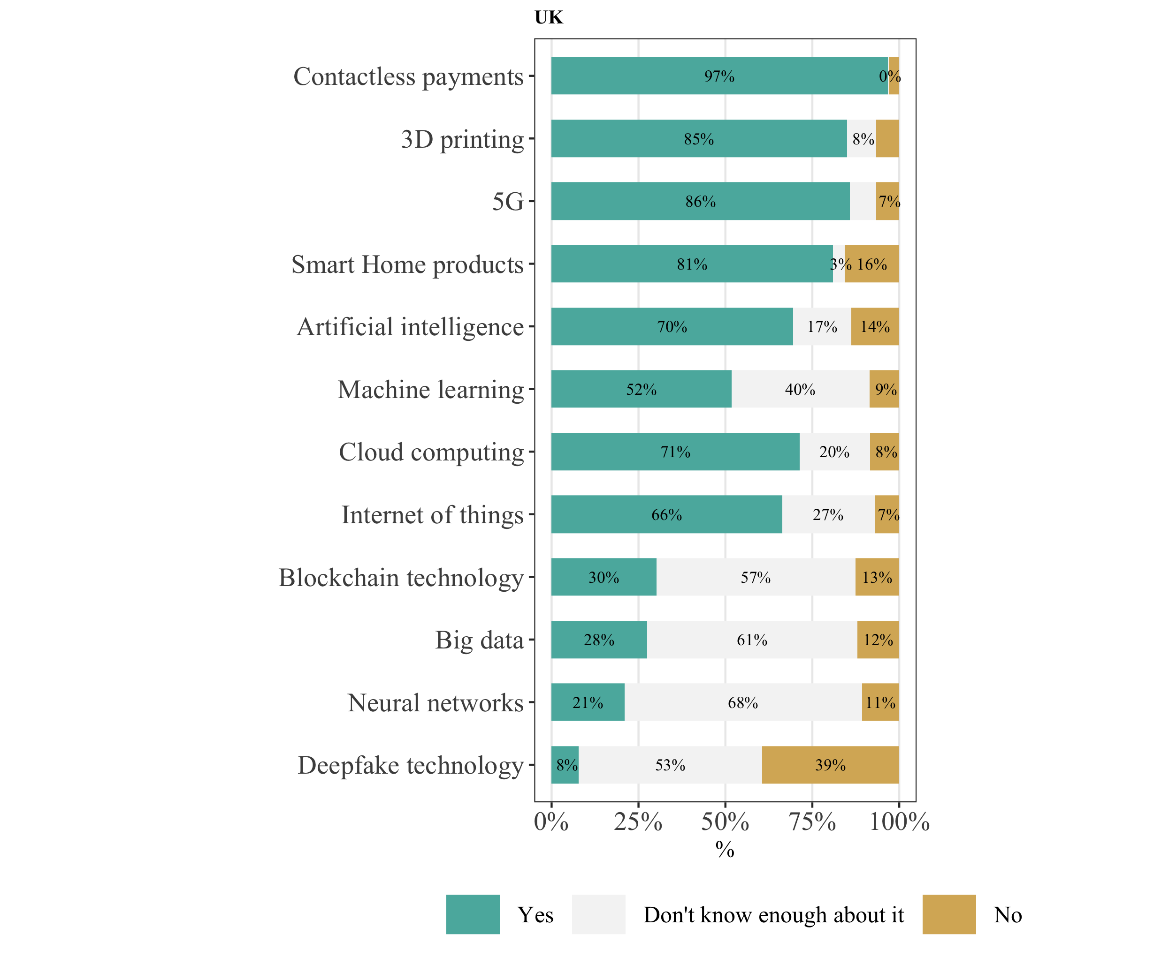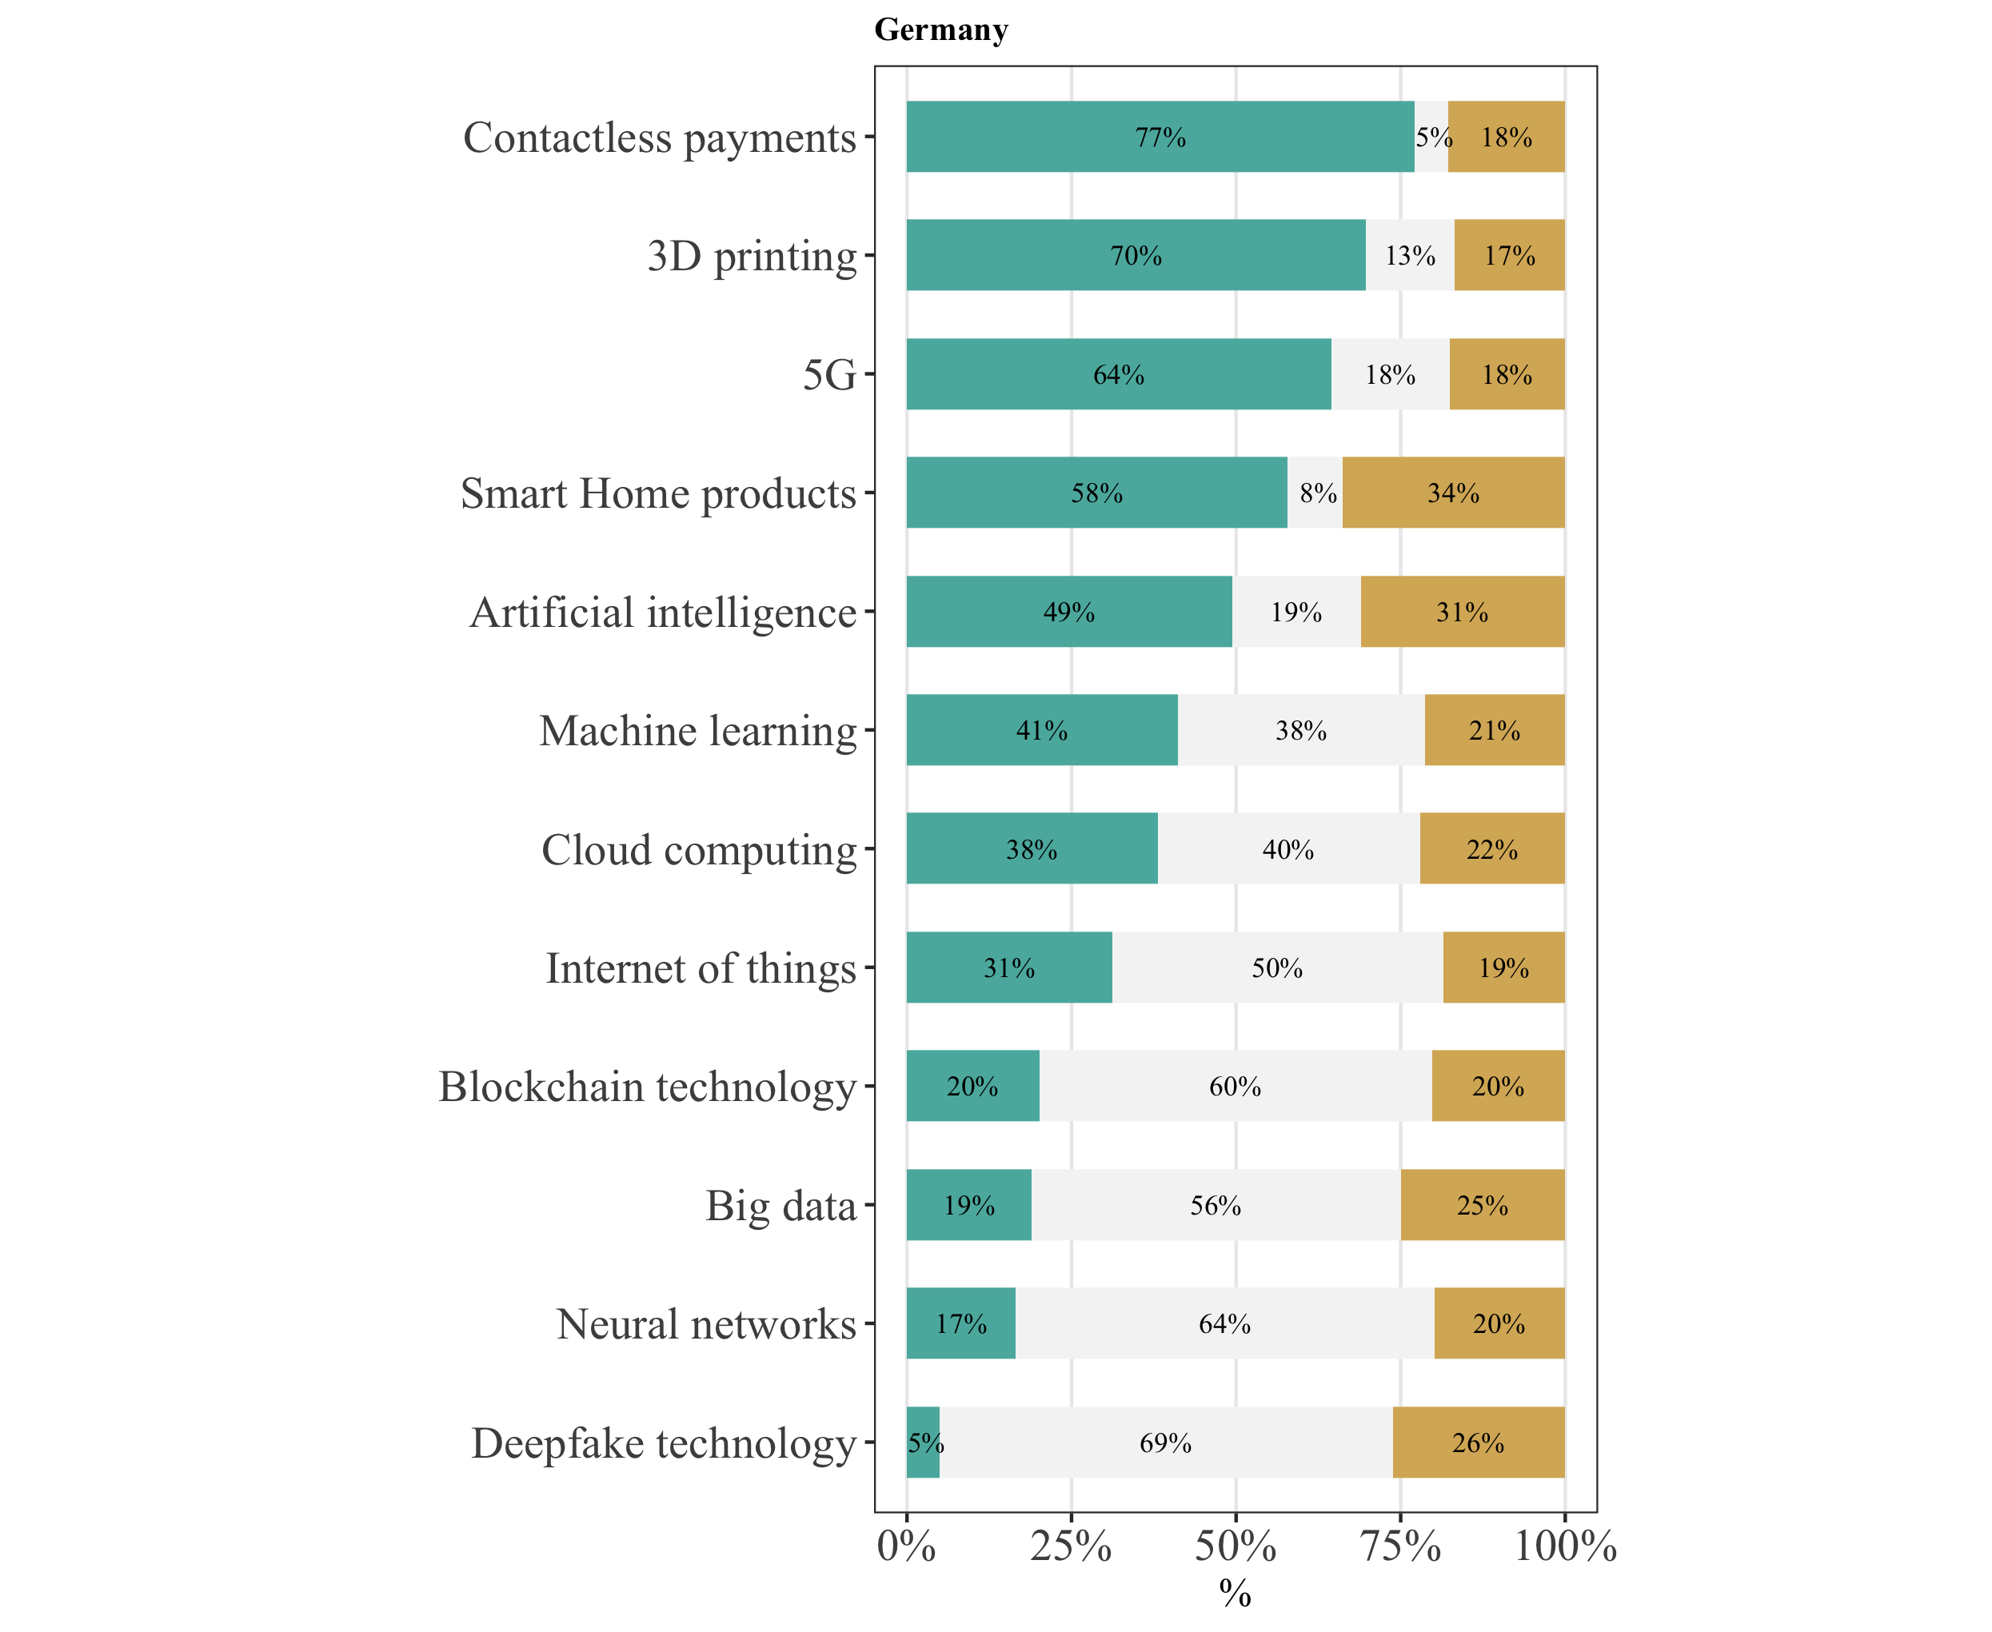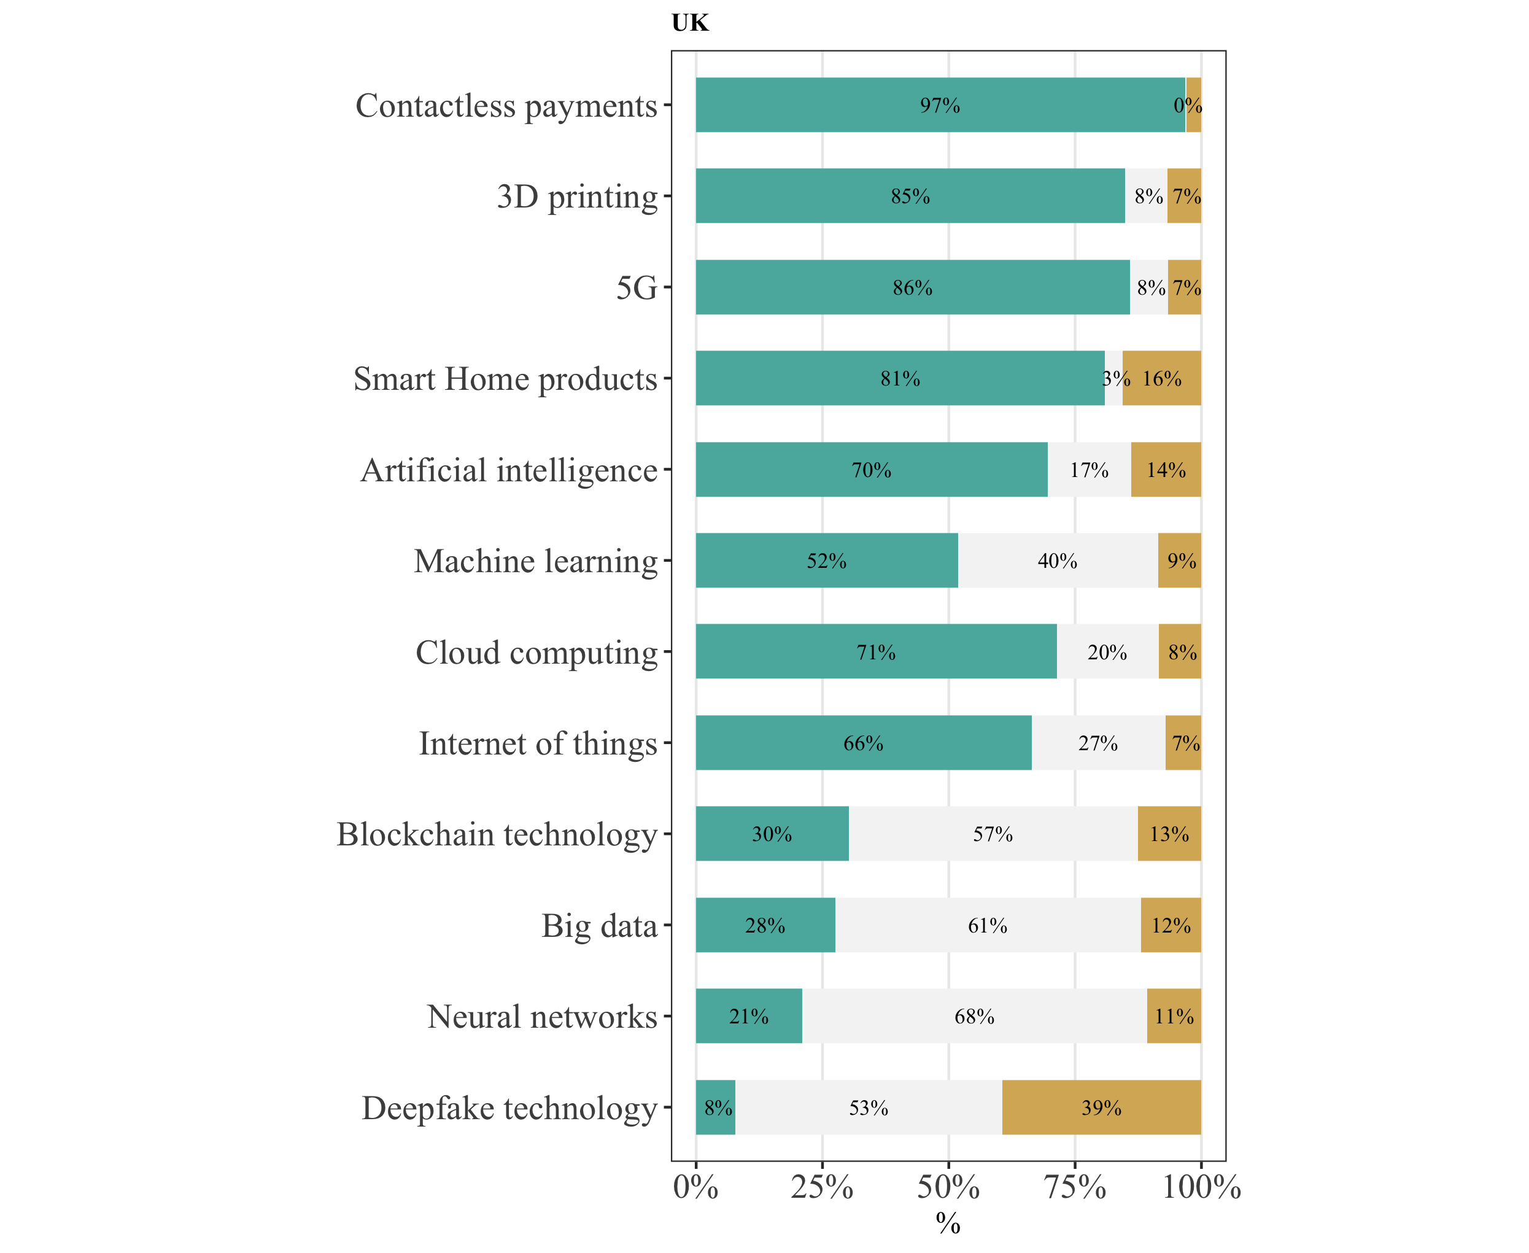

*Note:* NGER = 847. NUK = 898. The question asked the participant whether they would, purely intuitively and given the chance, use the mentioned technologies.

Consumers’ awareness of blockchain technology applications and their engagement with it is still low (See Figure 2). Additionally, consumers feel rather discouraged by their circle of friends to use blockchain technology (mean for G = 3.3, mean for B = 3.5; scale from 1 (*they would discourage me*) to 10 (*they would encourage me*)).

Figure 2:  
*Consumers’ awareness of blockchain technology applications*

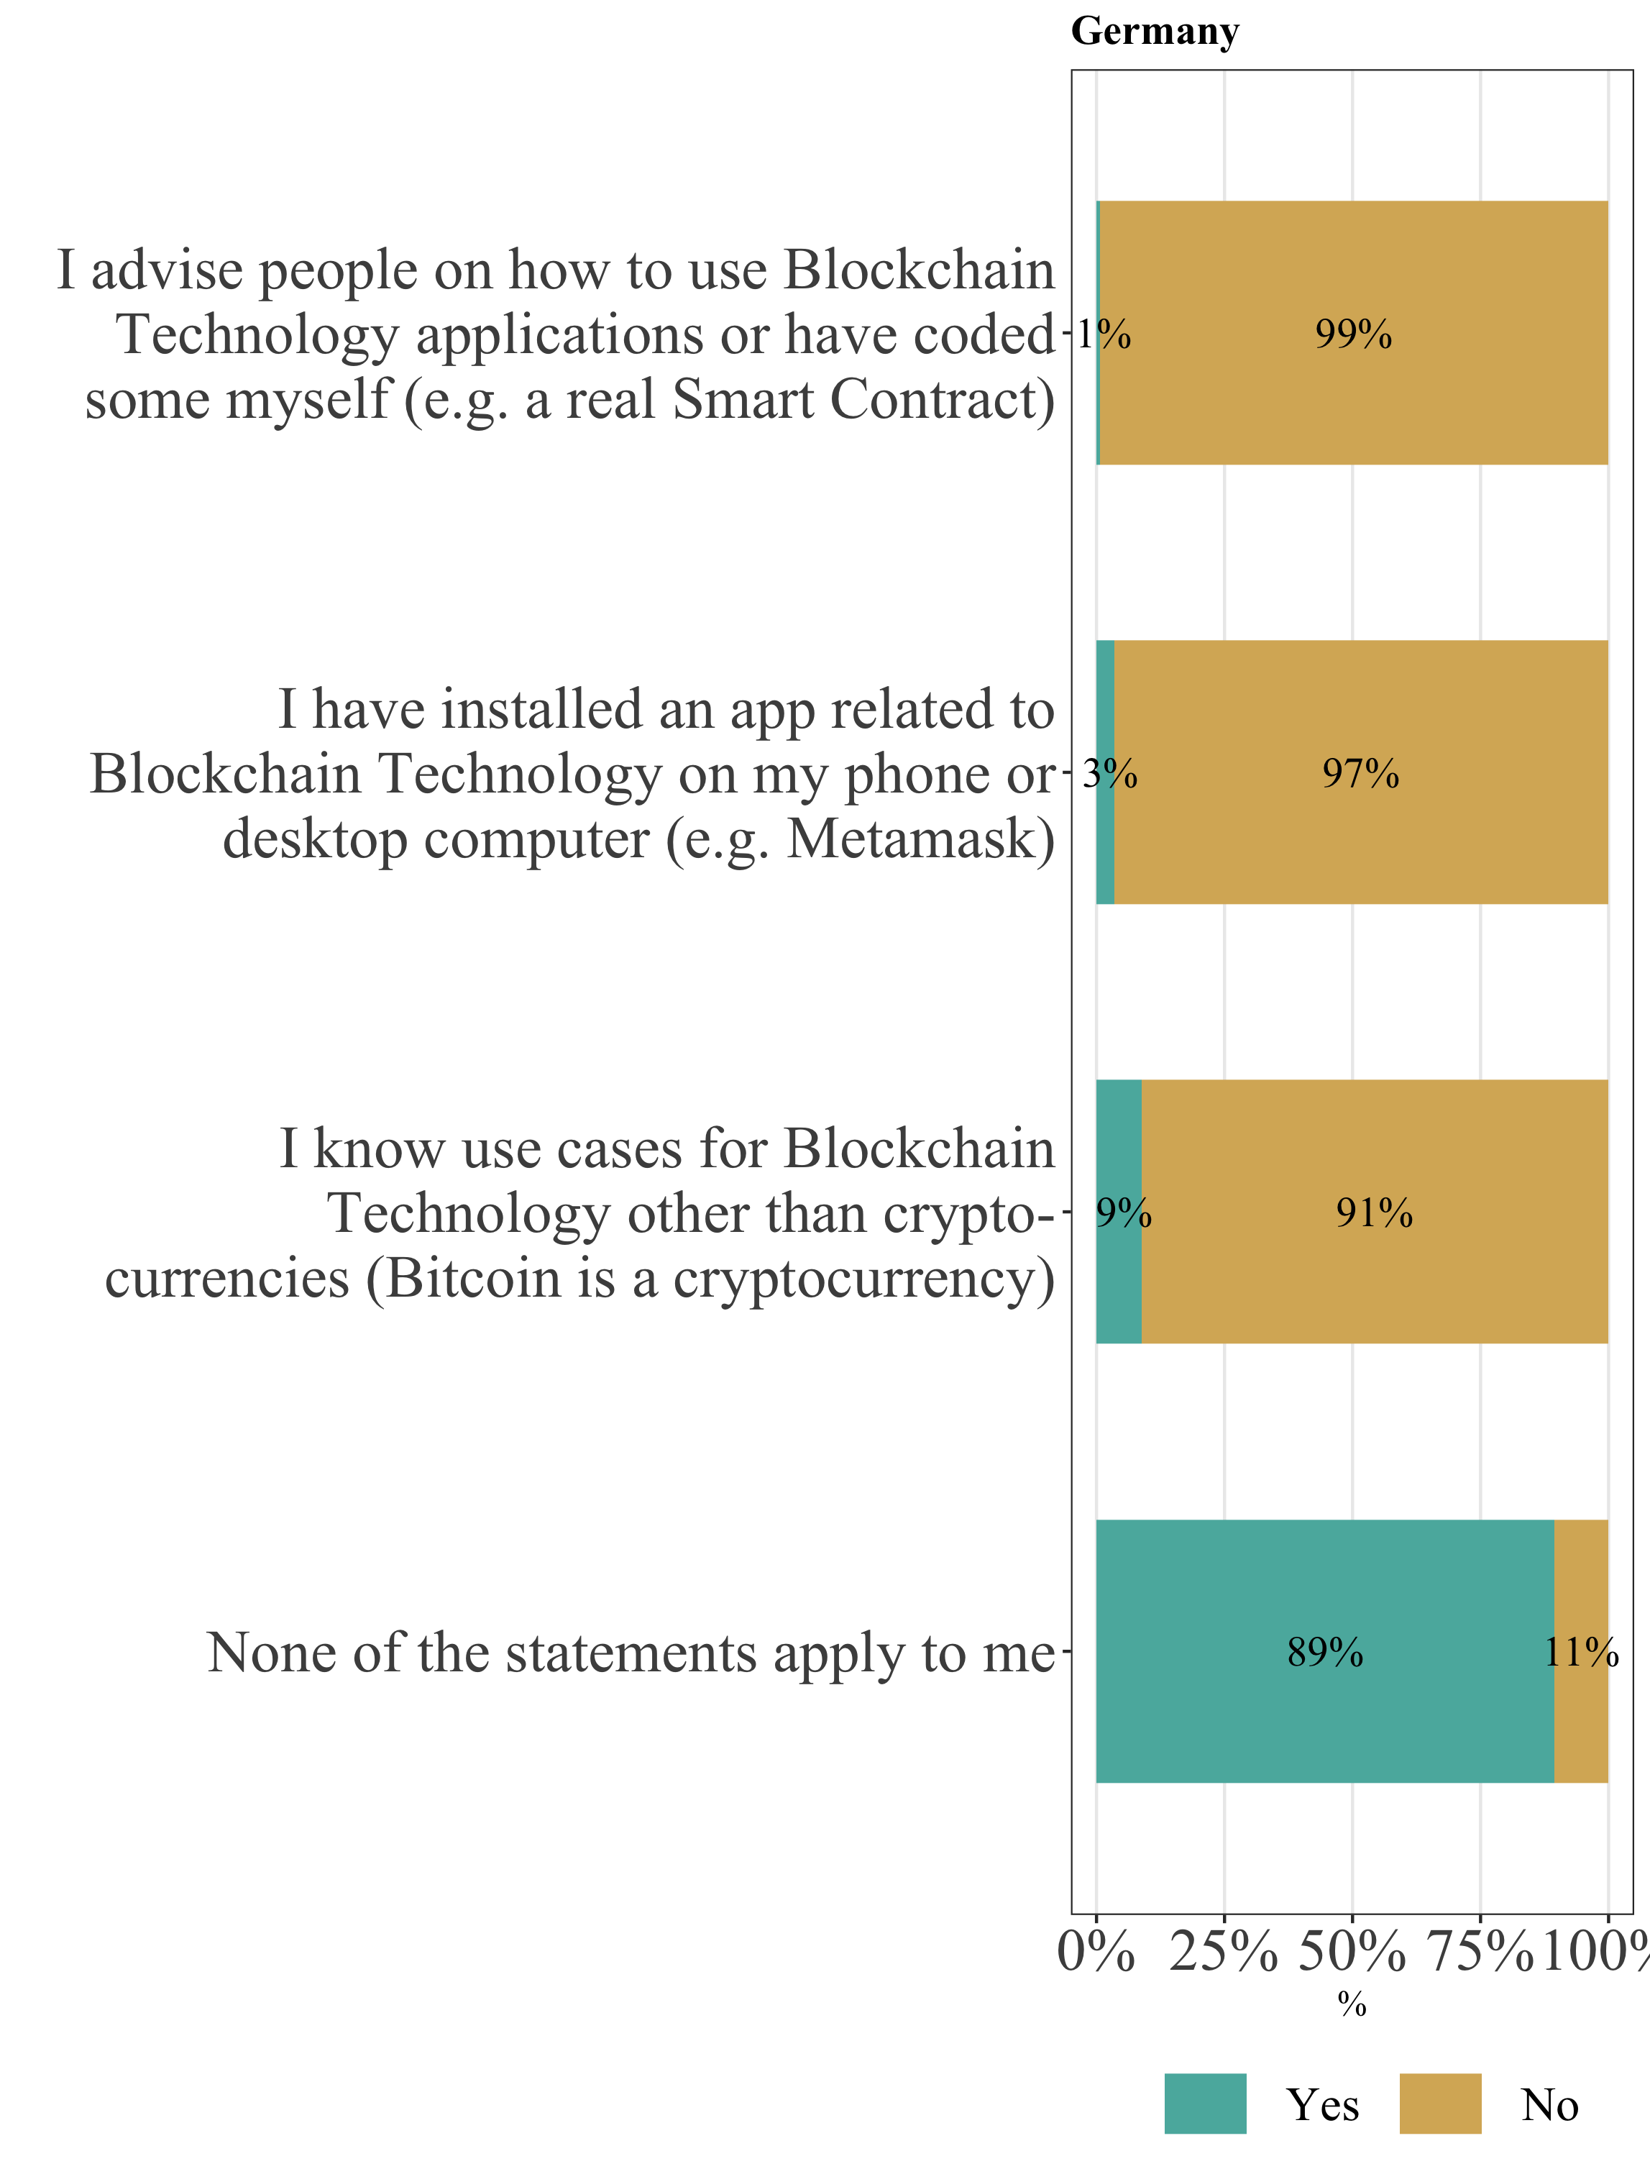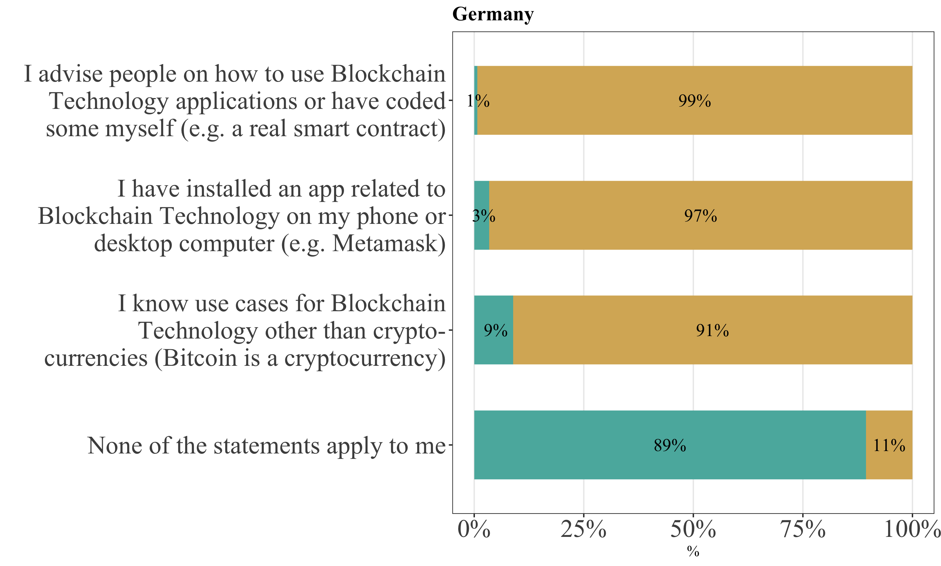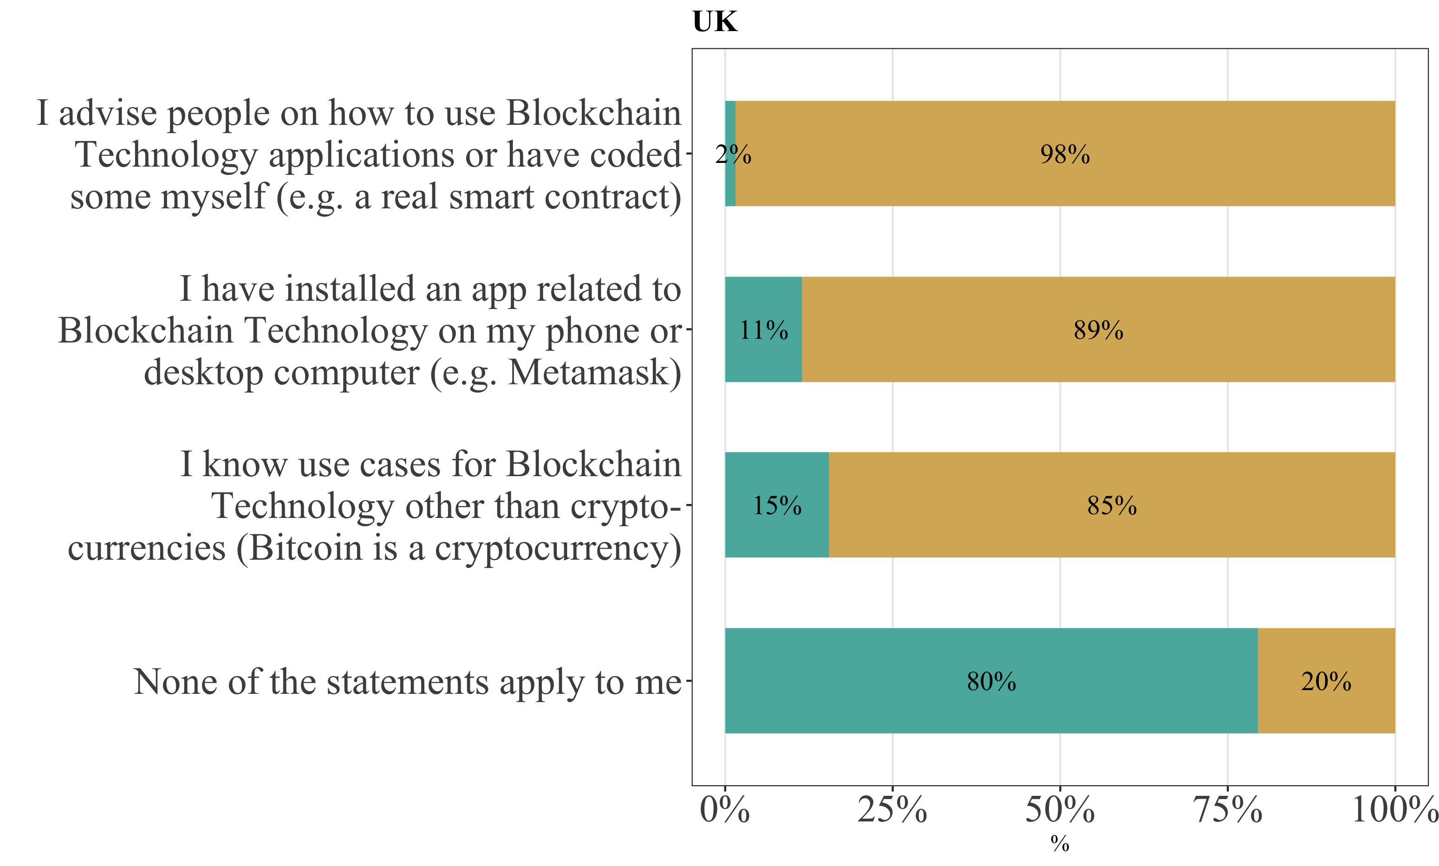

*Note:* NGER = 847. NUK = 898.

Consumers in Germany and Britain indicate restrained behavior in situations that reflect the functional traits of blockchain technology. For instance, only 5% of German consumers and 2% of British consumers would put their bank account statement on the street in a hypothetical scenario, where everyone could view the statement, but the consumer’s name is removed and just their bank account number, transaction data and account balance remain. Both consumer groups feel rather neutral towards the fact that with blockchain technology, their personal details are public, but encrypted as a string of numbers and letters (e.g., “39XpoaixBAbUZzaq7g7”), which ensures that their identity is not revealed (mean for G = 3.6, mean for B = 3.9; scale from 1 (*not comfortable at all*) to 7 (*very comfortable*)). Yet only 38% of Germans and 47% of Brits would transfer money to a verified seller without a name, but just a string of numbers, for the online purchase of an item of medium value (e.g., Bluetooth speaker). Both consumer groups show slight privacy concerns when using blockchain technology for financial transactions (mean for G = 4.5, mean for B = 4.3; scale from 1 (*no privacy concerns*) to 7 (*strong privacy concerns*)). For purchasing a pizza, only 20% of German consumers would use blockchain technology (B = 32%), 18% would use it to buy a jacket (B = 30%), 15% to buy a car (B = 19%) and 13% to buy a house (B = 15%). This could be a descriptive indication that with increasing monetary value, the intention of consumers to purchase via blockchain technology seems to decrease.

Consumers show rather low levels of trust in blockchain technology and its users. Figure 3 provides an overview of consumers’ trust in other blockchain users. Figure 4 depicts consumers’ trust in blockchain’s integrity, benevolence and ability (Hawlitschek et al., 2016). When asked about their general disposition to trust, which is a person’s general inclination to display faith in humanity and to adopt a trusting stance towards others (Gefen, 2000), 66% of German participants and 60% of British respondents answered “You cannot be careful enough”.

Figure 3:  
*Consumers’ trust in other blockchain technology users*

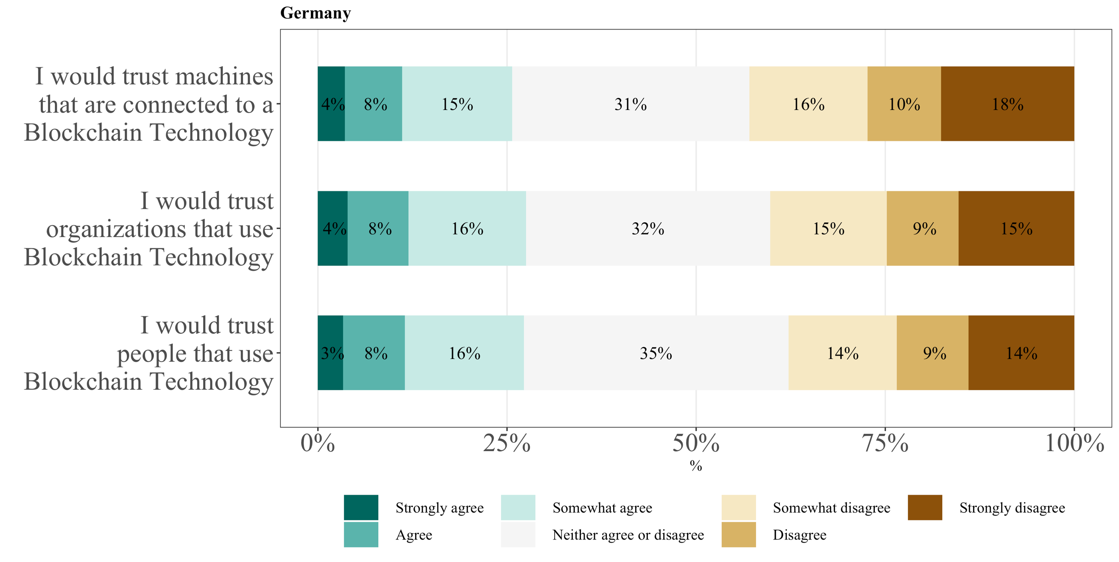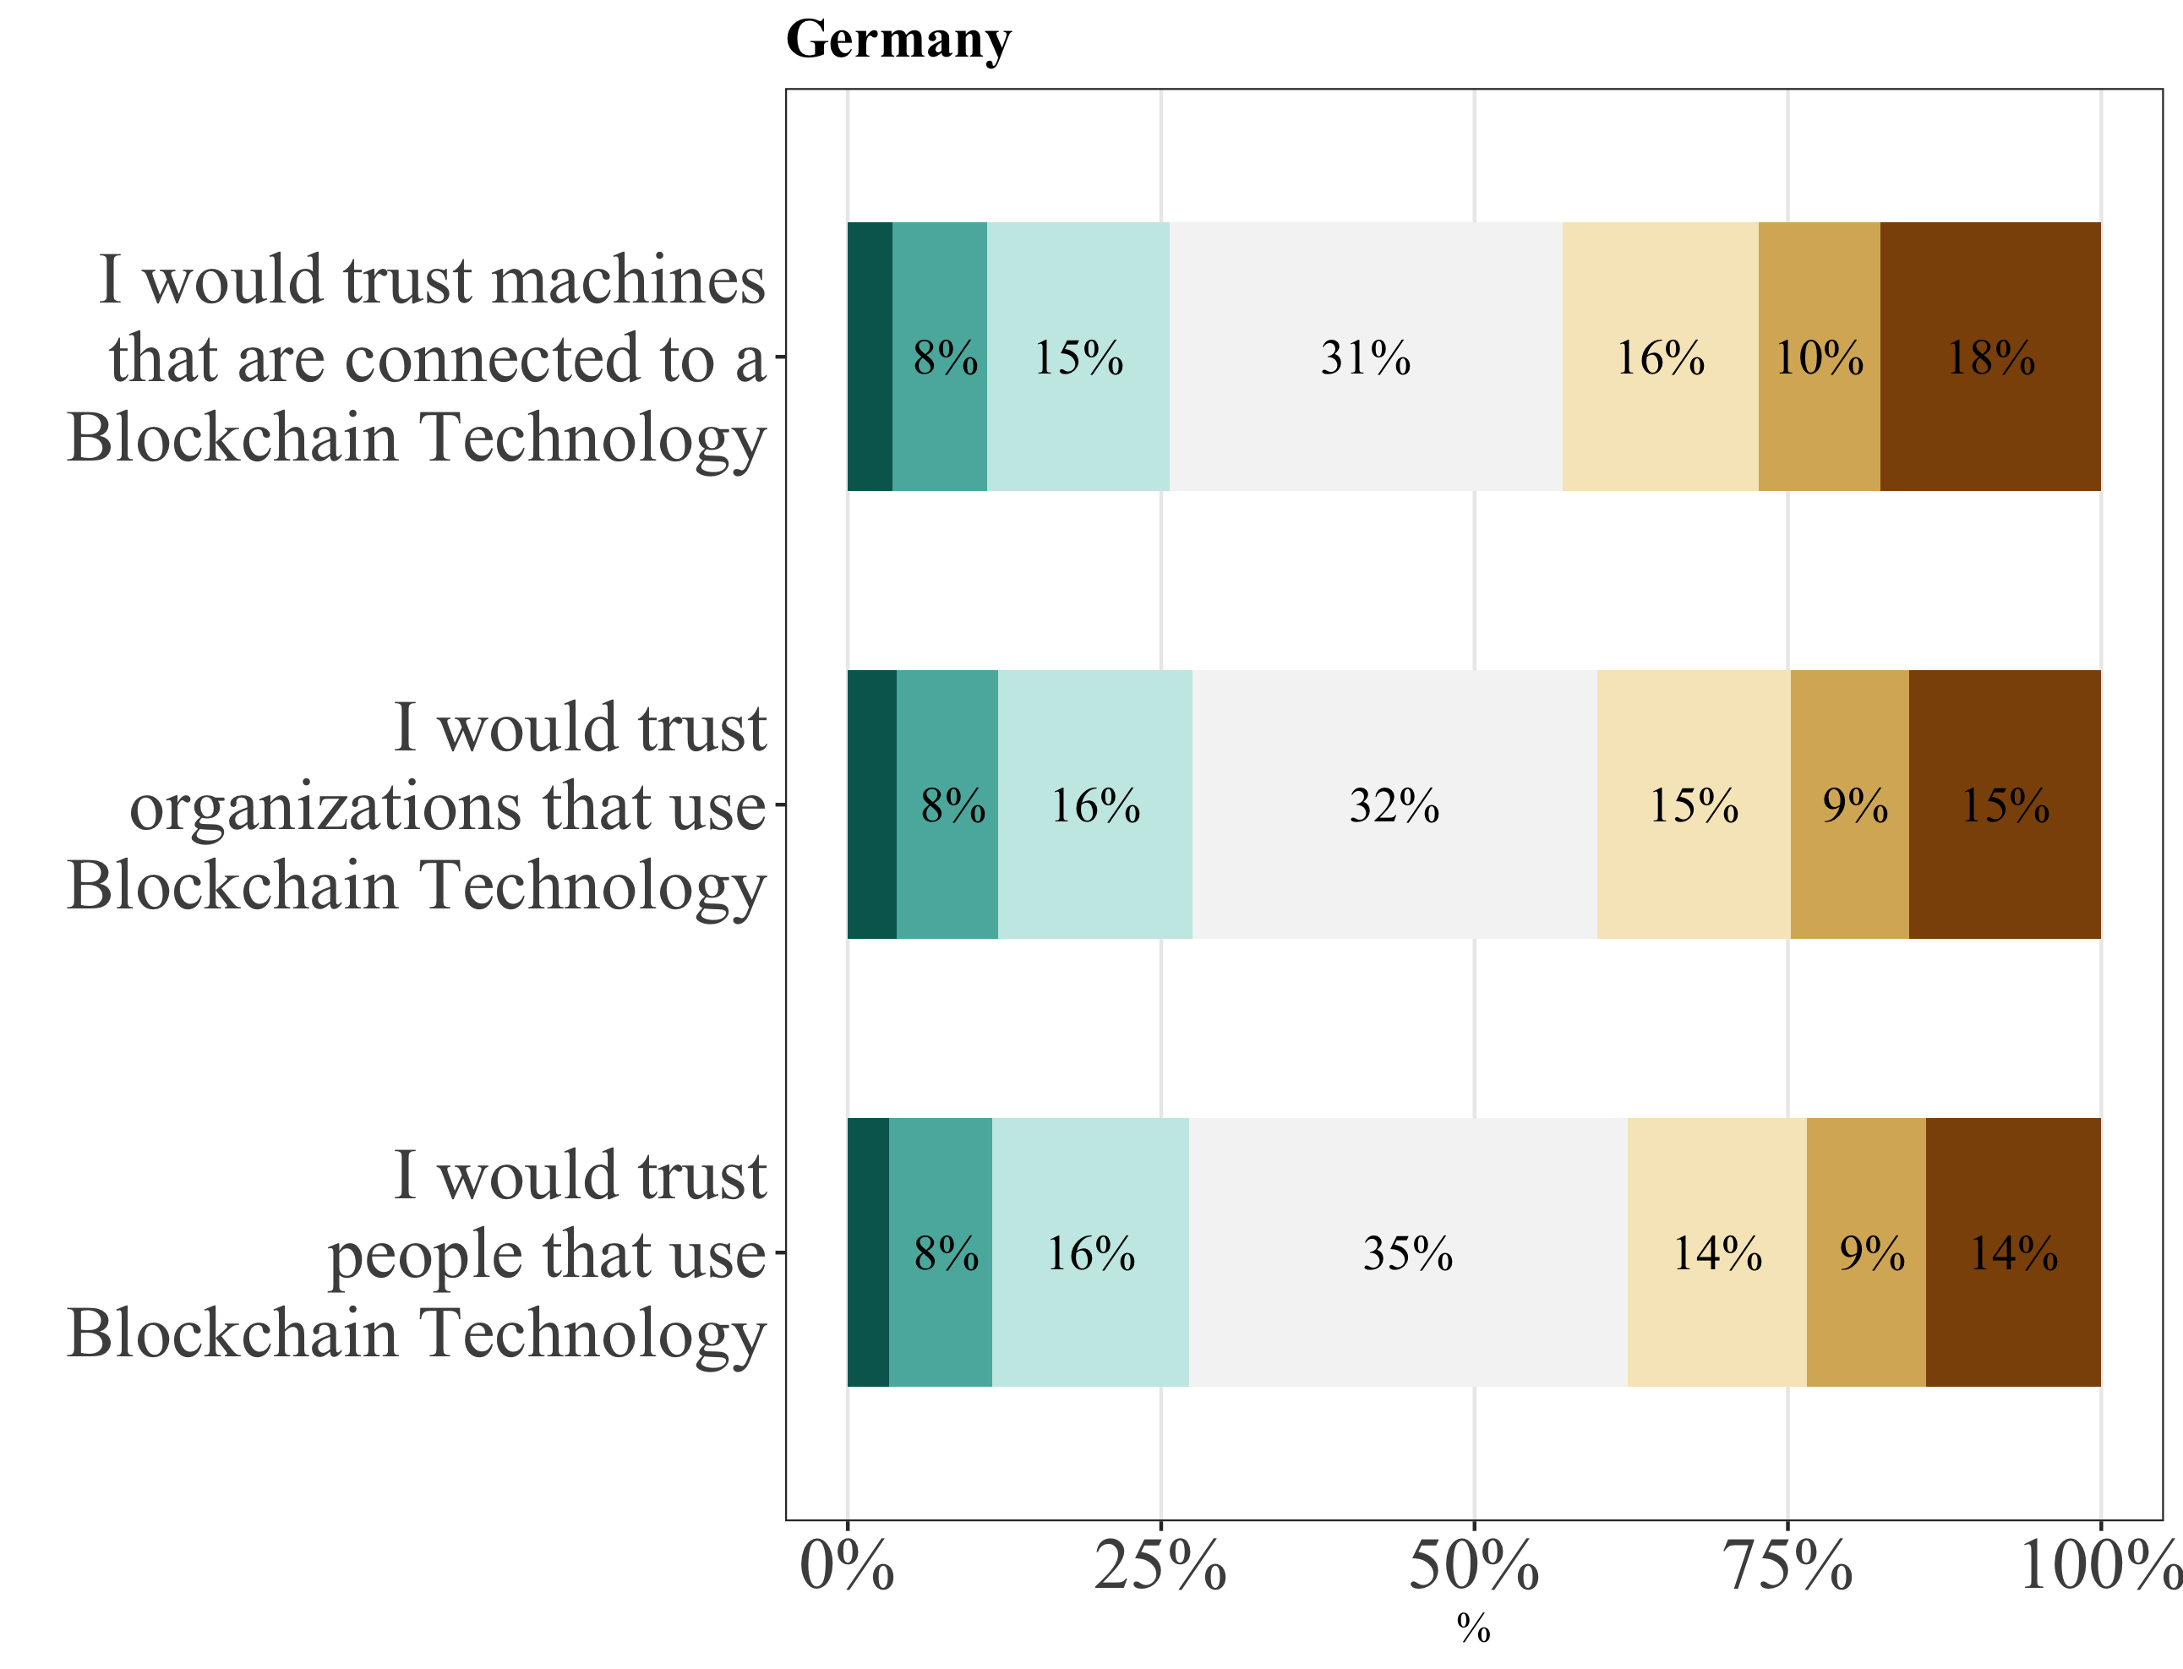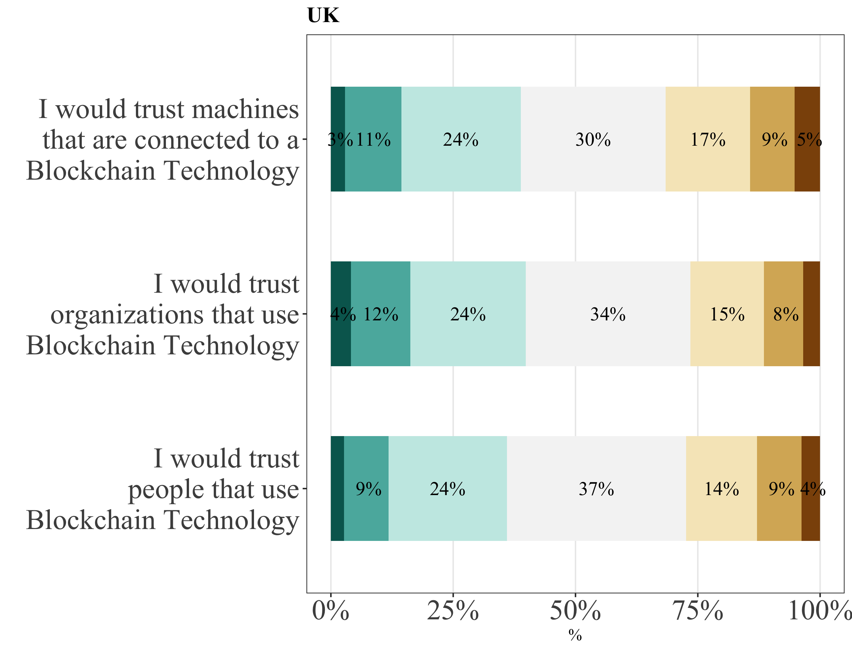

*Note:* NGER = 847. NUK = 898.

In sum, it is not only the case that the overall awareness of blockchain technology, its applications, cryptocurrencies and NFTs, is quite low, but also that consumers in Germany and the UK demonstrate a rather cautious attitude towards blockchain technology. The lack of knowledge and trust on part of the consumers could be obstacles, which weigh in on the limited usage intention and adoption of blockchain technology. However, British consumers seem to hold a slightly more approving attitude towards blockchain technology than German consumers. Nevertheless, from the perspective of the consumer, blockchain technology is still perceived to be in its infancy.

Figure 4:  
*Consumers’ trust in blockchain’s integrity, benevolence, and ability*

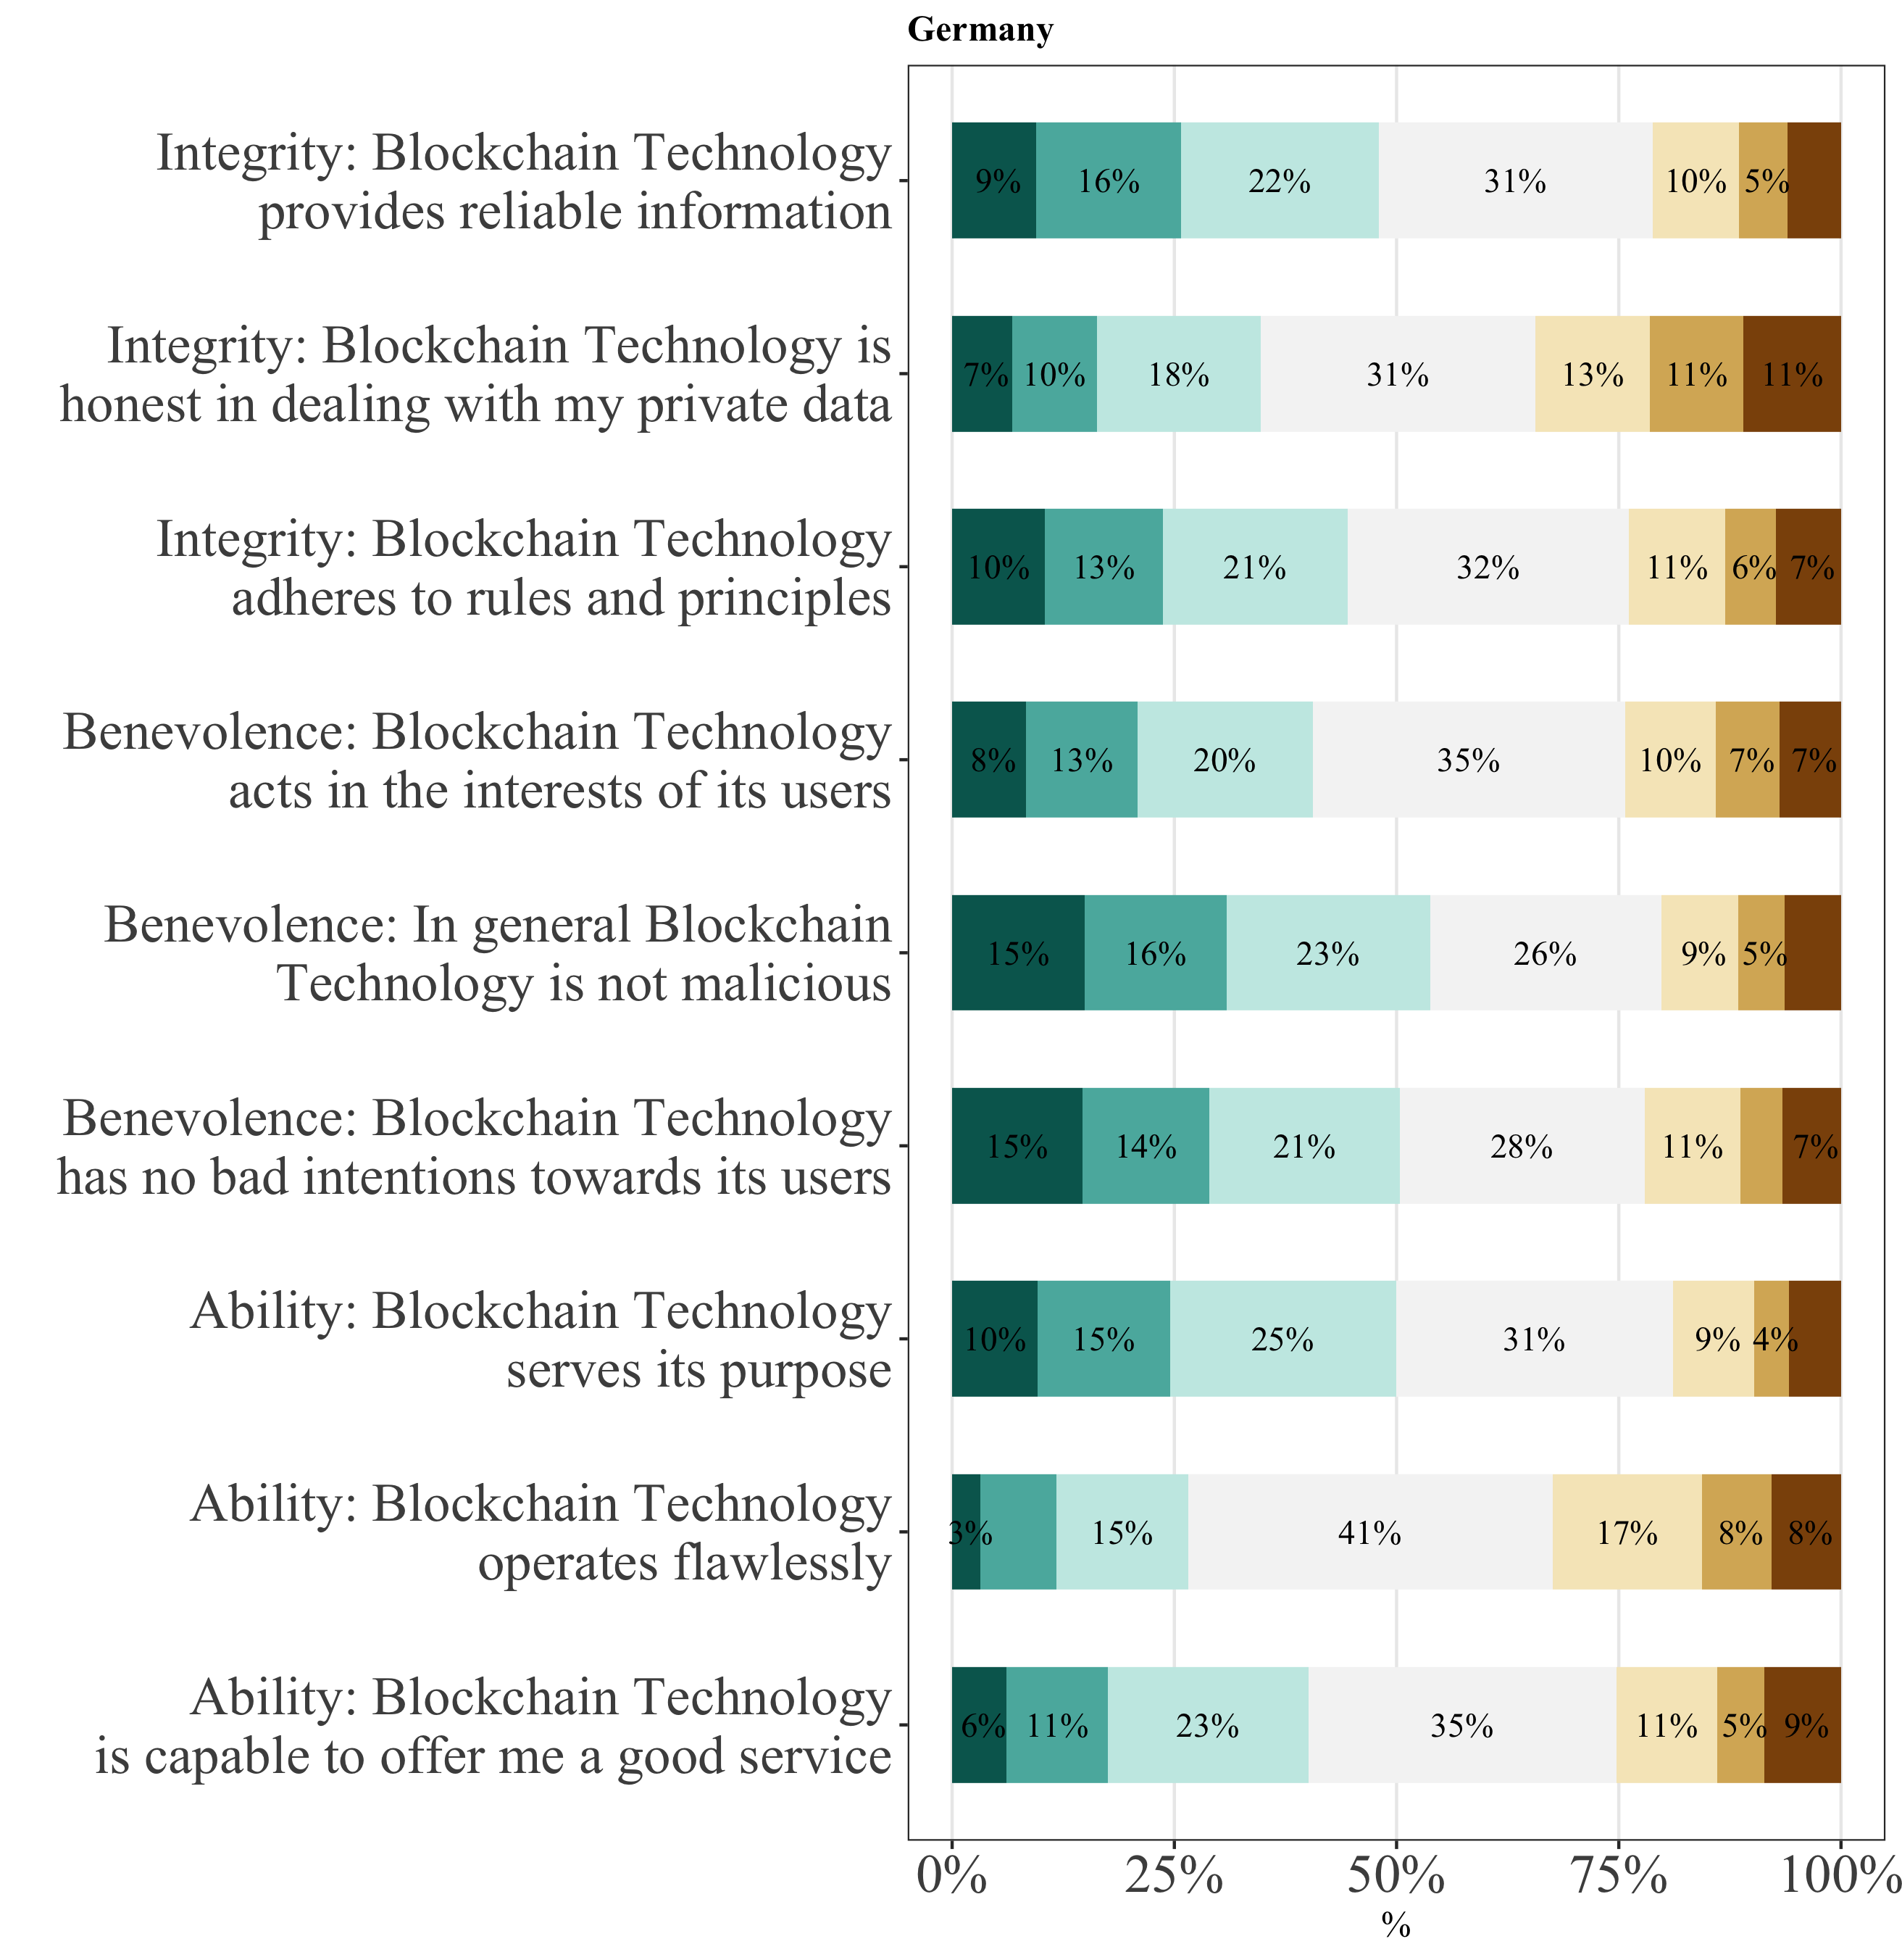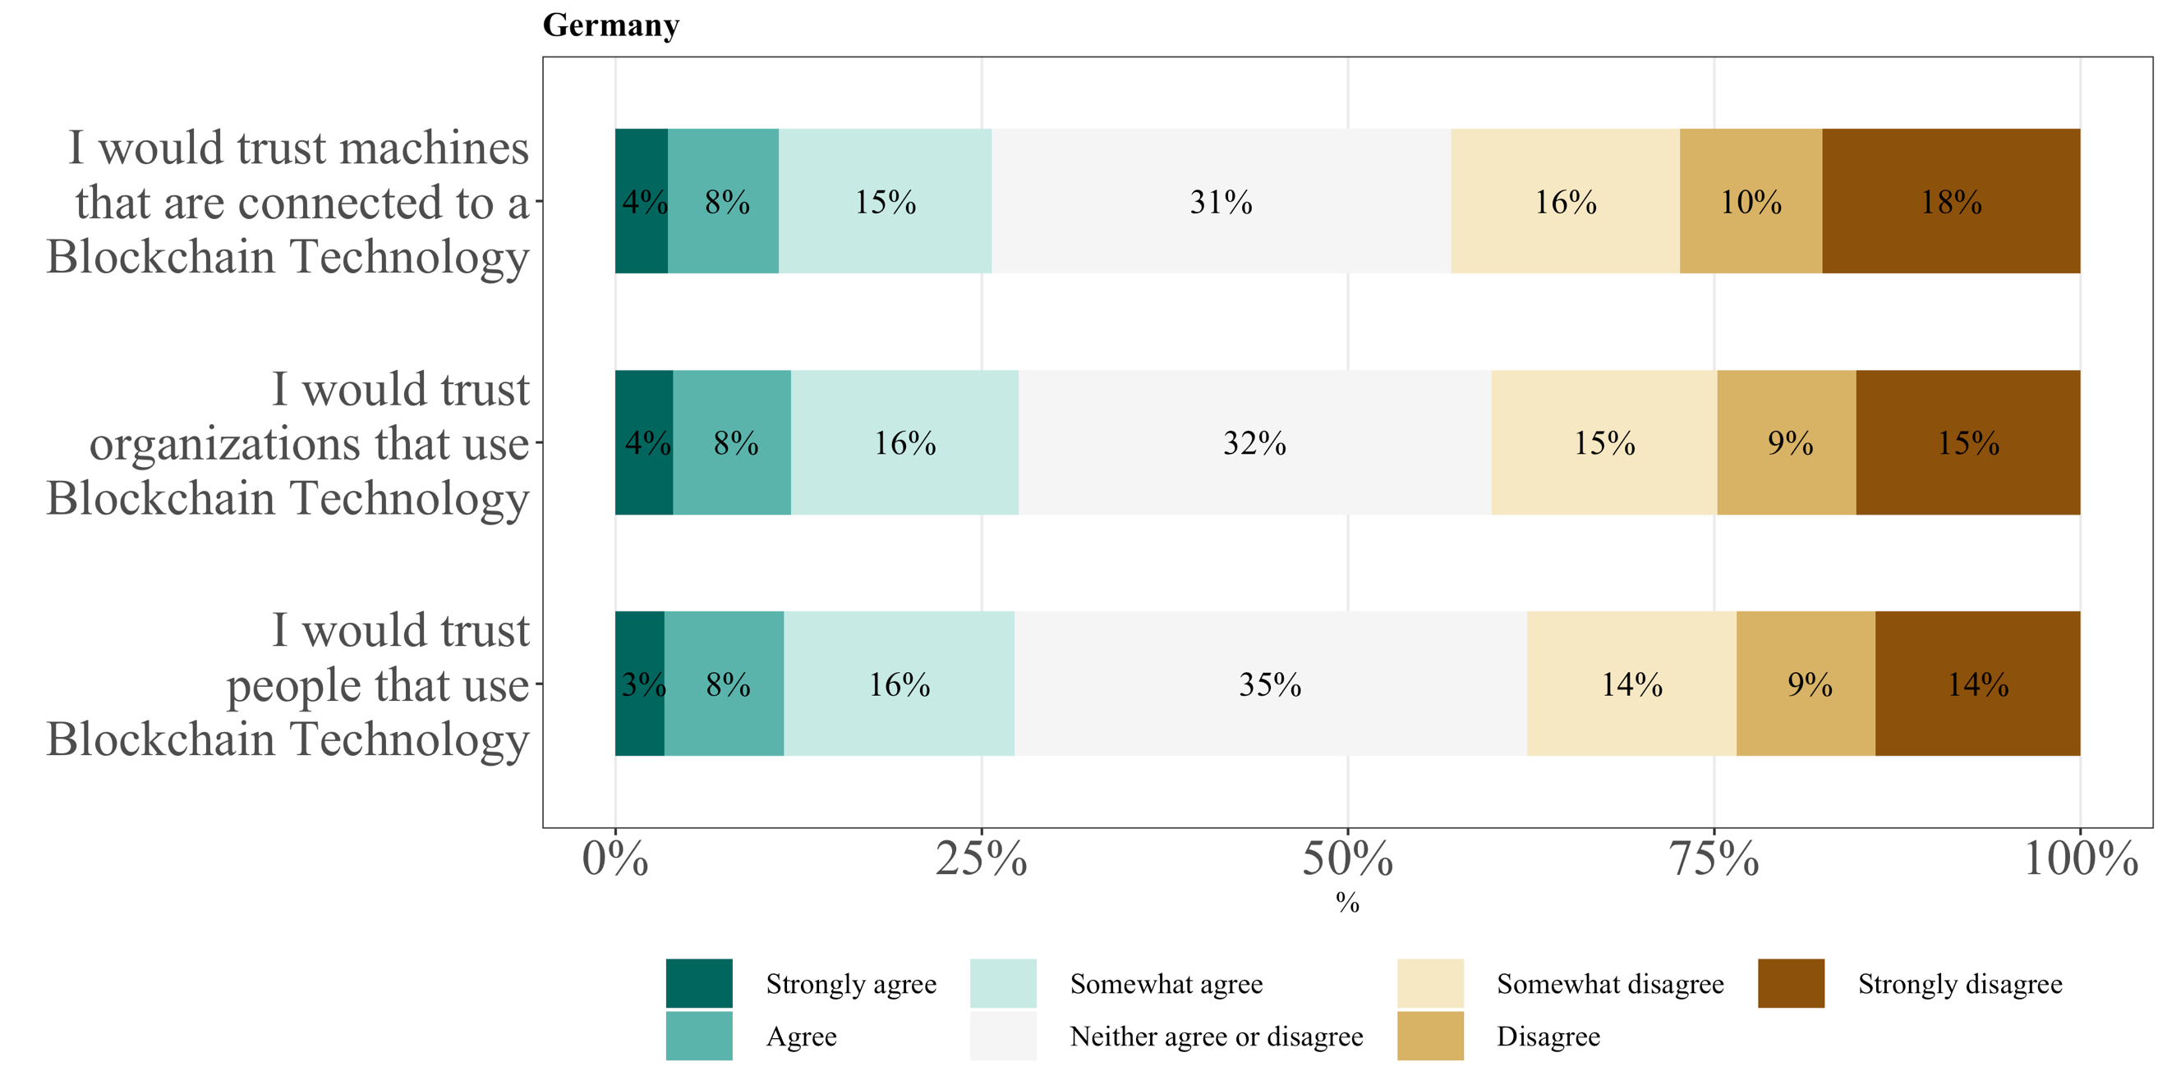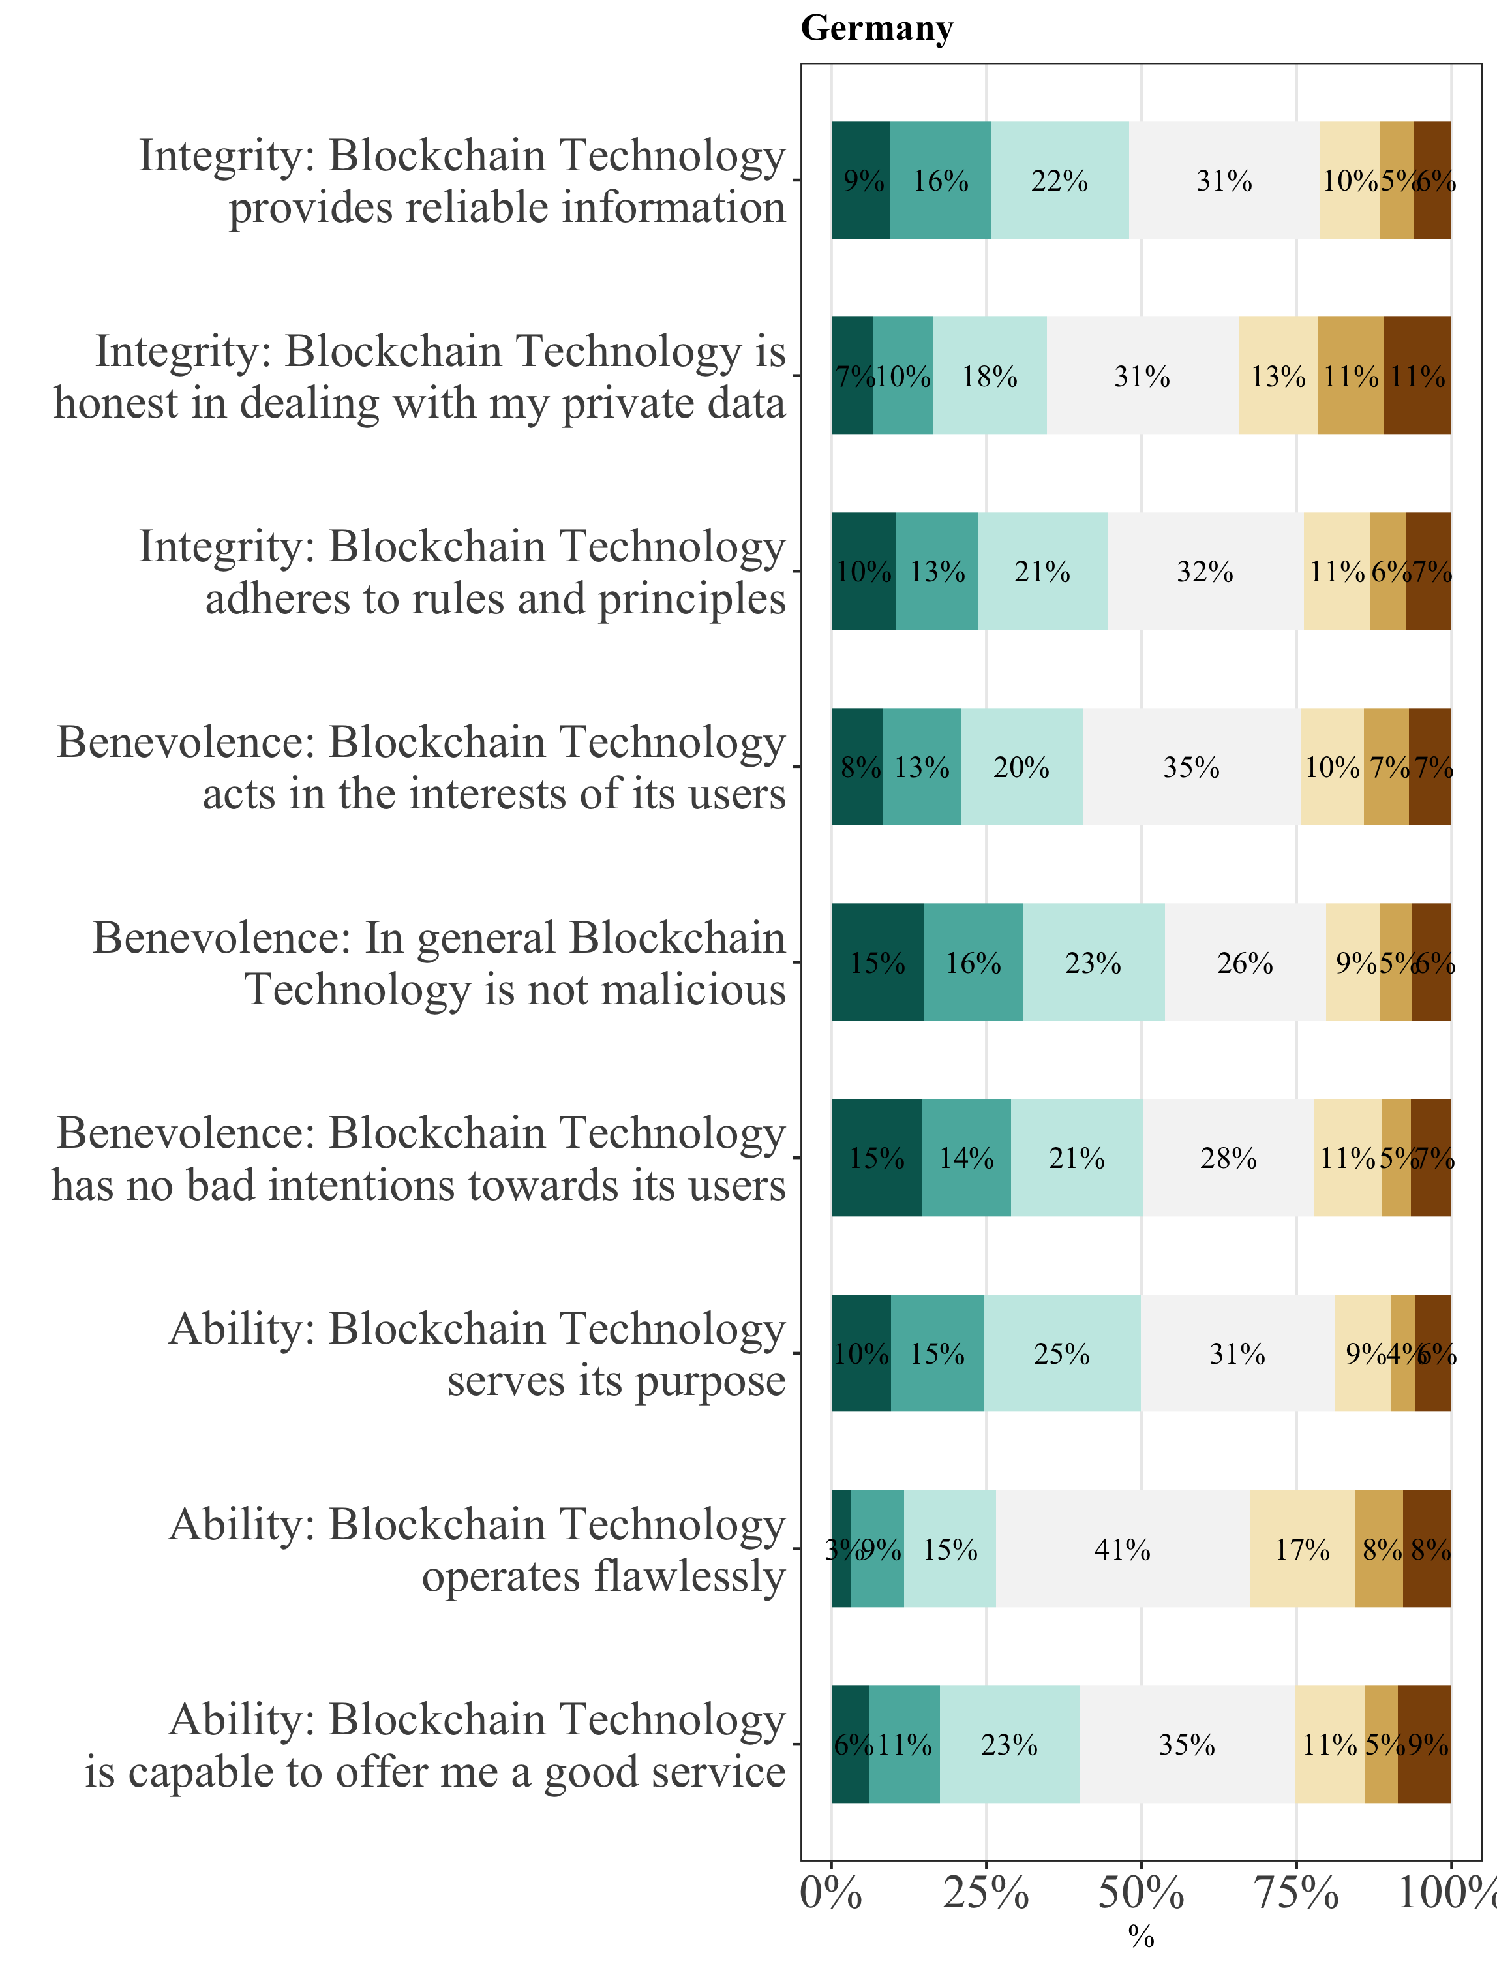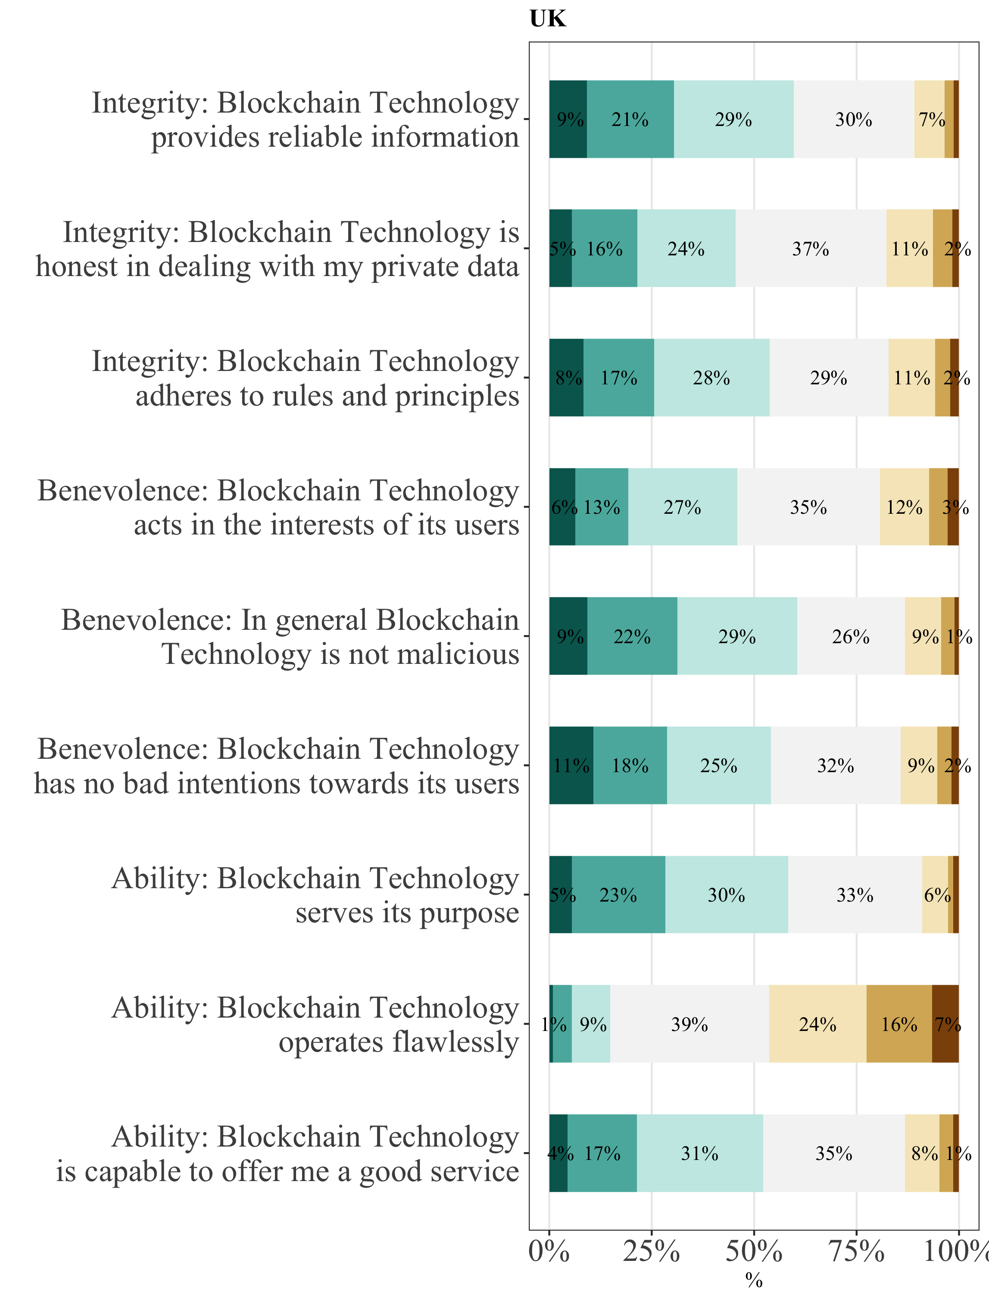

*Note:* NGER = 847. NUK = 898.

## Consumer technology readiness in Germany and the United Kingdom

To better understand people’s propensity to embrace and use cutting-edge technologies, we implemented the Technology Readiness Index (TRI) in our surveys (Parasuraman & Colby, 2015). In the TRI, two motivational and two inhibitory forces are considered, which collectively determine a person’s predisposition to use new technologies (Parasuraman, 2000). Motivators are the drivers that improve a person’s technology readiness, which comprise of optimism – a person’s positive view of technology – and innovativeness – a person’s willingness to try out new technology (Agarwal & Prasad, 1998; Blut & Wang, 2020; Parasuraman, 2000). Inhibitors are the detractors that lower an individual’s technology readiness, which entail discomfort – a person’s perceived lack of control over technology and a feeling of being overwhelmed by it – and insecurity – a person’s distrust of technology and skepticism about its ability to work properly (Blut & Wang, 2020; Parasuraman, 2000). Extant research shows that higher levels of technology readiness are correlated with higher adoption rates of cutting-edge technology, more intense usage of technology and greater perceived ease in doing so (Parasuraman & Colby, 2015).

Technology readiness is measured using an abbreviated version of TRI 2.0 in our study. The abbreviated index is comprised of ten items[2] covering the four abovementioned constructs, whereby each item is measured on a seven-point Likert scale, ranging from 1 (*strongly disagree*) to 7 (*strongly agree*). Figure 5 provides an overview of the answers of both sample populations on the TRI items.

Figure 5:  
*Consumers’ technology readiness*

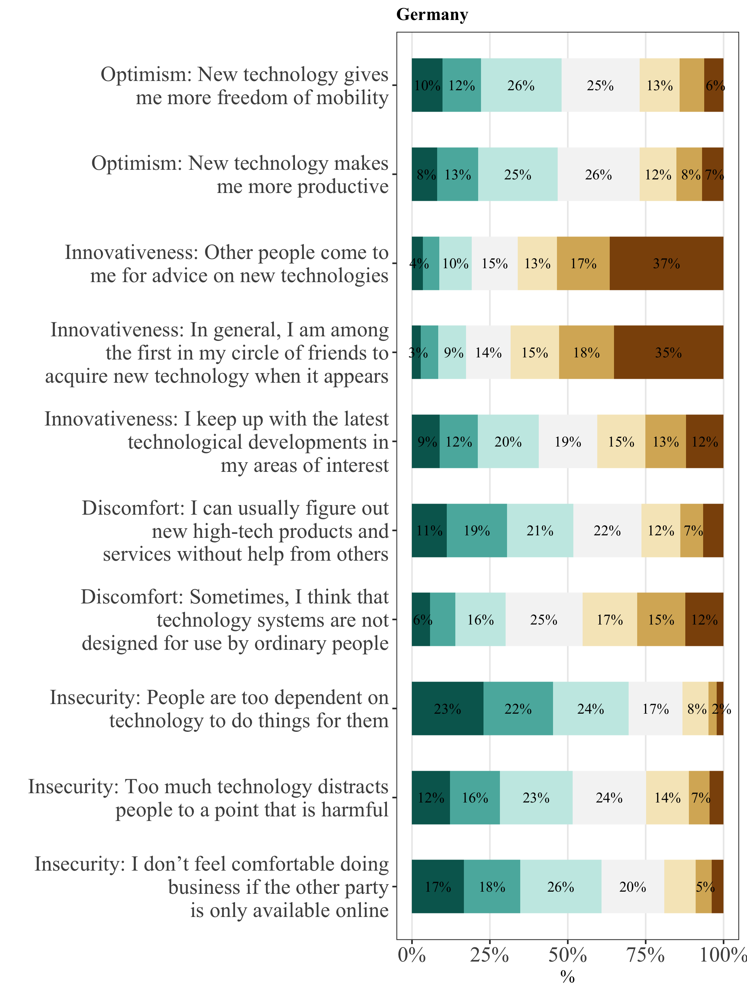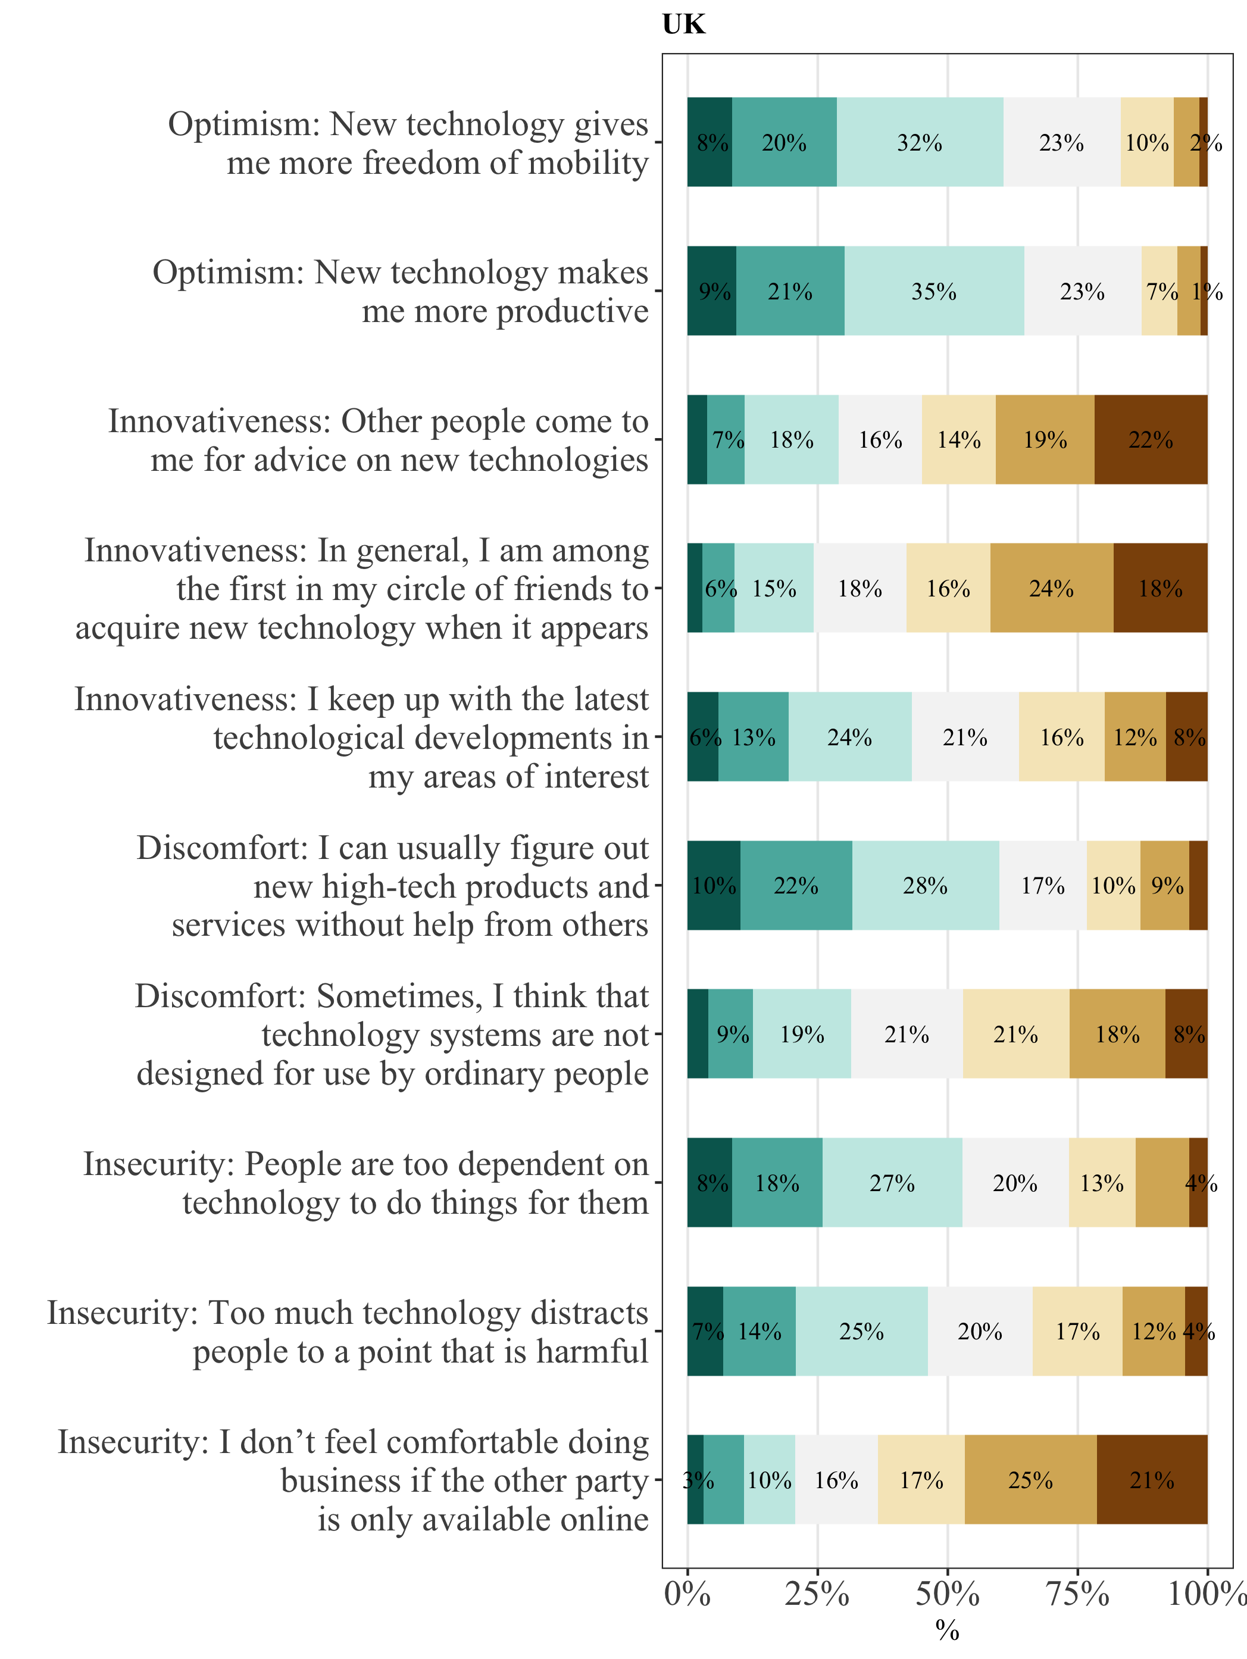

*Note:* NGER = 847. NUK = 898.

Operationalizing technology readiness by applying the TRI allows us to segment our German and British samples into distinct clusters of technology-related beliefs (Parasuraman & Colby, 2015). For that purpose, we conducted a latent class analysis (LCA) (Magidson & Vermunt, 2004) of the TRI item scores. Due to 25 invalid answers for the German sample and 18 for the British sample, the sample size for the cluster analysis had to be reduced to NGER = 822 and NUK = 880.

The LCA of the German sample population’s responses on TRI items results in four clusters of general technology readiness. A comparison of the Bayesian Information Criteria (BIC) of a three-, four-, five- or six-cluster solution demonstrates best fit for the four-cluster solution as indicated by the lowest BIC score (BIC3= 28088.98, BIC4 = 28032.88, BIC5 = 28104.56, BIC6 = 28264.16) (Magidson & Vermunt, 2004). Moreover, the four-cluster solution demonstrates better distinguishability between the clusters as opposed to the five-cluster solution by Parasuraman & Colby (2015). To maintain comparability of results, the four-cluster solution is applied for the British sample population as well.

We classify 15% (125) of the German sample population as Explorers, 36% (297) as Pioneers, 28% (227) as Hesitators and 21% (173) as Avoiders. As for Britain, 13% (114) of respondents are considered Explorers, 26% (226) Pioneers, 40% (352) Hesitators and 21% (188) Avoiders. Following Parasuraman & Colby (2015), Explorers are key consumers or lead users who have a strong motivation to use technology (highest optimism and innovativeness scores) while having a low degree of resistance (lowest discomfort and insecurity scores). Pioneers tend to hold both rather strong positive and negative technology-related beliefs. Hesitators have a high degree of resistance as well as a particularly low degree of innovativeness. Avoiders show the highest degree of resistance and lowest degree of motivation. Referring these clusters to Rogers' (1962) classifications in his theory on diffusion of innovations, Explorers are similar to innovators and early adopters, Pioneers are related to the early majority, Hesitators are similar to the late majority and Avoiders are related to laggards. Table 3 and Table 4 display a summary of the TRI-based LCA results of the German and British sample population, respectively.

Table 3:  
*Latent class segmentation using TRI data of German sample population*

|  |  |  |  |  |  |  |  |
| --- | --- | --- | --- | --- | --- | --- | --- |
| Cluster | n | % | Optimism | Innovativeness | Discomfort | Insecurity | Overall TRI |
| **Explorers** | 125 | 15 | 6.04 | 5.47 | 2.38 | 4.06 | 5.27 |
| **Pioneers** | 297 | 36 | 4.82 | 3.86 | 3.18 | 4.74 | 4.19 |
| **Hesitators** | 227 | 28 | 3.78 | 2.07 | 3.97 | 4.51 | 3.34 |
| **Avoiders** | 173 | 21 | 2.81 | 1.61 | 4.60 | 6.03 | 2.45 |

*Note:* NGER = 822.

Table 4:  
*Latent class segmentation using TRI data of British sample population*

|  |  |  |  |  |  |  |  |
| --- | --- | --- | --- | --- | --- | --- | --- |
| Cluster | n | % | Optimism | Innovativeness | Discomfort | Insecurity | Overall TRI |
| **Explorers** | 114 | 13 | 6.06 | 5.34 | 2.09 | 2.62 | 5.67 |
| **Pioneers** | 226 | 26 | 5.20 | 4.84 | 3.03 | 3.85 | 4.79 |
| **Hesitators** | 352 | 40 | 4.62 | 3.05 | 3.65 | 3.90 | 4.03 |
| **Avoiders** | 188 | 21 | 3.80 | 1.58 | 4.76 | 4.69 | 2.98 |

*Note:* NUK = 880.

British consumers show a stronger technology affinity than German consumers. The mean TRI score of the British sample population is 4.22, whereas the mean TRI score of the German sample population is 3.75. The British sample population reveals stronger motivational forces across clusters while levels of discomfort and insecurity are lower. Thus, although the LCA reveals 40% of the British sample population to be Hesitators, their level of motivation is much higher while inhibitory levels are lower than the corresponding levels in the German Hesitator cluster. Additionally, note that insecurity levels of British consumers appear to be much lower than for German consumers. This might be an indication that German consumers have stronger safety concerns and tend to expect risks rather than benefits in a technology.

The four clusters of technology readiness have distinct demographic and technology-related characteristics (see Table 5 and Table 6). For instance, the cluster with the highest technology readiness, the Explorers, consists of relatively more men, is more highly educated, and possesses comparatively more knowledge about blockchain technology or the internet. Pioneers are even younger but have slightly less technology related knowledge, which applies especially for German consumers. Both Explorers and Pioneers possess more cryptocurrencies and NFTs than the other clusters, which could be a descriptive indication that technology adoption might be higher for Explorers and Pioneers, as suggested by the literature (Parasuraman & Colby, 2015). Avoiders constitute the polar opposite to the Explorers and Hesitators stand in between Pioneers and Avoiders in terms of cluster characteristics.

Table 5:  
*Demographic and technology characteristics of German TRI-based clusters*

|  |  |  |  |  |  |  |  |  |  |
| --- | --- | --- | --- | --- | --- | --- | --- | --- | --- |
| Cluster | Female (%) | Age 50+  (%) | Min. Bachelor’s degree (%) | Knowledge of BT1 | Explain BT1 | Explain the Internet1 | Possess. of cryptocurr. (%) | Possess. of NFT (%) | Know diff. between Bitcoin & BT (%) |
| **Explorers** | 32 | 51 | 41 | 3,95 | 2,72 | 5,51 | 22 | 5 | 50 |
| **Pioneers** | 42 | 43 | 37 | 3,07 | 2,18 | 5,04 | 18 | 1 | 35 |
| **Hesitators** | 65 | 52 | 30 | 1,83 | 1,33 | 4,22 | 4 | - | 10 |
| **Avoiders** | 61 | 62 | 21 | 1,62 | 1,25 | 4,02 | 5 | - | 6 |

*Note:* NGER = 822. BT = blockchain technology. 1 Question is measured on a scale from 1 (*no knowledge/ do not know how it works*) to 10 (*expert knowledge/ fully capable to explain how it works*).

Table 6:  
*Demographic and technology characteristics of British TRI-based clusters*

|  |  |  |  |  |  |  |  |  |  |
| --- | --- | --- | --- | --- | --- | --- | --- | --- | --- |
| Cluster | Female (%) | Age 50+  (%) | Min. Bachelor’s degree (%) | Knowledge of BT1 | Explain BT1 | Explain the Internet1 | Possess. of cryptocurr. (%) | Possess. of NFT (%) | Know diff. between Bitcoin & BT (%) |
| **Explorers** | 32 | 36 | 63 | 3.46 | 2.55 | 5.11 | 39 | 5 | 57 |
| **Pioneers** | 34 | 34 | 59 | 3.33 | 2.47 | 5.17 | 42 | 9 | 54 |
| **Hesitators** | 59 | 42 | 61 | 2.16 | 1.57 | 4.30 | 22 | 2 | 32 |
| **Avoiders** | 74 | 61 | 53 | 1.59 | 1.16 | 3.75 | 13 | 1 | 12 |

*Note:* NUK = 880. BT = blockchain technology. 1 Question is measured on a scale from 1 (*no knowledge/ do not know how it works*) to 10 (*expert knowledge/ fully capable to explain how it works*).

# Literature review

To evaluate the current state of research on technology adoption and on the potentials of blockchain technology, we conducted a systematic literature review according to the guidelines by Webster & Watson (2002). For our search, we used the EBSCOhost Business Source Complete database. To ensure for high-quality scientific knowledge in the field of information system, we searched seven of the eight journals of the Senior Scholars’ Basket of Journals[3]. We also included the 50 journals in the Financial Times 50 List in our search to explore the broader implications of technology adoption and blockchain for organizations, consumers, and business models. The initial search had a three-dimensional keyword design: the first field of research covered the keywords “blockchain”, “business model” and “distributed ledger technology”, the second field of research “industry”, “application” and “perception”, the third “potential”, “innovation”, “opportunity”, “transformation”, “impact”, “use” and “usage”. We further aimed to focus our review on the latest scientific research by restricting our search to the time frame from 2016 to 2022. We specified the language to be English. This resulted in 153 articles that were eligible for review. After examining the titles and abstracts regarding the fit of the articles for this paper, 30 articles were chosen for a full text analysis. Two articles had to be discarded as their full text was not available (such as “Call for Papers”). After reviewing the 28 remaining articles, we identified additional 20 articles during forward and backward search. Thus, a total of 48 articles were considered for the literature review. Moreover, to enhance the practical merit of our paper, we complemented our literature review with grey literature. This comprises, for instance, reports by consultancies (Boston Consulting Group, 2019), newspaper articles (Quiroz-Gutierrez, 2022) as well as insights on blockchain technology from market intelligence platforms (Amberdata, 2022). See Appendix 1 for an overview of the literature review methodology.

## Blockchain technology and its applications

Blockchain technology is a decentralized ledger that allows tamper-proof, transparent storage of data and enables peer-to-peer transactions without a central party (Liang et al., 2021; Nakamoto, 2008; Toufaily et al., 2021; Yin et al., 2019). Blocks of transactions are saved and stored in nodes that are encrypted using pseudonyms and are only known to the parties to the transactions (Liang et al., 2021). Therefore, a system of accountability is enabled, while not revealing a user’s true identity (Raddatz et al., 2021; Yin et al., 2019).

The cryptocurrency Bitcoin was the first application for blockchain technology (Nakamoto, 2008) and more than 13,000 cryptocurrencies have been established since then (CoinGecko, 2022). Further developments of blockchain technology expanded the possibilities to apply blockchain technology beyond pure cryptocurrency. For example, the emerging field of decentralized finance revolutionizes great parts of the financial industry (Meyer et al., 2021) with a current market size of $239 billion in 2022, up from $601 million in early 2020 (Amberdata, 2022). Other examples are the arts, gaming and collectibles industries that combined experienced over 21,000% growth with $17.6 billion in sales in 2021 (Quiroz-Gutierrez, 2022) from the NFTs market. NFTs are certificates of ownership, which are stored on a blockchain.

Beyond these megatrends, literature refers to a vast variety of blockchain applications, taking into account different use cases that blockchain offers. The most mentioned blockchain applications are self-sovereign identity, tokenization of assets, fractional ownership, micropayments, smart contracts, and anonymous transactions. Appendix 2 entails an overview of the frequency with which the specific blockchain applications are mentioned by literature. However, we want to address and explain the most frequently discussed blockchain applications briefly here.

In the case of self-sovereign identity, users are able to control their own data and their identity (Toufaily et al., 2021). For example, a blockchain-based ID card and confirmation of residence by the Swiss canton Aargau lets citizens verify their residency without having to disclose information about their identity (Canton of Aargau, 2022). Next, blockchain enables the digital representation of physical assets through tokens, called tokenization, which allows for clear data ownership, reduced fraud and facilitated processing in the blockchain system itself (Abdollahi et al., 2022; Zheng & Boh, 2021; Ziolkowski et al., 2020). Due to decreased cost of verification through disintermediation, property rights can be assigned at a more granular scale (Catalini & Gans, 2016). This way, blockchain enables fractional ownership, as any (illiquid) asset (e.g. a car or house) or a small fraction of it can be traded, exchanged or tracked (Catalini & Gans, 2016). Moreover, through reduced transaction costs with efficient transaction processing, and very small denomination of currency, microtransactions are possible and feasible (Babich & Hilary, 2020; Schlecht et al., 2021). In monetary terms, these are micropayments, such as small on-demand or pay-per-use payments for consumers and creators (Schlecht et al., 2021). For example, the app Fountain lets listeners pay podcast hosts with as little as 1 Satoshi (1/106 Bitcoin) per minute. Some practitioners and scholars suggest that micropayments are one of the most likely upcoming business model developments (Boston Consulting Group, 2019; Schlecht et al., 2021). Tokens can also be used for financial incentive- and reward programs (Zheng & Boh, 2021). Furthermore, blockchain gave rise to smart contracts. These are digital contracts based on pre-defined terms, which are tamper-proof and self-enforcing through automated execution (Cong & He, 2019; Marikyan et al., 2021). Thus, smart contracts ensure accurate value transfers among (pseudo)-anonymous stakeholders in the blockchain network (Marikyan et al., 2021). Irrespective of the area of application, use cases of blockchain leverage the benefits of a tamper-proof information system (Bossler & Kroenung, 2022) that enhances the security and privacy of digital transactions (Marikyan et al., 2022).

## Blockchain technology adoption

Technology adoption describes consumers’ behavioral decision to use a technology. Understanding antecedents for consumers’ technology adoption is an essential part of information systems research (Blut et al., 2022; Davis, 1989). Other concepts have been developed and applied to explain technology adoption, for example the Theory of Reasoned Action (Fishbein et al., 1975), Technology Acceptance Model (Davis 1989), Diffusion of Innovation (Rogers, 1962), and UTAUT (Venkatesh et al., 2003). The UTAUT provides a particularly broad picture of user acceptance of technology. Blut et al. (2022) present a revisited UTAUT in their paper and suggest that UTAUT should always consider contextual differences. Even more so, studies on technology adoption should relate to users and include personal characteristics and other context specific predictors. This is in line with the TRI, which indicates that personal motivational factors include optimism and innovativeness while discomfort and insecurity present inhibitors for technology adoption (Parasuraman, 2000; Parasuraman & Colby, 2015). Also, user-oriented technology design is more important than selecting the right user (Blut et al., 2022).

Regarding the adoption of blockchain technology, use cases for organizations or entire industries on the disruptive potential of blockchain technology have been a focus of blockchain research. Adopting an organizational, managerial perspective (Liang et al., 2021), past research has, for example, looked at business model innovation (Chong et al., 2019; Frizzo-Barker et al., 2020; Weking et al., 2020), its use cases in operations and supply chain (Klöckner et al., 2022), the private and public sector (Toufaily et al., 2021), the insurance industry (Zhang et al., 2021), as well as opportunities in industry 4.0 (Olsen & Tomlin, 2020), and global shipping (Sarker et al., 2021). But an organizational or industry perspective differs from the consumer’s perspective. A consumer’s usage intention is a prerequisite for actual usage (Blut et al., 2022; Venkatesh et al., 2003) and should be studied on an individual level, also combining personal predictors, like personal innovativeness, and context specific factors (Blut et al., 2022). Some studies on the adoption of cryptocurrency indicate that knowledge about cryptocurrencies and associated trust could be drivers of cryptocurrency usage (Steinmetz 2021). However, most papers take a general perspective on blockchain technology adoption. Thus, the current state of research lacks an understanding of the usefulness perceptions for specific blockchain applications from a consumer’s perspective. Identifying those drivers for perceived usefulness of specific applications would help to better address consumers’ motivations and, in turn, influence adoption.

Building on the tenets and findings from technology adoption research in general and blockchain technology adoption studies in particular, we inform our hypotheses on the drivers of usage intention and on perceived usefulness of specific blockchain applications.

# Research model and hypotheses derivation

## Research model

To better understand the usage intention of blockchain technology, we conflate the abovementioned aspects into two research models (Figure 6 and Figure 7).

**Research model I.** Technology adoption literature suggests usage intention *increases* in case of higher optimism (H1a), personal innovativeness (H2a), social influence (H5a), trust (H7a), perceived benefits for society (H9a), potential of disruption (H10a), and perceived usefulness across specific applications (H11a). Usage intention *decreases* in case of higher discomfort (H3a), insecurity (H4a), disposition to privacy (H6a), and perceived risk (H8a). To enhance the level of contextualization, we examine interaction effects for age, gender, experience, and cryptocurrency possession.

**Research model II.** Analogously, application usefulness *increases* with higher optimism (H1b), personal innovativeness (H2b), social influence (H5b), trust (H7b), perceived benefits for society (H9b), and potential of disruption (H10b). Application usefulness *decreases* in case of higher discomfort (H3b), insecurity (H4b), disposition to privacy (H6b) and perceived risk (H8b).

Figure 6:  
*Research model I*



Research model I focuses on usage intention of blockchain technology in general, also searching for moderating effects. We examine the established moderators gender, age, and experience (Venkatesh et al., 2003) and consider contextual differences among consumers by adding possession of cryptocurrency as a moderator (Blut et al., 2022). This is supported by extant literature, as advocating cryptocurrencies is linked to accelerating the pace of blockchain adoption (Catalini & Gans, 2016; Toufaily et al., 2021). Therefore, incorporating cryptocurrency possession is a blockchain specific contextualization measure on the individual level. Instead of articulating distinct hypotheses for all moderating effects, we offer results on those relationships that are observed to be significant.

Figure 7:  
*Research model II*



Taking it a step further, research model II differentiates among the usefulness of six blockchain technology applications, namely: self-sovereign identity, tokenization, fractional ownership, micropayments, smart contracts, and (pseudo-)anonymous transactions, thus providing a more granular view on blockchain technology. Additionally, in line with Blut et al.’s (2022) revised version of UTAUT, we consider a large set of context-aware endogenous mechanisms to study blockchain technology adoption. Table 7 provides an overview of the descriptions of specific blockchain applications.

Table 7:  
*Descriptions of specific blockchain applications*

|  |  |  |  |
| --- | --- | --- | --- |
|  | Application | Description for consumers | Source |
| I | **Self-sovereign identity** | Details about your identity are digitally stored and you can make selections of it available to others. | Hendershott et al., 2021; Toufaily et al., 2021; Zhang et al., 2021 |
| II | **Tokenization of assets** | A real-world item (asset) has a unique, uncopiable, digital representation (token). | Toufaily et al., 2021; Zhang et al., 2021 |
| III | **Fractional ownership** | You can own parts of any real world or digital item or asset. | Kim, 2020; Whitaker & Kräussl, 2020 |
| IV | **Micropayments** | Actions online can trigger micropayments for consumers and creators of content. | Ilk et al., 2021; Schlecht et al., 2021; Ziolkowski et al., 2020 |
| V | **Smart contracts** | You program a contract digitally and the contract is only fully executed if certain contract details are met. Contracts are not changeable once initiated. | Cong & He, 2019; Frizzo-Barker et al., 2020; Marikyan et al., 2022; Rossi et al., 2019; Schlecht et al., 2021 |
| VI | **Anonymous transactions** | Transactions are possible without having to expose your full identity; only a pseudonym like “8s7dasllsdudmmy8”. | Raddatz et al., 2021; Zheng & Boh, 2021; Ziolkowski et al., 2020 |

## Hypotheses derivation

**H1**; **H2**; **H3**; **H4**.In line with the TRI by Parasuraman & Colby (2015), on the one hand, personal innovativeness and optimism towards new technology are important drivers to predict the technology adoption decision (Blut et al., 2022; Jokisch et al., 2020; Parasuraman, 2000). On the other hand, discomfort and insecurity regarding new technology hinder technology adoption.

**H5**. Consumers are influenced by the degree to which important others, such as friends and family, believe a technology should be used (Blut et al., 2022; Venkatesh et al., 2003).

**H6**. Blockchain technology’s transparent nature contrasts with peoples’ need for privacy (Raddatz et al., 2021). As transactions in blockchains are transparent and pseudonymous, privacy concerns might arise in the consumer (Rossi et al., 2019).

**H7**. Literature indicates that consumers’ trust in blockchain technology is a key prerequisite to establish relationships and interactions in peer-to-peer markets (Hawlitschek et al., 2016). Trust is established when blockchain technology is perceived as having benevolence, integrity and ability (Hawlitschek et al., 2016). Moreover, prior research suggests that cryptocurrency ownership is driven by trust (Steinmetz et al., 2021).

**H8**. Risk perception refers to the degree to which consumers have beliefs about potential negative outcomes when using a technology. Therefore, a higher risk perception hinders technology adoption (Koohikamali et al., 2015; Pavlou, 2003).

**H9**. Using blockchain technology can also bring along benefits for society. For instance, economic growth via financial and social inclusion (Toufaily et al., 2021). Thus, an expected societal gain may lead to a higher blockchain adoption (Koohikamali et al., 2015).

**H10**. Literature attributes blockchain technology to be of disruptive nature for business, society and everyday life (Aydiner, 2021; Frizzo-Barker et al., 2020). Hence, consumers’ expected efficiency gains will result in an increased adoption.

**H11**. Originally introduced by Venkatesh et al. (2003) as performance expectancy, its roots are conceptually identical to perceived usefulness (Blut et al., 2022). Consumers are more likely to use transaction technologies such as blockchain if they find them useful. Thus, consumers’ expected usefulness of specific blockchain applications drives overall blockchain adoption (Blut et al., 2022; Loh et al., 2020; Venkatesh et al., 2003).

Beyond the revised UTUAT, we draw upon literature on technology acceptance focused on blockchain technology and also consider literature related to people’s technological affinity and possible societal implications. Table 8 grants an overview over the used constructs with context specific definitions.

Table 8:  
*Construct variables*

|  |  |  |
| --- | --- | --- |
| Construct | Context specific definition | Source |
| **Optimism** | A consumer’s positive view of technology. | Parasuraman, 2000 |
| **Innovativeness** | A consumer’s willingness to try out new technology. | Agarwal & Prasad, 1998; Parasuraman, 2000 |
| **Discomfort** | A consumer’s perceived lack of control over technology and a feeling of being overwhelmed by it. | Parasuraman, 2000 |
| **Insecurity** | A consumer’s distrust of technology and skepticism about its ability to work properly. | Parasuraman, 2000 |
| **Social influence** | A consumer’s perception that others believe they should use blockchain technology. | Venkatesh et al., 2003 |
| **Disposition to privacy** | A consumer’s desire or need for privacy regarding personal information. | Y. Li, 2014 |
| **Trust** | The believe that blockchain does what they expect from it. | Hawlitschek et al., 2016; Lu et al., 2010 |
| **Perceived risk** | The consumer’s beliefs about potential negative outcomes from using blockchain technologies. | Koohikamali et al., 2015 |
| **Perceived benefit for society** | The consumer’s belief of how beneficial blockchain will be for society in general. | Koohikamali et al., 2015 |
| **Potential of disruption** | The consumer’s perception that blockchain technology can fundamentally change businesses or everyday life. | Aydiner, 2021; Frizzo-Barker et al., 2020 |
| **Perceived usefulness** | The perceived degree to which technology will provide benefits to the consumer across blockchain applications. | c.f. Performance Expectancy Venkatesh et al., 2003 |
| **Experience** | A consumer’s exposure to blockchain technology. | Blut et al., 2022; Venkatesh et al., 2003 |
| **Possession of cryptocurrency** | A consumer was in possession of cryptocurrency at some point in his or her life. | Steinmetz et al., 2021; Toufaily et al., 2021 |
| **Usage intention** | The extent to which a person has conscious plans to use blockchain technology. | Venkatesh et al., 2003; Warshaw & Davis, 1985 |
| **Application usefulness** | The perceived degree to which a specific blockchain application will provide benefits to the consumer. | Venkatesh et al., 2003 |

# Methodology

## Data analysis

We tested our research model I and II and its associated hypotheses by applying a multiple regression analysis on the German sample population in RStudio 2021.09.1 (view section 2.1 for a summary of the data collection and Table 1 for an overview of the German sample baseline characteristics). With the aim of identifying significant predictors of usage intention (research model I) and application usefulness (research model II) with regards to blockchain technology, it was necessary to maintain comparability of the regression outputs. This comparability of estimates of effects of different variables is a key advantage of path-analytic models such as multiple regression (J. Cohen et al., 2003). Therefore, we deliberately chose a multiple regression approach over other commonly used approaches, such as hierarchical regression. Neither did theory constrain an order of predictors before performing the analysis (B. H. Cohen, 2013), nor did our focus lay on assessing the change in predictability that would result from adding further independent variables to the previous included predictors (J. Cohen et al., 2003). Note that multiple regression is equivalently applicable for moderation analysis as is hierarchical regression, as they are mathematically identical and yield the same answer in this respect (Hayes, 2018). As introduced by Venkatesh et al. (2003) in the UTAUT, moderators were applied for tests on usage intention (model I), but not on application usefulness (model II) in our analysis.

## Measures

To ensure content validity, we used validated scales and adapted them to the context of this study. A seven-point Likert scale, ranging from 1 (*strongly disagree*; *very low; not useful at all*) to 7 (*strongly agree; very high; very useful*), was used for the measurement of the items of usage intention, application usefulness, innovativeness, discomfort, insecurity, disposition to privacy, trust, perceived risk, perceived benefits for society, potential of disruption and experience. The arithmetic mean was used to quantify all multi-item constructs.

### Dependent variables

This research consists of two separately tested dependent variables, namely usage intention for blockchain technology and specific application usefulness. Usage intention was adapted from UTAUT introduced by Venkatesh et al. (2003) and measured with two items. The first item stated whether the respondent would use blockchain technology applications, the second whether it is very likely that they would use it. To measure the construct of application usefulness, six specific applications were derived from our systematic literature review (Table 7). The survey participants were presented with a short scenario-based description of each application before separately assessing its usefulness. Thus, the research model II was run separately for each application to respectively identify significant predictors.

### Independent variables

The items on optimism address whether new technology gives the participant more freedom of mobility and whether new technology makes them more productive.

The items of the innovativeness construct consider firstly whether other people come to the participant for advice on new technologies, secondly whether they are among the first of their friends to acquire new technology, and thirdly whether they keep up with the latest technological developments.

The items on discomfort address whether the respondent could figure out new high-tech products independently and whether they think that technology systems are not designed for use by ordinary people.

The items covering insecurity ask whether the participant believes that people are too dependent on technology, whether too much technology distracts people and whether they do not feel comfortable doing business if the other party is only available online.

Social influence was measured as a single item, inquiring whether the respondent’s circle of friends believes that they should use blockchain technology. The scale ranged from 1 (*they would discourage me*) to 10 (*they would encourage me*) but was adjusted to the level of a seven-point Likert scale before analysis.

Items covering disposition to privacy measured participant’s sensitivity towards people or organizations handling personal information, the importance of keeping personal information private, and whether the respondent is less concerned about threats to their personal privacy.

The construct of trust is three-dimensional. Items on integrity cover whether the respondent believes that blockchain technology provides reliable information, is honest in dealing with private data, and adheres to principles. Items on benevolence ask about whether the participant thinks that blockchain technology acts in the interest of its users, is not malicious and has no bad intentions. Lastly, items on ability address whether blockchain technology serves its purpose, operates flawlessly and is capable to offer good service.

Perceived risk is quantified using two items, that inquire whether the respondents believe blockchain is risky and whether they feel unsafe using blockchain technology.

Perceived benefit for society was measured by means of two items, examining whether the participant believes that using blockchain technology has advantages for society and whether it has disadvantages.

Potential of disruption was measured using four items, which address whether the respondent thinks that blockchain technology has great potential to disrupt the business world or everyday life, whether it would be as disruptive as the internet or whether it has no disruptive potential at all.

By computing the arithmetic mean of all specific applications usefulness assessments, we measured blockchain’s overall perceived usefulness for research model I.

### Moderator variables

Research model I consists of four moderating variables: age, gender, experience, and possession of cryptocurrency. Consistent with prior research, age was coded as a continuous variable and gender as a 0/1 dummy variable for women and men, respectively (Venkatesh et al., 2003). Experience was operationalized by self-assessed level of knowledge – scale of 1 (*no knowledge*) to 10 (*expert knowledge)* – and the amount of contact to blockchain in the participant’s life – professional and private. Knowledge was rescaled before the analysis to the level of a seven-point Likert scale. We applied a 0/1 dummy variable on whether the respondent possess(ed) cryptocurrency or not. The model was run for each moderator respectively.

In sum, the two regression equations in this study are:

1. *Usage intention = b0 + b1Optimism + b2Innovativeness + b3Discomfort +*

*b4Insecurity + b5Social influence + b6Disposition to privacy + b7Trust + b8Perceived risk + b9Perceived benefit for society + b10Potential of disruption + b11Perceived usefulness + b12M + b13Optimism* ✕ *M + b14Innovativeness* ✕ *M +*

*b15Discomfort* ✕ *M + b16Insecurity* ✕ *M +*

*b17Social influence* ✕ *M+ b18Disposition to privacy* ✕ *M + b19Trust* ✕ *M+ b20Perceived risk* ✕ *M +*

*b21Perceived benefit for society* ✕ *M +*

*b22Potential of disruption* ✕ *M + b23Perceived usefulness* ✕ *M;*

1. *Application usefulness = b0 + b1Optimism + b2Innovativeness + b3Discomfort +*

*b4Insecurity + b5Social influence + b6Disposition to privacy + b7Trust + b8Perceived risk + b9Perceived benefit for society + b10Potential of disruption,*

in which M represents the moderating variables age, gender, experience, and possession of cryptocurrency. Appendix 3 provides an overview of the items used to measure the constructs of this study.

### Reliability and validity

All variables in multivariate analysis must be assumed to incorporate some degree of measurement error (Hair, 2014). Therefore, it is necessary to assess the degree of measurement error by firstly addressing the reliability and secondly the validity of any measure (Hair, 2014).

Construct reliability refers to the degree of consistency between multiple measurements of a variable or set of variables (Hair, 2014). It was measured using Cronbach’s a (Cronbach, 1951), the most widely used reliability coefficient (Hair, 2014). As originally introduced by Nunnally (1978), measured variables representing latent constructs should have a coefficients of at least .7 or higher to demonstrate good reliability (Hair, 2014). With the lowest a coefficient at .709 for the construct of perceived benefit for society, good reliability is established. Table 9 shows the a coefficients of the constructs.

Validity is the extent to which a set of measured indicator variables (e.g., items) is associated with their respective underlying factor (e.g., the unobservable construct) (Brown & Moore, 2012; Hair, 2014). To examine validity, both convergent and discriminant validity of the constructs need to be assessed (Hair, 2014). Convergent validity refers to the degree to which items of a specific construct converge or share a high proportion of variance in common (Hair, 2014). For that purpose, we conducted confirmatory factor analysis (CFA) on the measurement model in R to analyze the factor loadings of the items on their respective construct as well as their average variance extracted (AVE) (Hair, 2014). As suggested by prior research, minimum standardized loadings should be at least .5 or higher (Hair, 2014). Therefore, the second item on discomfort (DIS2; See Appendix 3) with a standardized loading of .292 and the first item of experience (EXP1; See Appendix 3) with a standardized loading of .495 were deleted. The resulting CFA reveals that the lowest factor loading is .564, supporting the criteria of convergent validity. Moreover, all measures exceed the recommended AVE minimum of .5 (Parasuraman & Colby, 2015). Thus, convergent validity of the model is confirmed. See Table 9 for all factor loadings and AVEs based on CFA.

Discriminant validity refers to the extent to which constructs are truly distinct to another, both in terms of their correlations and whether the items represent only their associated construct (Hair, 2014). Due to the limitations of examining discriminant validity based on traditional approaches, like by assessing the Fornell-Larcker criterion or cross-loadings, we instead used the heterotrait-monotrait (HTMT) ratio of correlations (Henseler et al., 2015). The HTMT ratio of correlation measures the degree of similarity between constructs (Henseler et al., 2015; Raddatz et al., 2021). Due to potential difficulties in empirically distinguishing constructs in technology acceptance models, HTMT ratios below .9 indicate discriminant validity (Henseler et al., 2015). All HTMT values are below .9, except from a ratio of .934 between the constructs perceived risk and perceived benefit for society. Table 10 provides an overview of the HTMT ratios.

To rule out any multicollinearity issues arising from this result, an analysis of the variance inflation factors (VIF) shows that all non-moderated independent variables are below the recommended threshold of 5 (Hair, 2014). As McClelland et al. (2017) suggest, multicollinearity is not a concern for moderator variables. See Table 9 for the results on the VIFs of the constructs.

Moreover, we used CFA to assess the overall measurement model fit to examine whether a high correlation estimate undermines the discriminant validity and unidimensionality of the constructs (Rönkkö & Cho, 2022). The results on the χ2 index, Comparative Fit Index (CFI), Tucker-Lewis Index (TLI), Root Mean Square Error of Approximation (RMSEA) and Standardized Root Mean Square Residual (SRMR) (Hair, 2014) indicate that the measurement model fits the data well (χ2 index = 3.383, CFI = .931, TLI = .920, RMSEA = .055 and SRMR = .044). Therefore, acceptable discriminant validity is confirmed. See Table 11 for an overview of the model fit statistics and their recommended values (Brown, 2015; Hair, 2014; Hu & Bentler, 1999).

Note that the reliability and validity of single-item constructs cannot be computed (Hair, 2014), which is why discomfort (a single-item construct after validity testing), social influence, age, gender and possession of cryptocurrency were omitted from reliability and validity criteria. VIFs of discomfort and social influence can be found in the notes of Table 9.

In sum, the items and constructs of the measurement model demonstrate reliability, convergent and discriminant validity as well as a good overall model fit. Thus, the measures can be used confidently for statistical analysis.

Table 9:  
*CFA results*

|  |  |  |  |  |  |
| --- | --- | --- | --- | --- | --- |
| Construct | Itema | Loading  > .5 | CR a  > .7 | AVE  > .5 | VIFb  < 5 |
| **Optimism** |  |  | .837 | .720 | 2.063 |
|  | OPT1 | .849 |  |  |  |
|  | OPT2 | .848 |  |  |  |
| **Innovativeness** |  |  | .864 | .682 | 2.104 |
|  | INN1 | .841 |  |  |  |
|  | INN2 | .847 |  |  |  |
|  | INN3 | .791 |  |  |  |
| **Insecurity** |  |  | .758 | .520 | 1.271 |
|  | INS1 | .634 |  |  |  |
|  | INS2 | .772 |  |  |  |
|  | INS3 | .740 |  |  |  |
| **Disposition to privacy** |  |  | .753 | .521 | 1.137 |
|  | DTP1 | .756 |  |  |  |
|  | DTP2 | .828 |  |  |  |
|  | DTP3 | .564 |  |  |  |
| **Trust** |  |  | .949 | .680 | 2.771 |
|  | TIN1 | .854 |  |  |  |
|  | TIN2 | .811 |  |  |  |
|  | TIN3 | .841 |  |  |  |
|  | TBE1 | .830 |  |  |  |
|  | TBE2 | .837 |  |  |  |
|  | TBE3 | .842 |  |  |  |
|  | TAB1 | .804 |  |  |  |
|  | TAB2 | .785 |  |  |  |
|  | TAB3 | .805 |  |  |  |
| **Perceived risk** |  |  | .773 | .639 | 2.085 |
|  | RIS1 | .763 |  |  |  |
|  | RIS2 | .829 |  |  |  |
| **Perceived benefit for society** |  |  | .709 | .566 | 3.362 |
|  | BSO1 | .838 |  |  |  |
|  | BSO2 | .655 |  |  |  |

*Table 9 continued*

|  |  |  |  |  |  |
| --- | --- | --- | --- | --- | --- |
| Construct | Itema | Loading  > .5 | CR a  > .7 | AVE  > .5 | VIFb  < 5 |
| **Potential of disruption** |  |  | .869 | .641 | 2.179 |
|  | PDI1 | .884 |  |  |  |
|  | PDI2 | .920 |  |  |  |
|  | PDI3 | .800 |  |  |  |
|  | PDI4 | .579 |  |  |  |
| **Perceived usefulness** |  |  | .884 | .559 | 2.103 |
|  | USF1 | .774 |  |  |  |
|  | USF2 | .746 |  |  |  |
|  | USF3 | .816 |  |  |  |
|  | USF4 | .755 |  |  |  |
|  | USF5 | .667 |  |  |  |
|  | USF6 | .739 |  |  |  |
| **Usage intention** |  |  | .960 | .924 | - |
|  | UIN1 | .953 |  |  |  |
|  | UIN2 | .969 |  |  |  |
| **Experience** |  |  | .724 | .604 | - |
|  | EXP2 | .731 |  |  |  |
|  | EXP3 | .803 |  |  |  |

*Note:* CFA was applied using the “lavaan” package in R, which reduced N to 787 for this purpose. AVE = Average Variance Extracted; CR a = Cronbach’s a; VIF = Variance Inflation Factor. a List of all corresponding items can be found in the Appendix 3 b VIF of discomfort = 1.657; VIF of social influence = 1.240.

Table 10:  
*HTMT ratios*

|  |  |  |  |  |  |  |  |  |  |  |  |
| --- | --- | --- | --- | --- | --- | --- | --- | --- | --- | --- | --- |
|  | OPT | INN | INS | DTP | TRU | RIS | BSO | PDI | USF | UIN | EXP |
| **OPT** | 1 |  |  |  |  |  |  |  |  |  |  |
| **INN** | .709 | 1 |  |  |  |  |  |  |  |  |  |
| **INS** | .407 | .360 | 1 |  |  |  |  |  |  |  |  |
| **DTP** | .219 | .128 | .363 | 1 |  |  |  |  |  |  |  |
| **TRU** | .551 | .370 | .190 | .214 | 1 |  |  |  |  |  |  |
| **RIS** | .387 | .391 | .347 | .249 | .643 | 1 |  |  |  |  |  |
| **BSO** | .547 | .372 | .330 | .273 | .891 | .934 | 1 |  |  |  |  |
| **PDI** | .492 | .291 | .122 | .134 | .732 | .556 | .841 | 1 |  |  |  |
| **USF** | .535 | .351 | .195 | .186 | .698 | .547 | .794 | .713 | 1 |  |  |
| **UIN** | .524 | .515 | .257 | .184 | .693 | .719 | .779 | .661 | .700 | 1 |  |
| **EXP** | .378 | .656 | .211 | .091 | .387 | .474 | .408 | .362 | .396 | .596 | 1 |

*Note:* N = 847. OPT = Optimism; INN = Innovativeness; INS = Insecurity; DTP = Disposition to privacy; TRU = Trust; RIS = Perceived risk; BSO = Perceived benefits for society; PDI = Potential of disruption; USF = Perceived usefulness; UIN = Usage intention; EXP = Experience.

Table 11:  
*CFA model fit statistics*

|  |  |  |
| --- | --- | --- |
| Goodness-of-fit statistic | Recommended value | Computed value |
| χ2 (Chi-square) | - | 2063.595 |
| Degrees of freedom | - | 610 |
| p-value of χ2 | - | .000 |
| χ2 index (χ2 / degrees of freedom) | < 5 (Hair, 2014) | 3.383 |
| Comparative Fit Index (CFI) | ≥ .9 (Hair, 2014) | .931 |
| Tucker-Lewis Index (TLI) | ≥ .9 (Hair, 2014) | .920 |
| Root Mean Square Error of Approximation (RMSEA) | ≤ .06 (Hu & Bentler, 1999) | .055 |
| Standardized Root Mean Square Residual (SRMR) | ≤ .08 (Hu & Bentler, 1999) | .044 |

*Note:* CFA was applied using the “lavaan” package in R, which reduced N to 787 for this purpose.

# Results

## Descriptive results

Before performing multiple regression analysis, the means, standard deviations, and correlation coefficients of all variables were derived (Table 12).

Table 12:  
*Descriptive statistics*

|  |  |  |  |  |  |  |  |  |  |  |  |  |  |  |  |  |  |
| --- | --- | --- | --- | --- | --- | --- | --- | --- | --- | --- | --- | --- | --- | --- | --- | --- | --- |
| Variable | *M* | *SD* | 1 | 2 | 3 | 4 | 5 | 6 | 7 | 8 | 9 | 10 | 11 | 12 | 13 | 14 | 15 |
| 1. OPT | 4.30 | 1.48 |  |  |  |  |  |  |  |  |  |  |  |  |  |  |  |
| 2. INN | 3.13 | 1.57 | .60** |  |  |  |  |  |  |  |  |  |  |  |  |  |  |
| 3. DIS | 3.53 | 1.67 | -.48** | -.60** |  |  |  |  |  |  |  |  |  |  |  |  |  |
| 4. INS | 4.83 | 1.28 | -.32** | -.27** | .11** |  |  |  |  |  |  |  |  |  |  |  |  |
| 5. SOC | 3.30 | 1.92 | .31** | .33** | -.25** | -.16** |  |  |  |  |  |  |  |  |  |  |  |
| 6. DTP | 4.60 | 1.33 | -.17** | -.05 | .06 | .28** | -.09* |  |  |  |  |  |  |  |  |  |  |
| 7. TRU | 4.29 | 1.31 | .46** | .32** | -.27** | -.15** | .33** | -.19** |  |  |  |  |  |  |  |  |  |
| 8. RIS | 4.43 | 1.52 | -.29** | -.31** | .23** | .26** | -.32** | .20** | -.55** |  |  |  |  |  |  |  |  |
| 9. BSO | 4.13 | 1.34 | .41** | .28** | -.20** | -.23** | .32** | -.21** | **.**73** | -.69** |  |  |  |  |  |  |  |
| 10. PDI | 4.21 | 1.44 | .40** | .25** | -.18** | -.10** | .28** | -.11** | .66** | -.45** | .65** |  |  |  |  |  |  |
| 11. USF | 4.10 | 1.53 | .45** | .31** | -.22** | -.15** | .32** | -.17** | .64** | -.46** | .63** | .62** |  |  |  |  |  |
| 12. UIN | 3.22 | 1.69 | .44** | .44** | -.34** | -.20** | .44** | -.16** | .66** | -.61** | .64** | .60** | .64** |  |  |  |  |
| 13. AGE | 48.79 | 17.07 | -.16** | -.17** | .24** | .00 | -.24** | .13** | -.12** | .19** | -.17** | -.07* | -.19** | -.26** |  |  |  |
| 14. GEN | .49 | .50 | .11** | .30** | -.22** | -.07* | .08* | .01 | .11** | -.12** | .10** | .07* | .12** | .17** | .15** |  |  |
| 15. EXP | 1.93 | 1.21 | .29** | .52** | -.34** | -.14** | .45** | -.05 | .32** | -.35** | .30** | .29** | .32** | .49** | -.17** | .27** |  |
| 16. POC | .12 | .32 | .15** | .26** | -.19** | -.06 | .24** | -.10** | .23** | -.29** | .20** | .21** | .22** | .36** | -.16** | .17** | .56** |

*Note*: N = 847. M = Mean; SD = Standard deviation; OPT = Optimism; INN = Innovativeness; DIS = Discomfort; INS = Insecurity; SOC = Social influence; DTP = Disposition to privacy; TRU = Trust; RIS = Perceived risk; BSO = Perceived benefits for society; PDI = Potential of disruption; USF = Perceived usefulness; UIN = Usage intention; AGE = Age; GEN = Gender; EXP = Experience; POC = Possession of cryptocurrency. * p < .05. ** p < .01.

Out of the TRI-based constructs, optimism and insecurity show mean values above their scale’s center of 4 (4.30 and 4.83), whereas discomfort and innovativeness are below (3.53 and 3.13). On the same scale, the mean value of social influence is 3.30, for disposition to privacy it is 4.60, for trust it is 4.29, for perceived risk it is 4.43, for perceived benefit for society it is 4.13, for potential of disruption it is 4.21 and for experience it is 1.93. Perceived usefulness has a mean of 4.10 and usage intention a mean of 3.22. Implemented as a continuous variable, age has a mean of 48.79. The two dummy variables gender and possession of cryptocurrency demonstrate mean values of .49 and .12, respectively.

A correlation analysis of the variables yields significant correlation coefficients at the 5% level for 95% (114) of all 120 correlation coefficients. 91% (109) of correlation coefficients are significant at the 1% level. 87% (104) of the coefficients remain below .5. However, a correlation analysis does not provide the level of statistical rigor to test the hypothesized relationships in this paper. Thus, the results of the (moderated) multiple regression can be found in the following section.

## Effects on usage intention

For research model I, five regression models were performed on usage intention. Table 13 provides the results of the tests of research model I. As the moderated regressions significantly increase the explained variance compared to the unmoderated model (DR2A= .021, *p* < .01; DR2B= .010, *p* < .05; DR2C= .021, *p* < .01; DR2D= .016, *p* < .01), the results of the unmoderated model are negligible (Hair, 2014).

Inconsistent with the hypothesis that optimism has a positive effect on usage intention, optimism displays no significant (n.s.) effect (bA-D, n.s.). Thus, H1a is not supported. As predicted, innovativeness shows a statistically significant positive effect across all models (bA = .20, *p* < .05; bB = .13, *p* < .01; bC = .15, *p* < .05; bD = .12, *p* < .01). Therefore, H2a is confirmed.

Table 13:  
*Regression results of research model I: Usage intention*

|  |  |  |  |  |  |  |  |  |  |  |  |  |  |  |  |
| --- | --- | --- | --- | --- | --- | --- | --- | --- | --- | --- | --- | --- | --- | --- | --- |
| *Dependent variable:*  *Usage intention* | Unmoderated regression | | | Moderated regression | | | | | | | | | | | |
| (A) Age | | | (B) Gender | | | (C) Experience | | | (D) POC | | |
| b | *t* | *p* | b | *t* | *p* | b | *t* | *p* | b | *t* | *p* | b | *t* | *p* |
| ***Direct effects*** |  |  |  |  |  |  |  |  |  |  |  |  |  |  |  |
| Intercept | .98* | 2.57 | .01 | -.62 | -.51 | .61 | .45 | .82 | .41 | 1.91** | 2.81 | .01 | 1.21** | 2.99 | .00 |
| Optimism | -.03 | -.75 | .45 | -.11 | -1.01 | .31 | .03 | .60 | .55 | .00 | .06 | .95 | -.01 | -.20 | .84 |
| Innovativeness | .15** | 4.61 | .00 | .20* | 2.08 | .04 | .13** | 2.82 | .00 | .15* | 2.27 | .02 | .12** | 3.45 | .00 |
| Discomfort | -.05 | -1.91 | .06 | .04 | .54 | .59 | -.08* | -2.16 | .03 | -.13* | -2.36 | .02 | -.06* | -2.01 | .04 |
| Insecurity | .00 | .09 | .93 | -.03 | -.26 | .79 | .00 | .02 | .99 | -.02 | -.37 | .71 | -.01 | -.25 | .80 |
| Social influence | .11** | 5.62 | .00 | .07 | 1.16 | .25 | .15** | 5.25 | .00 | .10** | 2.77 | .01 | .10** | 4.65 | .00 |
| Disposition to privacy | .00 | -.08 | .93 | -.15 | -1.72 | .09 | -.01 | -.31 | .75 | -.03 | -.64 | .52 | .01 | .24 | .81 |
| Trust | .21** | 4.84 | .00 | .81** | 5.68 | .00 | .19** | 3.05 | .00 | .02 | .23 | .82 | .17** | 3.74 | .00 |
| Perc. risk | -.27** | -8.00 | .00 | -.07 | -.67 | .50 | -.17** | -3.51 | .00 | -.31** | -5.13 | .00 | -.28** | -7.82 | .00 |
| Perc. benefit for society | .03 | .55 | .58 | -.23 | -1.48 | .14 | .12 | 1.75 | .08 | .05 | .55 | .58 | .02 | .37 | .71 |
| Potential of disruption | .18** | 5.12 | .00 | .31** | 2.68 | .01 | .13* | 2.44 | .01 | .12 | 1.81 | .07 | .18** | 4.80 | .00 |
| Perc. usefulness | .26** | 7.81 | .00 | .24* | 2.16 | .03 | .23** | 4.85 | .00 | .33** | 5.80 | .00 | .27** | 7.72 | .00 |
| Age |  |  |  | .03 | 1.34 | .18 |  |  |  |  |  |  |  |  |  |
| Gender |  |  |  |  |  |  | .87 | 1.14 | .25 |  |  |  |  |  |  |
| Experience |  |  |  |  |  |  |  |  |  | -.49 | -1.60 | .11 |  |  |  |
| Possession of cryptocurrency |  |  |  |  |  |  |  |  |  |  |  |  | -2.30 | -1.96 | .05 |
| ***Moderation effects*** |  |  |  |  |  |  |  |  |  |  |  |  |  |  |  |
| M ✕ Optimism |  |  |  | .00 | .74 | .46 | -.12 | -1.79 | .07 | .00 | -.14 | .89 | -.06 | -.56 | .58 |
| M ✕ Innovativeness |  |  |  | .00 | -.57 | .57 | .06 | .82 | .41 | -.03 | -.98 | .33 | -.02 | -.24 | .81 |
| M ✕ Discomfort |  |  |  | .00 | -1.06 | .29 | .07 | 1.36 | .17 | .05 | 1.92 | .05 | .07 | .72 | .47 |
| M ✕ Insecurity |  |  |  | .00 | .17 | .87 | .02 | .35 | .73 | .01 | .54 | .59 | .02 | .17 | .87 |
| M ✕ Social influence |  |  |  | .00 | .49 | .62 | -.07 | -1.78 | .08 | -.01 | -.55 | .59 | -.01 | -.22 | .82 |
| M ✕ Disposition to privacy |  |  |  | .00 | 1.92 | .06 | .02 | .38 | .71 | .02 | .89 | .37 | .02 | .27 | .78 |
| M ✕ Trust |  |  |  | -.01** | -4.29 | .00 | .05 | .58 | .56 | .11** | 2.91 | .00 | .33* | 2.31 | .02 |
| M ✕ Perc. risk |  |  |  | .00 | -1.90 | .06 | -.19** | -2.80 | .01 | .04 | 1.41 | .16 | .32** | 2.86 | .00 |
| M ✕ Perc. benefit for society |  |  |  | .01 | 1.89 | .06 | -.19 | -1.95 | .05 | .00 | -.13 | .90 | .22 | 1.54 | .12 |
| M ✕ Potential of disruption |  |  |  | .00 | -.99 | .32 | .11 | 1.49 | .14 | .02 | .79 | .43 | .01 | .06 | .95 |
| M ✕ Perc. usefulness |  |  |  | .00 | -.07 | .94 | .06 | .97 | .33 | -.05* | -1.98 | .05 | -.18 | -1.70 | .09 |
| R2 | .644** | | | .664** | | | .653** | | | .664** | | | .660** | | |
| DR2 to unmoderated model |  | | | .021** | | | .010* | | | .021** | | | .016** | | |

*Note:* N = 847. M = moderator variable, which is a generic representative for the respective moderator of the moderated model (A-D); b = unstandardized regression weight; *t* = t-value. *p* = p-value, POC = Possession of cryptocurrency; * *p* < .05. ** *p* < .01.

In line with the hypothesis, discomfort shows a pattern of negative effects on usage intention in three out of four models (bA = .04, n.s.; bB = -.08, *p* < .05; bC = -.13, *p* < .05; bD = -.06, *p* < .05). Thus, H3a is confirmed in the models including gender, experience, or cryptocurrency possession. Inconsistent with the hypothesized relationship, no significant effect is observed for insecurity (bA-D, n.s.). Hence, H4a is not confirmed. As hypothesized, social influence has a positive effect on usage intention, which is significant in three out of four models (bA = .07, n.s.; bB = .15, *p* < .01; bC = .10, *p* < .01; bD = .10, *p* < .01). Therefore, H5a is confirmed in the models including gender, experience, or cryptocurrency possession. No significant relationship is found for disposition to privacy (bA-D, n.s.). Consequently, H6a is not supported.

As predicted, there is a consistent pattern that trust positively affects usage intention (bA = .81, *p* < .01; bB = .19, *p* < .01; bC = .02, n.s.; bD = .17, *p* < .01). As the interaction effect of trust and experience is significant in model C (bC = .11, *p* < .01), the positive effect of trust is observed in model C as well, although the simple unmoderated effect is not significant. Thus, H7a is supported. However, the moderators age, experience and possession of cryptocurrency affect the relationship between trust and usage intention significantly. Specifically, the positive effect of trust on usage intention decreases with an increase in age (bA = -.01, *p* < .01), it increases with an increase in experience (bC = .11, *p* < .01) and it increases with the possession of cryptocurrency (bD = .33, *p* < .05).

In line with the prediction, perceived risk affects usage intention negatively, which is significant in three out of four models (bA = -.07, n.s.; bB = -.17, *p* < .01; bC = -.31, *p* < .01; bD = -.28, *p* < .01). Therefore, H8a is confirmed in the models including gender, experience, or cryptocurrency possession. Moreover, the moderators gender and possession of cryptocurrency significantly affect this relationship. Specifically, the negative effect of perceived risk on usage intention increases for males (bB = -.19, *p* < .01) and it decreases with the possession of cryptocurrency (bD = .32, *p* < .01).

Inconsistent with the hypothesis, no significant effect is observed for perceived benefit for society (bA-D, n.s.). Hence, H9a is not supported. As hypothesized, potential of disruption has a positive effect on usage intention, which is significant in three out of four models (bA = .31, *p* < .01; bB = .13, *p* < .05; bC = .12, n.s.; bD = .18, *p* < .01). Thus, H10a is supported in the models including age, gender, or cryptocurrency possession. There is a consistent pattern that perceived usefulness has a positive effect on usage intention, in line with the prediction (bA = .24, *p* < .05; bB = .23, *p* < .01; bC = .33, *p* < .01.; bD = .27, *p* < .01). Consequently, H11a is confirmed. Furthermore, experience significantly moderates the relationship between perceived usefulness and usage intention. The positive effect of perceived usefulness on usage intention decreases with an increase in experience (bC = -.05, *p* < .05).

## Effects on application usefulness

For research model II, six regression models were performed on application usefulness. See Table 14 for the results of the tests of research model II.

Table 14:  
*Regression results of research model II: Application usefulness*

|  |  |  |  |  |  |  |  |  |  |  |  |  |  |  |  |  |  |  |
| --- | --- | --- | --- | --- | --- | --- | --- | --- | --- | --- | --- | --- | --- | --- | --- | --- | --- | --- |
| *Dependent var.:*  *Application usefulness* | Applications | | | | | | | | | | | | | | | | | |
| TOA | | | FOW | | | SSI | | | SCO | | | MPY | | | ATR | | |
| b | *t* | *p* | b | *t* | *p* | b | *t* | *p* | b | *t* | *p* | b | *t* | *p* | b | *t* | *p* |
| Intercept | -.50 | -.94 | .35 | -.30 | -.51 | .61 | -.10 | -.17 | .86 | .41 | .69 | .49 | .39 | .57 | .57 | -.03 | -.06 | .95 |
| Optimism | .16** | 3.44 | .00 | .13* | 2.46 | .01 | .21** | 4.15 | .00 | .13* | 2.37 | .02 | .06 | 1.04 | .30 | .14** | 2.69 | .01 |
| Innovativeness | .02 | .40 | .69 | .09 | 1.84 | .07 | -.02 | -.40 | .69 | -.02 | -.34 | .74 | .07 | 1.23 | .22 | .02 | .43 | .67 |
| Discomfort | .02 | .65 | .51 | .07 | 1.67 | .10 | .01 | .13 | .89 | -.02 | -.37 | .71 | .01 | .19 | .85 | .02 | .55 | .58 |
| Insecurity | .04 | 1.02 | .31 | .03 | .55 | .58 | .04 | .80 | .42 | .08 | 1.65 | .10 | -.01 | -.23 | .82 | .03 | .64 | .53 |
| Social influence | .06* | 2.13 | .03 | .08** | 2.58 | .01 | .00 | .05 | .96 | .03 | .89 | .37 | .07 | 1.88 | .06 | .03 | .85 | .40 |
| Disp. to privacy | -.02 | -.51 | .61 | .00 | .01 | .99 | -.08* | -1.98 | .05 | -.15** | -3.38 | .00 | -.02 | -.40 | .69 | .06 | 1.37 | .17 |
| Trust | .26** | 4.32 | .00 | .21** | 3.12 | .00 | .28** | 4.40 | .00 | .20** | 2.89 | .00 | .31** | 3.91 | .00 | .22** | 3.31 | .00 |
| Perc. risk | .04 | .95 | .34 | -.06 | -1.26 | .21 | .03 | .57 | .57 | .01 | .25 | .80 | -.05 | -.84 | .40 | -.04 | -.78 | .44 |
| Perc. ben. for soc. | .35** | 5.26 | .00 | .19** | 2.68 | .01 | .34** | 5.01 | .00 | .35** | 4.71 | .00 | .12 | 1.45 | .15 | .28** | 3.82 | .00 |
| Pot. of disruption | .23** | 4.77 | .00 | .27** | 5.02 | .00 | .26** | 5.21 | .00 | .26** | 4.75 | .00 | .30** | 4.82 | .00 | .25** | 4.62 | .00 |
| R2 | .399** | | | .324** | | | 0.408** | | | .332** | | | .268** | | | .317** | | |

*Note:* N = 847. TOA = Tokenization of Assets; FOW = Fractional Ownership; SSI = Self-Sovereign Identity; SCO = Smart Contracts; MPY = Micropayments; ATR = Anonymous Transactions; b = unstandardized regression weight. *t* = t-value. *p* = p-value. * *p* < .05. ** *p* < .01.

As predicted, optimism is observed to have a positive effect on the application usefulness of blockchain technology. A significant effect is found for five out of six applications (bTOA = .16, *p* < .01; bFOW = .13, *p* < .05; bSSI = .21, *p* < .01.; bSCO = .13, *p* < .05; bMPY = .06, n.s.; bATR = .14, *p* < .01). Therefore, H1b is supported for every application, except for micropayments. Inconsistent with the hypotheses, no significant effect is observed for the other TRI-based constructs of innovativeness (bTOA-ATR, n.s.), discomfort (bTOA-ATR, n.s.) and insecurity (bTOA-ATR, n.s.). Thus, H2b, H3b and H4b are not confirmed. The predicted positive effect of social influence on application usefulness can only be observed for the applications tokenization of assets and fractional ownership (bTOA = .06, *p* < .05; bFOW = .08, *p* < .01). Consequently, H5b is confirmed for tokenization and fractional ownership applications. Disposition to privacy shows a negative effect on the application usefulness of self-sovereign identity and smart contracts, which is in line with the hypothesis (bSSI = -.08, *p* < .05; bSCO = -.15, *p* < .01). Hence, H6b is confirmed for self-sovereign identity and smart contract applications. As hypothesized, trust has a positive effect on application usefulness (bTOA = .26, *p* < .01; bFOW = .21, *p* < .01; bSSI = .28, *p* < .01.; bSCO = .20, *p* < .01; bMPY = .31, *p* < .01; bATR = .22, *p* < .01). Therefore, H7b is supported for every application. Inconsistent with the predicted relationship, no significant effect is observed for perceived risk (bTOA-ATR, n.s.). Thus, H8b is not confirmed. In line with the prediction, perceived benefit for society positively affects application usefulness. A significant effect is observed for five out of six applications (bTOA = .35, *p* < .01; bFOW = .19, *p* < .01; bSSI = .34, *p* < .01.; bSCO = .35, *p* < .01; bMPY = .12, n.s.; bATR = .28, *p* < .01). Consequently, H9b is supported for every application, except for micropayments. As predicted, there is a consistent pattern that potential of disruption has a positive effect. (bTOA = .23, *p* < .01; bFOW = .27, *p* < .01; bSSI = .26, *p* < .01.; bSCO = .26, *p* < .01; bMPY = .30, *p* < .01; bATR = .25, *p* < .01). Hence, H10b is confirmed for every application. Moreover, the model for every application displays a significant R2 (R2TOA = .399, *p* < .01; R2FOW = .324, *p* < .01; R2SSI = .408, *p* < .01.; R2SCO = .332, *p* < .01; R2MPY = .268, *p* < .01; R2ATR = .317, *p* < .01). Table 15 provides an overview of the supported and not supported hypotheses investigated in this paper.

Table 15:  
*Summary of results of the hypothesized effects*

|  |  |  |  |  |  |
| --- | --- | --- | --- | --- | --- |
| Hypothesis | Effect on usage intention | Supported  *p* < .05 | Hypothesis | Effect on application usefulness | Supported  *p* < .05 |
| H1a | Optimism  (+) | **Not supported** | H1b | Optimism  (+) | **Supported**3 |
| H2a | Innovativeness  (+) | **Supported** | H2b | Innovativeness  (+) | **Not supported** |
| H3a | Discomfort  (-) | **Supported**1 | H3b | Discomfort  (-) | **Not supported** |
| H4a | Insecurity  (-) | **Not supported** | H4b | Insecurity  (-) | **Not supported** |
| H5a | Social influence  (+) | **Supported**1 | H5b | Social influence  (+) | **Supported**4 |
| H6a | Disposition to privacy (-) | **Not supported** | H6b | Disposition to privacy (-) | **Supported**5 |
| H7a | Trust  (+) | **Supported** | H7b | Trust  (+) | **Supported** |
| H8a | Perceived risk  (-) | **Supported**1 | H8b | Perceived risk  (-) | **Not supported** |
| H9a | Perceived benefit for society (+) | **Not supported** | H9b | Perceived benefit for society (+) | **Supported**3 |
| H10a | Potential of disruption (+) | **Supported**2 | H10b | Potential of disruption (+) | **Supported** |
| H11a | Perceived usefulness (+) | **Supported** |  |  |  |

*Note:* 1 Effect confirmed in the models including gender, experience, or possession of cryptocurrency.2Effect confirmed in the models including age, gender, or possession of cryptocurrency. 3 Effect confirmed for every specific application, except micropayments. 4 Effect confirmed for tokenization and fractional ownership applications. 5 Effect confirmed for self-sovereign identity and smart contract applications.

To add value to the statistical analysis of application usefulness, we investigated descriptively which specific blockchain applications were considered most useful. The results reveal that self-sovereign identity applications are currently considered most useful (53% of respondents answered between 5 (*somewhat useful*) and 7 (*very useful*) on the Likert scale), followed by tokenization of assets (52%), anonymous transactions (47%), smart contracts (44%), micropayments (44%) and fractional ownership (36%). See Figure 8 for an overview of consumers’ usefulness assessments of the specific blockchain applications. See Appendix 4 for an overview of the application usefulness assessments of the British sample population.

Figure 8:  
*Consumers’ usefulness assessment of specific blockchain applications*

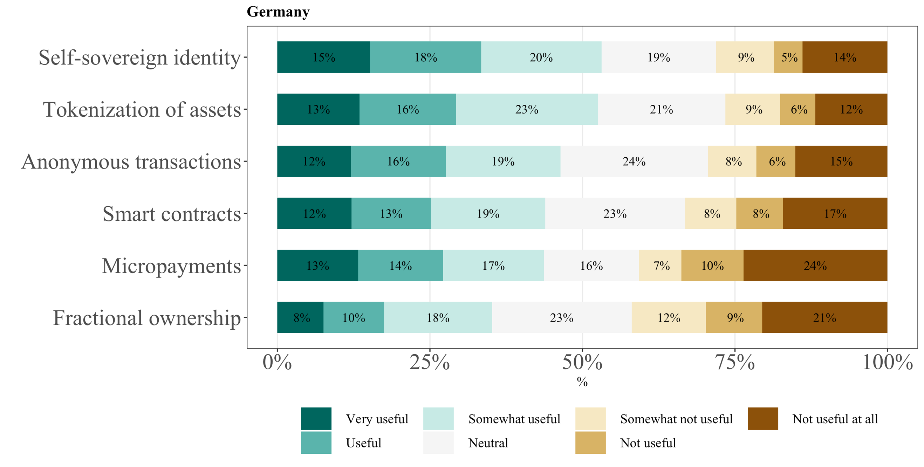

*Note:* N = 847.

# Discussion

Blockchain technology research has mainly been focused on general usage intention, mostly examined the organizational perspective, and lacked a differentiated view at specific blockchain applications from the viewpoint of the consumer. As we show in this paper, contextual factors influence the relationships of drivers for usage intention. Furthermore, consumers consider certain blockchain applications to be more useful than others. This indicates that blockchain adoption research should be more granular and differentiate between applications and contexts.

Trust and consumers’ perceived usefulness are found to be strong, positive drivers of usage intention. Our findings indicate that consumers, who recognize blockchain’s inherent integrity, benevolence, and ability, show trust towards the technology that consequently increases their usage intention. This is in line with existing literature on consumer-to-consumer markets, which indicates that trust towards peers and products increases consuming and purchasing intentions (Hawlitschek et al., 2016; Lu et al., 2010).

The result of perceived usefulness is consistent with prior UTAUT studies by Blut et al. (2022) and Venkatesh et al. (2003), who confirmed positive effects on behavioral intention. Therefore, if blockchain applications such as self-sovereign identity or tokenization of assets are designed to be of higher usefulness to the consumer, the consumers’ usage intention increases.

In contrast to the privacy value proposition of blockchain technology, consumers’ usage intention is not driven by their disposition to privacy. Although previous studies have emphasized the trade-off between risk and benefits for adoption decisions (Marikyan et al., 2022), consumer’s beliefs of keeping personal information private do not seem to play a significant role – at least not at the current stage of blockchain adoption. This surprising relationship is in line with Raddatz et al. (2021), who observed no influence of privacy concerns of consumers on their perceived benefits from using blockchain technology. Possible reasons might be that consumers have not yet fully understood the decentralized and transparent characteristics of blockchain or (pseudo-)anonymity fulfills their need for privacy.

Consumers’ perceived risk has a strong negative effect on blockchain usage intention. Concerns on system failure, security, reliability or other personal, psychological or financial risks should be minimized to boost adoption (Blut & Wang, 2020). Explorers might even face higher innovation failure risks than Hesitators or Avoiders (Abdollahi et al., 2022).

Social influence shows a weak, but positive effect on blockchain usage intention in the models including gender, experience, or possession of cryptocurrency. This finding confirms prior research (Liang et al., 2021; Venkatesh et al., 2003) and shows that blockchain usage intention is influenced by the people surrounding the consumer. Social influence is a particularly significant factor in the early adoption phase of a new technology, but might become insignificant over time (Liang et al., 2021).

Although prior studies supported a positive relationship between the overall perception of benefits and the attitude of consumers (Koohikamali et al., 2015), narrowing these benefits down to societal benefits shows no influence. This might be because societal benefits such as new economic opportunities, acceleration of peer-to-peer economies, or refined citizen-government interactions (Toufaily et al., 2021) take a long time to be realized and experienced by the consumer.

Consumers’ beliefs about the potential of disruption of blockchain show a positive effect in the models including age, gender, or possession of cryptocurrency. This indicates that consumers, who see some disruptive potential of blockchain, have a higher usage intention. Primed by many advocates as being a “disruptive innovation”, this label does not seem to go unnoticed by consumers (Frizzo-Barker et al., 2020).

Consumers’ innovativeness has a positive effect on blockchain usage intention. This is in line with Blut & Wang (2020), who observed strong positive, indirect effects of motivators on usage behavior. Moreover, our results are consistent with Blut et al. (2022), who showed a strong association of personal innovativeness with actual usage. Our results reveal that consumers, who are technology pioneers and thought leaders show a higher intention to use blockchain technology. Therefore, addressing lead-users and the Explorer segment of the population is critical when aiming to foster widespread blockchain adoption.

Interestingly, inhibitory forces (specifically discomfort) of the TRI show a weaker effect on usage intention than the motivational forces (specifically innovativeness). This is consistent with findings from Blut & Wang (2020) on technology usage. Thus, this study supports existing literature by indicating that consumers do not feel in control of blockchain technology and are somewhat overwhelmed by it (Marikyan et al., 2022). Alleviating their discomfort and fostering their understanding of blockchain technology is crucial to enhance blockchain adoption.

## Theoretical contributions

This paper makes five contributions to blockchain adoption research. First, this is one of the first papers to identify and investigate the drivers of blockchain usage intention from the perspective of the consumer by combining streams of technology adoption literature. Our results refine current UTAUT-, TRI-, and blockchain specific theory and reveal which predictors are relevant in the context of blockchain adoption. Second, our study shows the relevance of including individual characteristics and context specific moderators, such as possession of cryptocurrency. Past research has commonly focused on the main effect of predictors, specifically for UTAUT, while neglecting contextual differences (Blut et al., 2022). Third, as called for by Rossi et al. (2019), we systematically identify specific blockchain applications for future research to build upon. Our findings reveal which specific applications might be most promising from the perspective of the consumer. Fourth, distinguishing between general usage intention and specific application usefulness enables us to provide an indication on which predictors are more important for which specific application. Lastly, we provide a field report on the perception of blockchain technology by consumers in Germany and the UK as well as a cluster analysis based on the technology readiness of the German and British population. This provides research with a status quo and allows for contextualization in technology adoption research.

## Practical contributions

Based on our results, we put forward guiding principles for business managers and blockchain organizations to influence the adoption of blockchain technology. To boost the general intention to use blockchain, managers need to appeal to a consumer group that, on the one hand, contains a) innovative people, b) who recognize the usefulness of the specific application, c) who are influenced to a certain degree by their social environment, d) who show higher levels of trust in blockchain technology and e) credit blockchain some disruptive potential. Based on technology readiness, Explorers and Pioneers are most likely to fit this description.

Managers should utilize the public characteristic of blockchain and enable employees to experiment with it. Blockchain is easily accessible, even though its user interface is still in its infancy. Yet, managers need to alleviate perceived risks and concerns of discomfort of consumers. This could be achieved by e.g., designing user-oriented front ends of applications, providing a proper onboarding process, or encouraging hands-on experiences by giving out free product trials.

Organizations need to take into account age, gender, experience and cryptocurrency possession. First, managers should appeal to younger consumers by communicating technological features that convey benevolence, ability, and integrity of blockchain. For example, that the Bitcoin blockchain operates flawlessly since inception. Second, although men are more prevalent in the Explorer and Pioneer segment, their relationship between perceived risk and usage intention is more sensitive than it is among women. This indicates that men have more knowledge of blockchain technology, consider more risk factors and are more aware of the downfalls of blockchain technology, thus their usage intention is reduced. Therefore, managers should bear in mind that even though young men appear to be more inclined to use blockchain, it is critical to also reduce their perceived risk. Third, managers should aim to increase consumers’ experience levels with blockchain technology. As consumers gain more knowledge about blockchain and their exposure to blockchain increases, trust seems to become more important to the consumer than their perceived usefulness of the application. Therefore, managers should aim at increasing knowledge of consumers on blockchain and getting more consumers into contact with blockchain through e.g., free product versions or social media marketing campaigns with free training documents. Fourth, mangers should give potential customers cryptocurrency to incentivize blockchain adoption. Hands-on experience reduces the impact of consumers’ perceived risks when using blockchain technology. This is consistent with prior research on incentivizing and rewarding consumers with cryptocurrency (Steinmetz et al., 2021). Thus, giving Explorers financial incentives in the form of cryptocurrencies could boost adoption.

With regards to promising blockchain applications, organizations should focus on self-sovereign identity and tokenization of assets. Their usefulness is currently held to be the highest. Business models building upon self-sovereign identity applications need to appeal to a customer group that is driven by optimism, trust in blockchain technology and which sees blockchain applications as bringing benefits to society. However, privacy concerns are relevant and need to be alleviated. A similar notion applies for tokenization of assets applications, except that instead of privacy concerns, social influence is a driving factor. Therefore, managers in the context of tokenization applications need to be aware of and leverage the importance of network effects in growing their business. See, for instance, the current hype around NFT-collections. Explorers and Pioneers are most suitable for these applications. Anonymous transaction applications are perceived less useful. Yet, as the significance of trust and optimism is lower, managers should focus on appealing to Explorers for this application. Consumers perceive smart contract applications also to be less useful. This appears to be mainly driven by higher privacy concerns. It could be that consumers consider smart contracts as only containing highly confidential information, such as digital employment contracts or rental agreement contracts. Therefore, it is crucial for managers to ensure transparency and third-party verification of the functionality of smart contracts. Micropayment business models have been credited as one of the most likely upcoming blockchain developments (Schlecht et al 2021). However, our results cast doubt on this assessment. We encourage managers to allow for a testing phase for micropayments in which consumers have time to get used to this new type of business model. From a consumer’s perspective, fractional ownership applications score lowest on usefulness. However, managers can address similar customer groups as for tokenization applications.

## Limitations and future research

Before drawing generalized conclusions from the results of this study, some considerations should be made. Generalizations of our findings might be limited to the German population – with respect to the field report, the British population. Consumers of other countries with different cultures are likely to have experienced a different socialization, which ultimately impacts their technology perception (Blut et al., 2022). Future studies should consider implementing cultural variables as moderators or conducting similar studies in other countries and regions to enhance cross-contextualization of our findings (Blut et al., 2022). Additionally, qualitative insights on contextual factors could be enhanced by conducting interviews. Furthermore, our survey-based research design has methodological limits. To measure actual behavior, future research should conduct experiments or field studies on user behavior. Note that clusters were designed based on TRI scores, which are technology independent. Cluster design is therefore free from blockchain-specific indicators.Our study calls for a more differentiable view at blockchain usage intention and blockchain applications. Future papers should examine the business model potential of blockchain applications that consumers find useful.

# Conclusion

In this paper, we examine blockchain usage intention and application usefulness from the perspective of the consumer by conducting a quantitative study. We refine UTAUT-, TRI-, and blockchain specific theory and reveal which predictors are relevant in the context of blockchain adoption. Our research suggests several implications for practitioners, particularly with regards to fostering blockchain usage intention and assessing specific blockchain applications that look promising from the perspective of the consumer. However, in a highly dynamic market environment with surges in blockchain deal volumes and company valuations, forecasting the development of blockchain technology and its adoption is difficult. Consumer-centric research is required to examine the business model potential of blockchain applications. This enables businesses and consumers to gain a more profound understanding of the value potential of blockchain applications while ensuring that technology innovation and consumer perception are aligned.

References

Abdollahi, A., Sadeghvaziri, F., & Rejeb, A. (2022). Exploring the role of blockchain technology in value creation: A multiple case study approach. *Quality & Quantity*. https://doi.org/10.1007/s11135-022-01348-2

Agarwal, R., & Prasad, J. (1998). A Conceptual and Operational Definition of Personal Innovativeness in the Domain of Information Technology. *Information Systems Research*, *9*(2), 204–215. https://doi.org/10.1287/isre.9.2.204

Ali, O., Jaradat, A., Kulakli, A., & Abuhalimeh, A. (2021). A Comparative Study: Blockchain Technology Utilization Benefits, Challenges and Functionalities. *IEEE Access*, *9*, 12730–12749. https://doi.org/10.1109/ACCESS.2021.3050241

Amberdata. (2022). *DeFi and the Transformation of Institutional Finance*.

Aydiner, A. S. (2021). New Approach to A Disruptive Business Model with Dynamic Capability Under the Blockchain Technology. In H. Dincer & S. Yüksel (Eds.), *Management Strategies to Survive in a Competitive Environment* (pp. 17–32). Springer International Publishing. https://doi.org/10.1007/978-3-030-72288-3_2

Babich, V., & Hilary, G. (2020). OM Forum—Distributed Ledgers and Operations: What Operations Management Researchers Should Know About Blockchain Technology. *Manufacturing & Service Operations Management*, *22*(2), 223–240. Business Source Complete.

Blut, M., Chong, A. Y. L., Tsigna, Z., & Venkatesh, V. (2022). Meta-Analysis of the Unified Theory of Acceptance and Use of Technology (UTAUT): Challenging its Validity and Charting a Research Agenda in the Red Ocean. *Journal of the Association for Information Systems*, *23*(1), 13–95. https://doi.org/10.17705/1jais.00719

Blut, M., & Wang, C. (2020). Technology readiness: A meta-analysis of conceptualizations of the construct and its impact on technology usage. *Journal of the Academy of Marketing Science*, *48*(4), 649–669. https://doi.org/10.1007/s11747-019-00680-8

Bossler, L. F., & Kroenung, J. (2022). Exploring the Current State of Research on Blockchain and Cryptocurrency – Analyzing Enablers, Inhibitors, and Indeterminate Factors. *Wirtschaftsinformatik 2022 Proceedings*, *4*.

Boston Consulting Group. (2019). *Capturing the Value of Blockchain*.

Brown, T. A. (2015). *Confirmatory factor analysis for applied research* (Second edition). The Guilford Press.

Brown, T. A., & Moore, M. T. (2012). Confirmatory factor analysis. *Handbook of Structural Equation Modeling*, *361*, 379.

Canton of Aargau. (2022). *Confirmation of residence*. https://ssi-poc.ag.ch

Catalini, C., & Gans, J. S. (2016). Some Simple Economics of the Blockchain. *SSRN Electronic Journal*. https://doi.org/10.2139/ssrn.2874598

CB Insights. (2021). *State of Blockchain*.

Chong, A. Y. L., Lim, E. T. K., Hua, X., Zheng, S., & Tan, C.-W. (2019). Business on Chain: A Comparative Case Study of Five Blockchain-Inspired Business Models. *Journal of the Association for Information Systems*, *20*(9), 1308–1337. Business Source Complete.

Cohen, B. H. (2013). *Explaining psychological statistics* (Fourth Edition). Wiley.

Cohen, J., Cohen, P., West, S. G., & Aiken, L. S. (2003). *Applied multiple regression/correlation analysis for the behavioral sciences* (3rd ed). L. Erlbaum Associates.

CoinGecko. (2022). https://www.coingecko.com/de

Cong, L. W., & He, Z. (2019). Blockchain Disruption and Smart Contracts. *Review of Financial Studies*, *32*(5), 1754–1797. Business Source Complete.

Cronbach, L. J. (1951). Coefficient alpha and the internal structure of tests. *Psychometrika*, *16*(3), 297–334.

Davis, F. D. (1989). Perceived usefulness, perceived ease of use, and user acceptance of information technology. *MIS Quarterly*, 319–340.

Fishbein, M., Ajzen, I., & Belief, A. (1975). *Intention and Behavior: An introduction to theory and research*. Addison-Wesley, Reading, MA.

Frizzo-Barker, J., Chow-White, P. A., Adams, P. R., Mentanko, J., Ha, D., & Green, S. (2020). Blockchain as a disruptive technology for business: A systematic review. *International Journal of Information Management*, *51*, 102029. https://doi.org/10.1016/j.ijinfomgt.2019.10.014

Gefen, D. (2000). E-commerce: The role of familiarity and trust. *Omega*, *28*(6), 725–737.

Hair, J. F. (Ed.). (2014). *Multivariate data analysis* (7. ed., Pearson new internat. ed). Pearson.

Hawlitschek, F., Teubner, T., & Weinhardt, C. (2016). Trust in the Sharing Economy. *Die Unternehmung*, *70*(1), 26–44. https://doi.org/10.5771/0042-059X-2016-1-26

Hayes, A. F. (2018). *Introduction to mediation, moderation, and conditional process analysis: A regression-based approach* (Second edition). Guilford Press.

Hendershott, T., Zhang, X. (Michael), Zhao, J. L., & Zheng, Z. (Eric). (2021). FinTech as a Game Changer: Overview of Research Frontiers. *Information Systems Research*, *32*(1), 1–17. Business Source Complete.

Henseler, J., Ringle, C. M., & Sarstedt, M. (2015). A new criterion for assessing discriminant validity in variance-based structural equation modeling. *Journal of the Academy of Marketing Science*, *43*(1), 115–135. https://doi.org/10.1007/s11747-014-0403-8

Hu, L., & Bentler, P. M. (1999). Cutoff criteria for fit indexes in covariance structure analysis: Conventional criteria versus new alternatives. *Structural Equation Modeling: A Multidisciplinary Journal*, *6*(1), 1–55. https://doi.org/10.1080/10705519909540118

Iansiti, M., & Lakhani, K. (2017). The Truth About Blockchain. *Harvard Business Review*, *95*, 118–127.

Ilk, N., Guangzhi Shang, Shaokun Fan, & Zhao, J. L. (2021). Stability of Transaction Fees in Bitcoin: A Supply and Deemand Perspective. *MIS Quarterly*, *45*(2), 563–592. Business Source Complete.

Jokisch, M. R., Schmidt, L. I., Doh, M., Marquard, M., & Wahl, H.-W. (2020). The role of internet self-efficacy, innovativeness and technology avoidance in breadth of internet use: Comparing older technology experts and non-experts. *Computers in Human Behavior*, *111*, 106408. https://doi.org/10.1016/j.chb.2020.106408

Kim, S. (2020). *Fractional Ownership, Democratization and Bubble Formation—The Impact of Blockchain Enabled Asset Tokenization*. Americas Conference on Information Systems 2020 Proceedings.

Knauer, F., & Mann, A. (2020). What is in It for Me? Identifying Drivers of Blockchain Acceptance among German Consumers. *The Journal of the British Blockchain Association*, *3*(1), 1–16. https://doi.org/10.31585/jbba-3-1-(1)2020

Koohikamali, M., Gerhart, N., & Mousavizadeh, M. (2015). Location disclosure on LB-SNAs: The role of incentives on sharing behavior. *Decision Support Systems*, *71*, 78–87. https://doi.org/10.1016/j.dss.2015.01.008

Li, J. (2020). Blockchain Technology Adoption: Examining the Fundamental Drivers. *Proceedings of the 2020 2nd International Conference on Management Science and Industrial Engineering*, 253–260. https://doi.org/10.1145/3396743.3396750

Li, Y. (2014). The impact of disposition to privacy, website reputation and website familiarity on information privacy concerns. *Decision Support Systems*, *57*, 343–354. https://doi.org/10.1016/j.dss.2013.09.018

Liang, T.-P., Kohli, R., Huang, H.-C., & Li, Z.-L. (2021). What Drives the Adoption of the Blockchain Technology? A Fit-Viability Perspective. *Journal of Management Information Systems*, *38*(2), 314–337. Business Source Complete.

Loh, X.-M., Lee, V.-H., Tan, G. W.-H., Ooi, K.-B., & Dwivedi, Y. K. (2020). Switching from cash to mobile payment: What’s the hold-up? *Internet Research*, *31*(1), 376–399. https://doi.org/10.1108/INTR-04-2020-0175

Lu, Y., Zhao, L., & Wang, B. (2010). From virtual community members to C2C e-commerce buyers: Trust in virtual communities and its effect on consumers’ purchase intention. *Electronic Commerce Research and Applications*, *9*(4), 346–360. https://doi.org/10.1016/j.elerap.2009.07.003

Magidson, J., & Vermunt, J. K. (2004). Latent class models. In D. Kaplan (Ed.), *The Sage handbook of quantitative methodology for the social sciences* (pp. 175–198). Sage.

Marikyan, D., Papagiannidis, S., Rana, O. F., & Ranjan, R. (2022). Blockchain adoption: A study of cognitive factors underpinning decision making. *Computers in Human Behavior*, *131*, 107207. https://doi.org/10.1016/j.chb.2022.107207

Marikyan, D., Papagiannidis, S., Rana, O., & Ranjan, R. (2021). Blockchain in a Business Model: Exploring Benefits and Risks. In *Responsible AI and Analytics for an Ethical and Inclusive Digitized Society* (Vol. 12896, pp. 555–566). Springer International Publishing. https://doi.org/10.1007/978-3-030-85447-8_46

McClelland, G. H., Irwin, J. R., Disatnik, D., & Sivan, L. (2017). Multicollinearity is a red herring in the search for moderator variables: A guide to interpreting moderated multiple regression models and a critique of Iacobucci, Schneider, Popovich, and Bakamitsos (2016). *Behavior Research Methods*, *49*(1), 394–402. https://doi.org/10.3758/s13428-016-0785-2

Meyer, E., Welpe, I. M., & Sandner, P. (2021). Decentralized Finance—A systematic literature review and research directions. *SSRN Electronic Journal*. https://doi.org/10.2139/ssrn.4016497

Nakamoto, S. (2008). *Bitcoin: A peer-to-peer electronic cash system.* https://bitcoin.org/bitcoin.pdf

Nowiński, W., & Kozma, M. (2017). How Can Blockchain Technology Disrupt the Existing Business Models? *Entrepreneurial Business and Economics Review*, *5*(3), 173–188. https://doi.org/10.15678/EBER.2017.050309

Nunnally, J. C. (1978). *Psychometric theory* (2d ed). McGraw-Hill.

Olsen, T. L., & Tomlin, B. (2020). Industry 4.0: Opportunities and Challenges for Operations Management. *Manufacturing & Service Operations Management*, *22*(1), 113–122. Business Source Complete.

Page, M. J., McKenzie, J. E., Bossuyt, P. M., Boutron, I., Hoffmann, T. C., Mulrow, C. D., Shamseer, L., Tetzlaff, J. M., Akl, E. A., Brennan, S. E., Chou, R., Glanville, J., Grimshaw, J. M., Hróbjartsson, A., Lalu, M. M., Li, T., Loder, E. W., Mayo-Wilson, E., McDonald, S., … Moher, D. (2021). The PRISMA 2020 statement: An updated guideline for reporting systematic reviews. *BMJ*, n71. https://doi.org/10.1136/bmj.n71

Parasuraman, A. (2000). Technology Readiness Index (Tri): A Multiple-Item Scale to Measure Readiness to Embrace New Technologies. *Journal of Service Research*, *2*(4), 307–320. https://doi.org/10.1177/109467050024001

Parasuraman, A., & Colby, C. L. (2015). An Updated and Streamlined Technology Readiness Index: TRI 2.0. *Journal of Service Research*, *18*(1), 59–74. https://doi.org/10.1177/1094670514539730

Pavlou, P. A. (2003). Consumer acceptance of electronic commerce: Integrating trust and risk with the technology acceptance model. *International Journal of Electronic Commerce*, *7*(3), 101–134.

Podsakoff, P. M., MacKenzie, S. B., Lee, J.-Y., & Podsakoff, N. P. (2003). Common method biases in behavioral research: A critical review of the literature and recommended remedies. *Journal of Applied Psychology*, *88*(5), 879–903. https://doi.org/10.1037/0021-9010.88.5.879

Quiroz-Gutierrez, M. (2022). Bored Apes and CryptoPunks help jolt NFT market to over 21,000% growth and $17.6 billion in sales last year. *Fortune*.

Raddatz, N., Coyne, J., Menard, P., & Crossler, R. E. (2021). Becoming a blockchain user: Understanding consumers’ benefits realisation to use blockchain-based applications. *European Journal of Information Systems*, 1–28. Business Source Complete.

Rogers, E. M. (1962). *Diffusion of innovations.* Free Press.

Rönkkö, M., & Cho, E. (2022). An Updated Guideline for Assessing Discriminant Validity. *Organizational Research Methods*, *25*(1), 6–14. https://doi.org/10.1177/1094428120968614

Rossi, M., Mueller-Bloch, C., Thatcher, J. B., & Beck, R. (2019). Blockchain Research in Information Systems: Current Trends and an Inclusive Future Research Agenda. *Journal of the Association for Information Systems*, *20*(9), 1388–1403. Business Source Complete.

Sarker, S., Henningsson, S., Jensen, T., & Hedman, J. (2021). Use Of Blockchain As A Resource For Combating Corruption In Global Shipping: An Interpretive Case Study. *Journal of Management Information Systems*, *38*(2), 338–373. Business Source Complete.

Schlecht, L., Schneider, S., & Buchwald, A. (2021). The prospective value creation potential of Blockchain in business models: A delphi study. *Technological Forecasting and Social Change*, *166*, 120601. https://doi.org/10.1016/j.techfore.2021.120601

Steinmetz, F., von Meduna, M., Ante, L., & Fiedler, I. (2021). Ownership, uses and perceptions of cryptocurrency: Results from a population survey. *Technological Forecasting and Social Change*, *173*, 121073. https://doi.org/10.1016/j.techfore.2021.121073

Toufaily, E., Zalan, T., & Dhaou, S. B. (2021). A framework of blockchain technology adoption: An investigation of challenges and expected value. *Information & Management*, *58*(3), 103444. https://doi.org/10.1016/j.im.2021.103444

Venkatesh, Morris, Davis, & Davis. (2003). User Acceptance of Information Technology: Toward a Unified View. *MIS Quarterly*, *27*(3), 425. https://doi.org/10.2307/30036540

VISA. (2021). *The Crypto Phenomenon: Consumer Attitudes & Usage*.

Warshaw, P. R., & Davis, F. D. (1985). Disentangling behavioral intention and behavioral expectation. *Journal of Experimental Social Psychology*, *21*(3), 213–228. https://doi.org/10.1016/0022-1031(85)90017-4

Webster, J., & Watson, R. T. (2002). Analyzing the past to prepare for the future: Writing a literature review. *MIS Quarterly*, *26*(2), xiii–xxiii.

Weking, J., Mandalenakis, M., Hein, A., Hermes, S., Böhm, M., & Krcmar, H. (2020). The impact of blockchain technology on business models – a taxonomy and archetypal patterns. *Electronic Markets*, *30*(2), 285–305. https://doi.org/10.1007/s12525-019-00386-3

Whitaker, A., & Kräussl, R. (2020). Fractional Equity, Blockchain, and the Future of Creative Work. *Management Science*, *66*(10), 4594–4611. Business Source Complete.

Yin, H. H. S., Langenheldt, K., Harlev, M., Mukkamala, R. R., & Vatrapu, R. (2019). Regulating Cryptocurrencies: A Supervised Machine Learning Approach to De-Anonymizing the Bitcoin Blockchain. *Journal of Management Information Systems*, *36*(1), 37–73. Business Source Complete.

Zhang, W., Wei, C.-P., Jiang, Q., Peng, C.-H., & Zhao, J. L. (2021). Beyond the Block: A Novel Blockchain-Based Technical Model for Long-Term Care Insurance. *Journal of Management Information Systems*, *38*(2), 374–400. Business Source Complete.

Zheng, Y., & Boh, W. F. (2021). Value drivers of blockchain technology: A case study of blockchain-enabled online community. *Telematics and Informatics*, *58*, 101563. https://doi.org/10.1016/j.tele.2021.101563

Ziolkowski, R., Miscione, G., & Schwabe, G. (2020). Decision Problems in Blockchain Governance: Old Wine in New Bottles or Walking in Someone Else’s Shoes? *Journal of Management Information Systems*, *37*(2), 316–348. Business Source Complete.

Appendix

Appendix 1:  
*Literature review methodology*

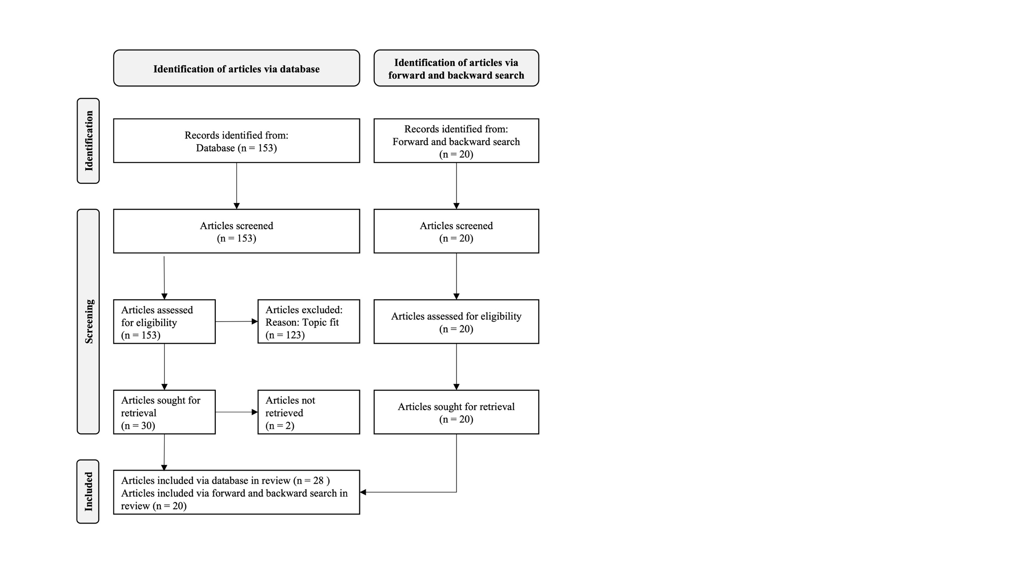

*Note:* This design was adapted from the PRISMA flow diagram byPage et al. (2021).

Appendix 2:  
*Frequency of literature on specific blockchain applications*

|  |  |  |
| --- | --- | --- |
| Specific blockchain application | Frequency of articles covering or relating to the specific blockchain application | |
| n | % |
| Self-sovereign identity | 9 | 19% |
| Tokenization of assets | 16 | 33% |
| Fractional ownership | 4 | 8% |
| Micropayments | 7 | 15% |
| Smart contracts | 31 | 65% |
| Anonymous transactions | 11 | 23% |

*Note*: N = 48.

Appendix 3:  
*Constructs and items*

|  |  |  |  |
| --- | --- | --- | --- |
| Construct | Item | | Source |
| **Optimism** | OPT1 | New technology gives me more freedom of mobility. | Parasuraman, 2000 |
| OPT2 | New technology makes me more productive. |
| **Innovativeness** | INN1 | Other people come to me for advice on new technologies. | Agarwal & Prasad, 1998; Parasuraman, 2000 |
| INN2 | In general, I am among the first in my circle of friends to acquire new technology when it appears. |
| INN3 | I keep up with the latest technological developments in my areas of interest. |
| **Discomfort** | DIS1 | I can usually figure out new high-tech products and services without help from others. | Parasuraman, 2000 |
| DIS2 | Sometimes, I think that technology systems are not designed for use by ordinary people. |
| **Insecurity** | INS1 | People are too dependent on technology to do things for them. | Parasuraman, 2000 |
| INS2 | Too much technology distracts people to a point that is harmful. |
| INS3 | I don’t feel comfortable doing business if the other party is only available online. |
| **Social influence** | SOC1 | Would your circle of friends and acquaintances believe that you should use Blockchain Technology? | Venkatesh et al., 2003 |
| **Disposition to privacy** | DTP1 | Compared to others, I am more sensitive about the way other people or organizations handle my personal information. | Y. Li, 2014 |
| DTP2 | Compared to others, I see more importance in keeping personal information private. |
| DTP3 | Compared to others, I am less concerned about potential threats to my personal privacy. |
| **Trust** | TIN1 | Blockchain Technology provides reliable information. | Hawlitschek et al., 2016; Lu et al., 2010 |
| TIN2 | Blockchain Technology is honest in dealing with my private data. |
| TIN3 | Blockchain Technology adheres to rules and principles. |
| TBE1 | Blockchain Technology acts in the interests of its users. |
| TBE2 | In general, Blockchain Technology is not malicious. |
| TBE3 | Blockchain Technology has no bad intentions towards its users. |
| TAB1 | Blockchain Technology serves its purpose. |
| TAB2 | Blockchain Technology operates flawlessly. |
| TAB3 | Blockchain Technology is capable to offer me a good service. |
| **Perceived risk** | RIS1 | In general, it seems risky to use Blockchain Technology. | Koohikamali et al., 2015 |
| RIS2 | I would feel unsafe using Blockchain Technology. |
| **Perceived benefit for society** | BSO1 | Using Blockchain Technology has many advantages for society. | Koohikamali et al., 2015 |
| BSO2 | Using Blockchain Technology has many disadvantages for society. |

*Appendix 3 continued*

|  |  |  |  |
| --- | --- | --- | --- |
| Construct | Item |  | Source |
| **Potential of disruption** | PDI1 | Your Feeling: Blockchain Technology has great potential to disrupt the business world. | Aydiner, 2021; Frizzo-Barker et al., 2020 |
| PDI2 | Your Feeling: Blockchain Technology has great potential to disrupt everyday life. |
| PDI3 | Your Feeling: Blockchain Technology has great potential to be as disruptive as the introduction of the internet. |
| PDI4 | Your Feeling: Blockchain Technology has no disruptive potential at all. |
| **Usage intention** | UIN1 | Given the chance, I would use Blockchain Technology applications. | Venkatesh et al., 2003; Warshaw & Davis, 1985 |
| UIN2 | Given the chance, it is very likely that I would use Blockchain Technology. |
| **Experience** | EXP1 | Currently, my contact with blockchain technology (or cryptocurrency) in my professional (job, uni, school) life is… | Blut et al., 2022; Venkatesh et al., 2003 |
| EXP2 | Currently, my contact with blockchain technology (or cryptocurrency) in my personal life is... |
| EXP3 | How would you rate your knowledge of Blockchain Technology? |
| **Possession of cryptocurrency** | POC1 | Are you currently, or have you ever been, in possession of any cryptocurrency? (e.g., Bitcoin, Ethereum or others) | Steinmetz et al., 2021; Toufaily et al., 2021 |
| **Application usefulness** (Tokenization of assets) | USF1 | How useful do you find this possibility? | Venkatesh et al., 2003 |
| **Application usefulness** (Fractional ownership) | USF2 | How useful do you find this possibility? | Venkatesh et al., 2003 |
| **Application usefulness** (Self-sovereign identity) | USF3 | How useful do you find this possibility? | Venkatesh et al., 2003 |
| **Application usefulness** (Smart contracts) | USF4 | How useful do you find this possibility? | Venkatesh et al., 2003 |
| **Application usefulness** (Micropayments) | USF5 | How useful do you find this possibility? | Venkatesh et al., 2003 |
| **Application usefulness** (Anonymous transactions) | USF6 | How useful do you find this possibility? | Venkatesh et al., 2003 |
| **Perceived usefulness** | USF1-6 | How useful do you find this possibility? | c.f. Performance Expectancy Venkatesh et al., 2003 |

Appendix 4:  
*British consumers’ usefulness assessment of specific blockchain applications*

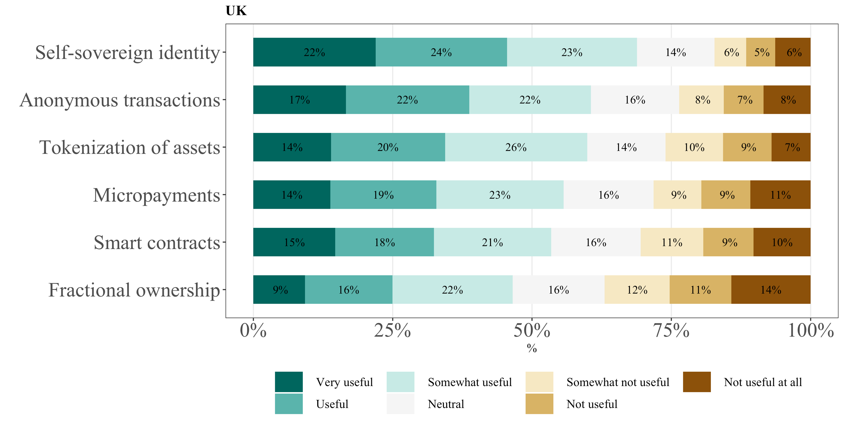

*Note*: N = 898.

Declaration of Authorship

I hereby declare that the thesis submitted is my own unaided work. All direct or indirect sources used are acknowledged as references.

I am aware that the thesis in digital form can be examined for the use of unauthorized aid and in order to determine whether the thesis as a whole or parts incorporated in it may be deemed as plagiarism. For the comparison of my work with existing sources I agree that it shall be entered in a database where it shall also remain after examination, to enable comparison with future theses submitted. Further rights of reproduction and usage, however, are not granted here.

This paper was not previously presented to another examination board and has not been published.

Munich, 31.05.2022 __________________________________



Dennis Henning

1. This thesis is based on the forthcoming paper by Mehrwald & Henning (2022): Consumers’ Perspective on Blockchain Technology: What drives Usage Intention and determines Application Usefulness?
2. The initial development of the TRI 1.0 is based on 36 items, whereas its updated version, TRI 2.0, is reduced to a 16-item scale (Parasuraman & Colby, 2015). For our purposes, we implemented an abbreviated TRI 2.0 index of ten items, as this version is also capable of predicting TR segment membership with a high degree of accuracy while leaving room for other questions in the survey (see also https://rockresearch.com/abbreviated-version-tri-2-0/).
3. EBSCOhost Business Source Complete does not provide access to the Journal of Strategic Information Systems.